Chemical Sciences,

Redeemer’s University,

Osun state, Nigeria.

26th April 2023.

The Editor,

# Applied Chemical Engineering,

# 

Dear Sir,

**COVERING LETTER FOR THE SUBMISSION OF ARTICLE FOR PUBLICATION**

I hereby write to submit a manuscript titled: **Development of nanocomposite membranes for removal of pharmaceutically active compounds in water: A review**

for publication in your reputable journal. The work is original and real. It has not been published anywhere before.

The work has not been submitted to a preprint server prior to this submission.

Adewale Adewuyi1*, Woei Jye Lau2

1Department of Chemical Sciences, Faculty of Natural Sciences, Redeemer’s University, Ede, Osun State, Nigeria

2Advanced Membrane Technology Research Centre (AMTEC), Faculty of Chemical and Energy Engineering, Universiti Teknologi Malaysia, 81310 Skudai, Johor, Malaysia

Corresponding author**\***: [walexy62@yahoo.com](mailto:walexy62@yahoo.com), Phone: +2348035826679

I hope that you will find it suitable for publication in your widely read journal.

Best regards

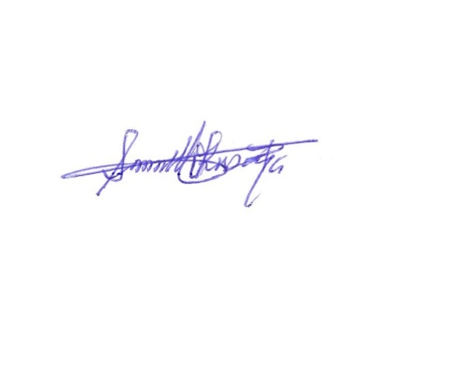

Adewale Adewuyi