Morphology and Characteristics of Polyethersulfone Membrane Modified with Polyethylene glycol Hexadecyl Ether and Nanocarbon

Rinal Dia’ul Haikal¹, Alwan Ziyad Marom¹, Muhammad Prayogie Aulia¹, Aulia Chintia Ambarita¹, Azwar¹, Afrilia Fahrina², Muhammad Roil Bilad³, Sri Mulyati^{1,4,5}, Mehmet Emin Pasaoglu⁶, Ismail Koyuncu⁶, Nasrul Arahman^{1,4,5,7*}

¹ Department of Chemical Engineering, Universitas Syiah Kuala, Jl. Syeh A. Rauf, No. 7, Banda Aceh 23111, Darussalam, Indonesia
²Research Center for Marine and Land Bioindustry, National Research and Innovation Agency (BRIN), North Lombok, 83756, Indonesia
³Faculty of Integrated Technologies, Universiti Brunei Darussalam, Bandar Seri Begawan BE1410, Brunei
⁴Graduate School of Environmental Management, Universitas Syiah Kuala, Jl. Tgk. Chik Pante Kulu No. 5, Banda Aceh 23111, Darussalam, Indonesia
⁵Research Center for Environmental and Natural Resources, Universitas Syiah Kuala, Jl. Hamzah Fansuri, No. 4, Darusslam, Banda Aceh, 23111, Indonesia
⁶National Research Center on Membrane Technologies, Istanbul Technical University, Maslak 34469, Istanbul, Turkey
⁷Atsiri Research Center, PUI, Universitas Syiah Kuala, Jl. Syeh A Rauf, No. 5, Banda Aceh 23111, Darussalam, Indonesia

*Corresponding Author: Nasrular@unsyiah.ac.id

ABSTRACT
Membrane filtration is one of the separation techniques based on the filtration media's morphological structure and pore size. This study aims to investigate the effect of organic and inorganic additives on the morphology and performance of polyethersulfone (PES) membranes. Two additives used are polyethylene glycol hexadecyl ether (PEG-HE) and Nanocarbon. PES membrane synthesis was carried out using a phase inversion technique. The membrane performance test includes analysis of pure permeability and rejection of synthetic fertilizer factory wastewater (Mg²⁺) with a concentration of 300 ppm. The membrane characterization was carried out by analyzing the morphology of the membrane structure using Scanning Electron Microscopy (SEM), water contact angle (WCA), porosity, and membrane pore size. Ultrafiltration experiment showed that the modified PES membrane with PEG-HE and Nanocarbon had the highest permeability. The most significant rejection coefficient of 96.88% was found in an ultrafiltration experiment using pure PES membranes. The characteristic of other membranes will be described in detail in this article.

Keywords: Hybrid membrane, Nano Carbon, Polyether sulfone, Polyethylene Glycol Hexadecyl Ether

1. Introduction
Recent developments in water purification technology have attracted the attention of researchers and industry activists to apply ultrafiltration or nanofiltration membrane techniques as a profitable alternative. Membrane technology has advantages over other separation processes, such as separation can be carried out continuously, the energy required is relatively low, and the membrane separation process can be combined with other separation processes (hybrid processing), does not require additional chemicals, and varies membrane materials, making it easy to adapt to the type of waste used^{[1]}.
The problem of membranes that is still challenging for researchers who develop membrane technology, especially in wastewater treatment, is forming a layer of organic matter or other materials on the membrane surface (fouling) during the membrane filtration process. Fouling hurts the overall filtration process by shortening the life of the membrane. Adding additives to the membrane surface is one way to minimize fouling formation on the membrane^{[2]}. Adding additives to the membrane-based material is to modify its morphological structure, hydrophilic properties, and mechanical properties^{[3]}. Several studies have reported the success of modifying membrane properties with the addition of organic additives such as polyvinylpyrrolidone^{[4]}, Pluronic F127^{[5]}, graphene oxide^{[6]}, and carbon nanotube grafting^{[7]}. All reports of this study concluded that modifying polymer solutions with organic or inorganic additives improved the morphology and performance of the resulting membranes.
Based on the literature review of recent studies on membrane modification, there has been no study on the use of organic and inorganic additives in improving the morphology and performance of membranes with polyethersulfone (PES) polymer as the base material and dimethyl formamide as solvent. Therefore, this research was initiated to look for alternative modifications of PES membranes with a combination of organic and inorganic additives in one dope solution. Additive to the organic polymer is polyethylene glycol hexadecyl ether (PEG-HE) and Nanocarbon as an inorganic additive. PEG-HE is an attractive amphiphilic molecule consisting of PEG and an alkyl group usually used as a surfactant to prepare colloidal micelles and sol-gel hybrid materials. Polyethylene glycol hexadecyl ether has good morphology, is stable, decomposition temperature is higher than the pure component, and nanopores can absorb and accommodate molecules well amphiphilically in nanochannels^{[8]}. Thus, this additive could improve the hydrophilic properties of the membrane produced in this study. Nano carbons are fine particles from the pyrolysis of oil palm shells, which improve the membrane's mechanical properties.

2. Experimental Method
2.1 Materials
The primary materials in this study, such as Polyethersulfone (PES Mw: 65 kDa, Ultrason E6020 P, BASF, Ludwigshafen, Germany) as the polymer, Dimethylformamide (DMF, Merck, Taufkirchen, Germany) as the solvent, Polyethylene Glycol Hexadecyl Ether (PEG-HE Mw: 4 kDa, Merck, Darmstadt, Germany) as the organic additive and Nanocarbon (Sw-Cnt, 0.78 nm, Sigma Aldrich, St. Louis, MI, USA) as the inorganic additive.

2.2 Membrane Fabrication
The dope solution was made from 16%wt of PES, then 5%wt PEG-HE and 0.05%wt Nanocarbon were added, and the last added was the solvent (DMF) with a total weight of the mixture is 20 grams. The detailed composition of the dope solution can be seen in Table 1. After the solution was homogenous, it should keep for one night to remove the bubble. The dope solution was ready to cast on a flat glass using a membrane applicator (thickness of 300 μm), followed by immersion into a bath containing distilled water after all the bubbles were removed.
Table 1. Composition of the dope solution by weight
PES (%) | PEG-HE (%) | Nanocarbon (%) | DMF (%) | Membrane
16 | 0 | 0 | 84 | MP
16 | 5 | 0 | 79 | MPB
16 | 0 | 0.05 | 83.95 | MPNc
16 | 5 | 0.05 | 78.95 | MPBNc

2.3 Membrane Characterization and Performance
2.3.1 Membrane Morphology
The morphology of the membranes was evaluated using scanning electron microscopy (SEM, FEI Quanta Feg 250 model). The samples were immersed in liquid nitrogen to create the cross-section specimen, which was freeze-dried at a temperature of -55°C before being fractured to create a clean cut. The surface analysis was prepared by cutting the membranes into small sizes (0.5 cm x 0.5 cm) and putting them on the metal holder.

2.3.2 Water Contact Angle (WCA)
The membrane's hydrophilicity was evaluated using water contact angle analysis. Measurement was conducted ten times in different ten points on the membrane's surface, and calculated the average value and standard deviation. The equipment type of this analysis was the KSV Attension Theta model, Turkey.

2.3.3 Membrane Permeation Performance
An effective membrane performance can be observed through the filtration process based on the results of flux and permeability. The series of nanofiltration module units used in this work is shown in Figure 1. The procedure was conducted by applying a peristaltic pump with a flow rate of 0.1 L/min and a pressure of 1.0 bar. Filtration time recording begins when the water exits through the membrane material, and measurements are taken every 10 minutes as the filtration occurs. The valve is opened to allow feed water to flow through the pipe to the membrane. Water that penetrates the membrane wall (permeate) is accommodated in a 100 ml measuring cup, and the permeate flow rate is measured by recording the volume accommodated every 10 minutes until it reaches a constant volume. Furthermore, the flux and the coefficient of permeability are calculated. Water that cannot penetrate the membrane wall is continuously returned to the feed tank.
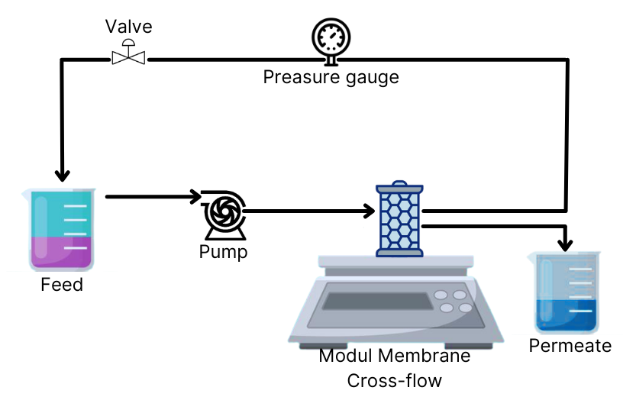
Figure 1. Schematic of Nanofiltration Equipment

The membrane flux was obtained from the change in the permeate volume per unit of time and the membrane surface area. The equation used to calculate the flux is shown in Equation (1), where J is flux (L/m².h), V is the volume of permeate (L), A is the surface area of the membrane (m²), and t is the filtration time (h).
(1)

The membrane permeability coefficient indicates the ease with which the feed passes through the membrane. The formula used to calculate the membrane permeability coefficient is shown in Equation (2), where Lp is the coefficient of permeability (L/m².h.atm), J is the water flux (L/m².h), and Δp is pressure different (atm).
(2)

The membrane's selectivity was obtained by measuring the rejection of 300 ppm Mg2+ solution. The concentration of the Mg²⁺ solution was analyzed using a UV-Vis Spectrometer. The rejection of the Mg²⁺ solution was calculated using Equation (3), where R is the rejection coefficient (%), Cf is the Mg²⁺ concentration in feed (ppm), and Cp is the Mg²⁺ concentration in permeate (ppm).
(3)

3. Result and Discussion
3.1 Membrane Morphological Analysis
Based on the results of SEM observation in Figure 2, all membranes generally appear to have similar surface morphology. However, adding PEG-HE and nanocarbon creates more macro voids than the original PES membranes. Based on Figure 2, it can be seen that the macro voids PES membrane cross-section have finger-shaped with the same size. The membrane cross-section with the addition of PEG-HE and nanocarbon also showed an increase in the membrane pores in the form of sponge macro cavities on all sides of the membrane cross-section. This increase is because adding the PEG-HE additive, which is amphiphilic with a hydrophilic head and hydrophobic tail, can reduce the surface tension at the points where surfactant molecules are present, thereby facilitating the diffusion of water molecules. This phenomenon causes a delay in demixing in the coagulation bath and increases pores in the cross-section membrane. The combination of hydrophilic PEG-HE and nanocarbon additives positively affects the membrane characteristics. The membrane produces using both additives shown has good porosity, flux values, and optimal rejection^{[9]}.
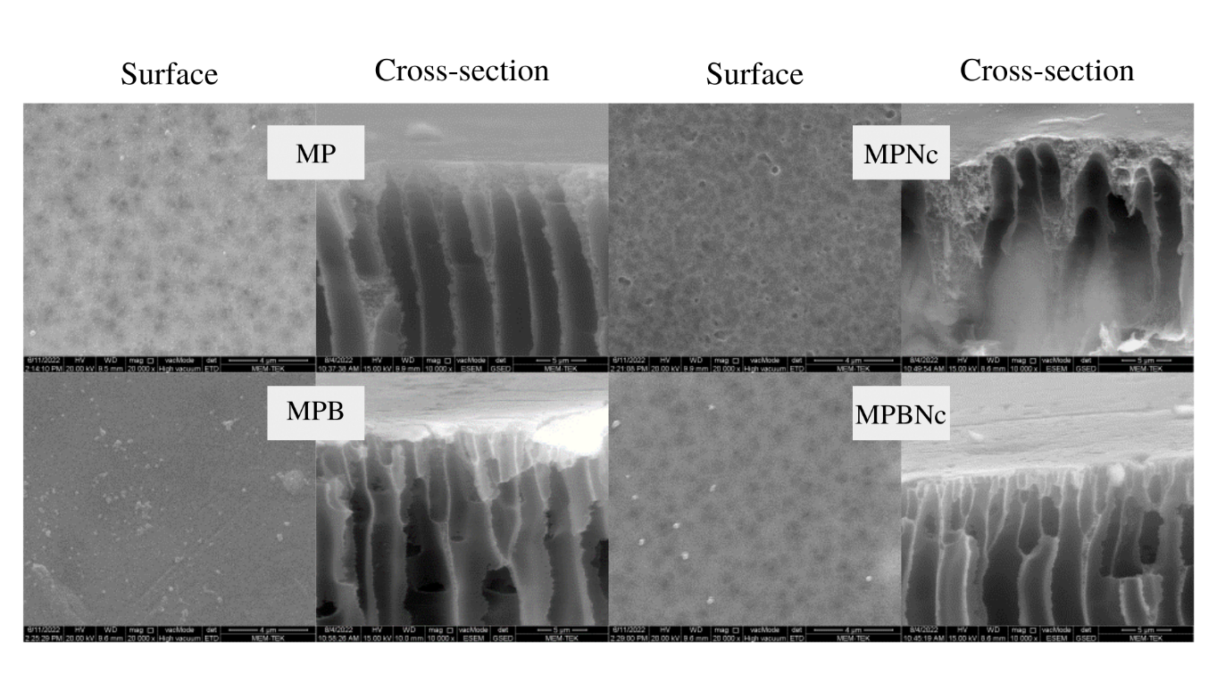
Figure 2. Surface and cross-section SEM images of the membrane samples

3.2 Membrane Hydrophilicity
The size of the angle formed between the membrane's surface and the air is represented by the water contact angle (WCA). A smaller WCA value indicates more hydrophilic properties of the membranes. The WCA analysis was conducted to determine the hydrophilicity of the membrane by dripping air onto its surface. The results of the WCA analysis can be seen in Figure 3. Based on Figure 3, it can be seen that the addition of the PEG-HE additive resulted in the WCA value decreasing from 69.5⁰ on the PES membrane without additives to 58⁰ on the PBNC membrane. The addition of the PEG-HE additive surfactant is proven to increase the hydrophilicity of the membrane, which is characterized by a decrease in the WCA value of the membrane. The surfactant additive will extend the formation of fingers-like pores and micro voids. The better hydrophilicity of the membrane has the potential to be an excellent anti-fouling agent. Impurities in the waste will not easily stick to the surface of the hydrophilic membrane, so the increase in hydrophilicity can prevent the membrane from fouling effect^{[10]}.
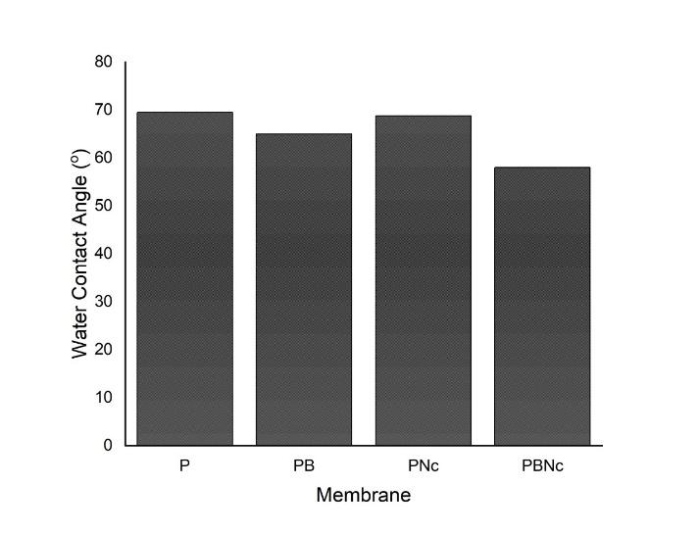
Figure 3. Hydrophilicity profile of the membranes

3.3 Porosity and Pore Size
Porosity is the ratio between the pore volume and the total membrane volume. The porosity test is carried out to determine space (cavity) in the membrane. The membrane pore size significantly affects the membrane's performance in determining the water flux's value. The results of the porosity and pore size test can be seen in Figure 4. Based on Figure 4, it can be seen that the modified PBNC membrane has the most significant porosity value, which is 89.44%. Adding hydrophilic additives causes a slowdown of solvent-non-solvent exchange in the solidification process. This slowdown results in the formation of cavities in the membrane structure. According to Kusworo et al.^{[11]}, adding additives can increase the porosity of the membrane because the additives can diffuse evenly to form a larger pore size.
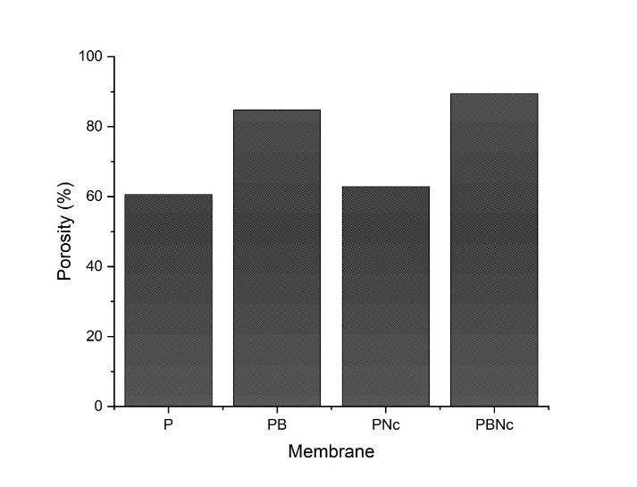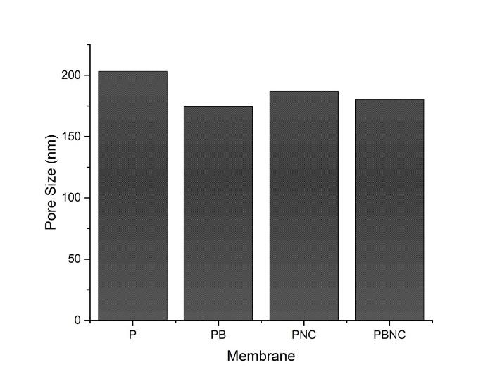
(a) (b)
Figure 4. Porosity (a) and membrane pore size value (b)

3.4 Membrane Permeability
Determination of membrane permeability was carried out by flowing pure water as feed into a series of nanofiltration membrane module units using a peristaltic pump with a flow rate of 0.1 L/min and a pressure of 1.0 bar. The recording of the filtration time begins when the water comes out through the membrane wall, and measurements are made every 10 minutes the filtration takes place. The results of the membrane permeability test can be seen in Figure 5. Based on Figure 5, it can be seen that PBNC membranes have the highest permeability compared to PES, PB, and PNC membranes. According to the hydrophilicity value of the membrane shown in Figure 3, the PBNC membrane has the lowest WCA value of 58⁰. Figure 5 shows that the PNC membrane has the lowest permeability compared to other membrane types; this phenomenon can happen because the added nanocarbon only changes the cross-sectional properties but does not change the pore structure of the membrane surface, affecting the permeability^{[12]}.
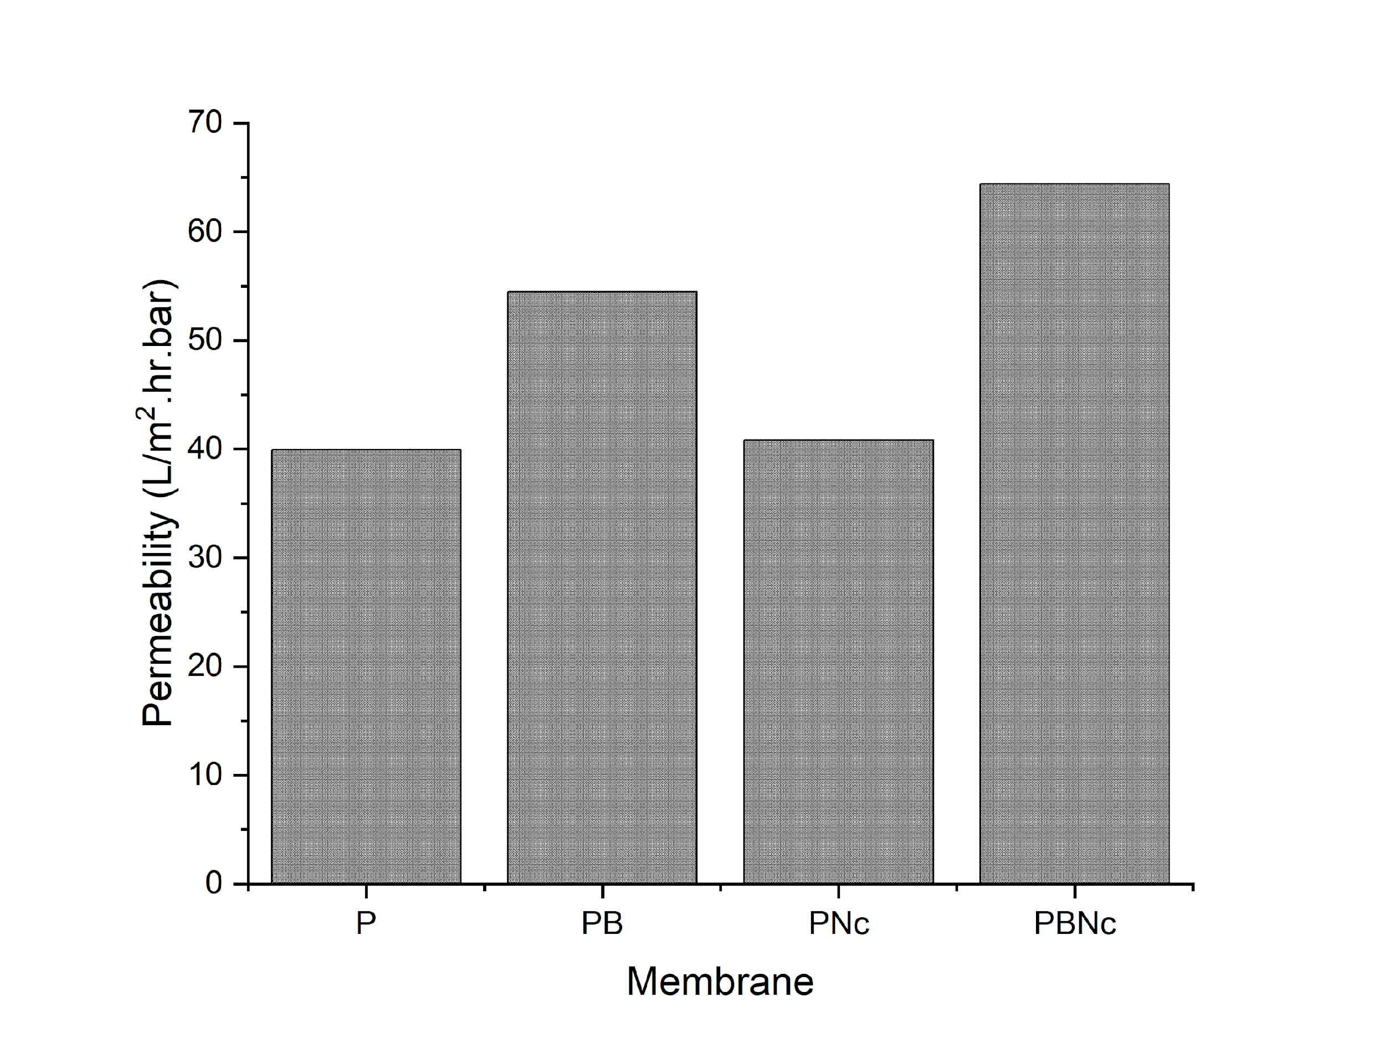
Figure 5. Permeability profile of pure water

3.5 Effect of Additives on Mg Rejection
Determination of membrane rejection was accomplished by feeding synthetic fertilizer factory wastewater with a concentration of Mg²⁺ 300 ppm. The ability of membrane rejection can be seen from the amount of Mg²⁺ retained when passing through the membrane; the results of the membrane rejection test can be seen in Figure 6. Based on Figure 6, it can be seen that the addition of additives to the membrane can affect the mg ions pass through the membrane pores; the higher of Mg²⁺ ions that are retained, the greater the rejection coefficient on the membrane, and the most significant rejection coefficient is pure PES membranes, which is 96.88%, then followed by a PBNC membrane with a rejection coefficient of 96.45%. In this study, the PBNC membrane achieves the best result, evident from the high flux and sufficient rejection value.
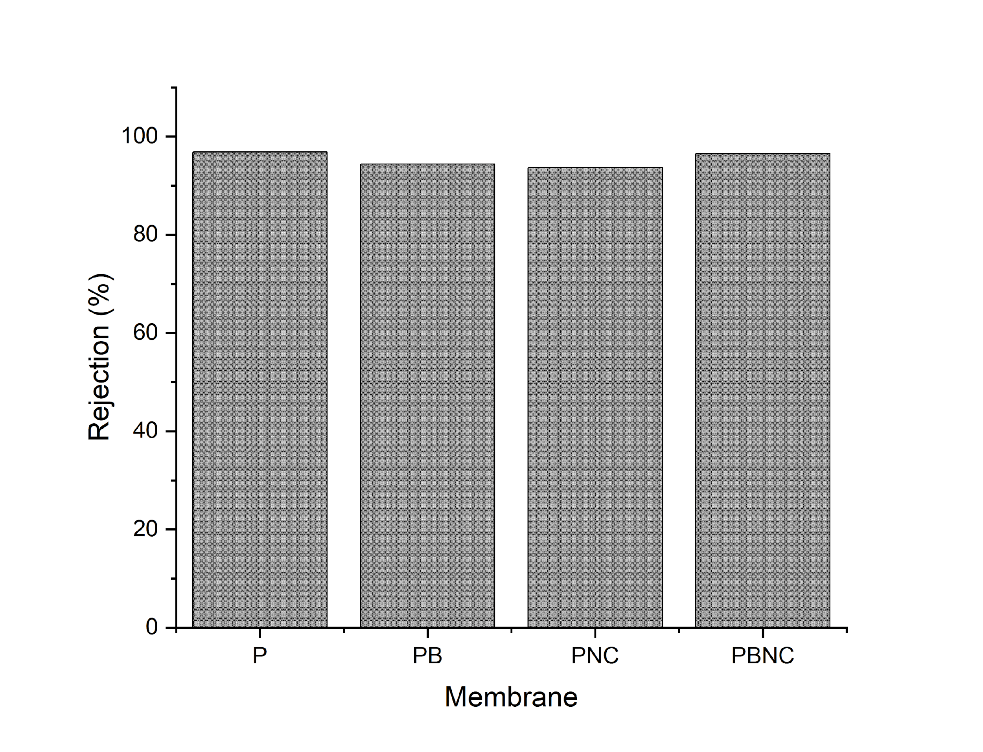
Figure 6. Mg²⁺ rejection ability of the membranes

4. Conclusion
Based on the results of research and data analysis, the addition of PEG-HE and Nanocarbon additives to the PES membrane increased the hydrophilicity of the membrane from 69.5° to 58°, besides that the addition of PEG-HE and Nanocarbon additives was also proven to increase the porosity of the PES membrane. The membrane PES-modified PEG-HE and Nano carbon have the best performance with a permeability value of 61.23 L/m².hr.bar and a rejection of 96.45%.

Acknowledgments
The authors would like to gratefully thank the Universitas Syiah Kuala for financial support of the research under the Scheme of Penelitian Professor Contract Number :141/UN11/SPK/PNBP/2022.

Conflict of interest
The authors declare no conflict of interest.

References
1 Agustina S. Teknologi Membran dalam Pengolahan Limbah Cair Industri [Membrane Technology in Industrial Liquid Waste Treatment]. Bull Penelit 2006;28:18–24.
2 Arahman N, Arifin B, Razi F. Profil Permeabilitas Berdasarkan Struktur Morfologi Membran Polietersulfon pada Pemekatan Larutan Tokoferol [Permeability Profile Based on Morphological Structure of Polyethersulfone Membrane in Concentrated Tocopherol Solution]. AGRITECH 2016;36:416–23.
3 Zaiyar. Pengaruh Zat Aditif pada Morfolohi Membran Hibrid Polisulfon-Lempung [The Effect of Additives on the Morphology of Polysulfone-Clay Hybrid Membranes]. J Sains dan Kesehat 2014;4:33–38.
4 Wardani A., Ariono D, Subagji S et al. Fouling Tendency of PDA/PVP Surface Modified PP Membrane. Surf Interfaces 2020;:1–9.
5 Zhao J, Chong J., Shi L et al. PTFE-Assisted Immobilization of Pluronic F127 In PVDF Hollow Fiber Membrans with Enhanced Hydrophilicity Through Nonsolvent-Thermally Induced Phase Separation Method. J Memb Sci 2020;620:1–14.
6 Tran TT., Kumar S., Nguyen C. et al. High-permeability graphene oxide and poly (vinyl pyrrolidone) blended poly (vinylidene fluoride) membrans: Roles of additives and their cumulative effects. J Memb Sci 2021;619:1–15.
7 Zhang S, Wang Q, Li D et al. Single-Walled Karbon Nanotubes Grafted with Dextran as Additive to Improve Separation Performance of Polymer Membranes. Sep Purif Technol 2021;254:1–10.
8 Zhang L, Haifeng S, Weiwei L et al. Thermal Performance and Crystallization Behavior of Poly (Ethylene Glycol) Hexadecyl Ether in Confined Environment. Soc Chem Ind 2013;63:982–88.
9 Saljoughi E, Mousavi S., Hosseini S. Polysulfone/Brij‐58 blend nanofiltration membranes: preparation, morphology and performance. Polym Adv Technol 2011;24:383–90.
10 Bolandi S, Ashtiani F., Okhovat A et al. The effects of surfactant additives on properties and morphologies of cellulose acetate membranes prepared by phase inversion. Theor Found Chem Eng 2020;54:931–39.
11 Kusworo TD, Ismail AF, Mustafa A. Hybrid membrane using polyethersulfone-modification of multiwalled carbon nanotubes with silane agent to enhance high performance oxygen separation. Int J Sci Eng 2014;6:163–68.
12 Arahman N, Fahrina A, Wahab M. et al. Morphology and Performance of Polyvinyl Chloride Membrane Modified with Pluronic F127. F1000 Res 2018;2:1–17.

