**Carbon nanomaterials for metal-free electrocatalysis**

**Ana M.B. Honorato1*, Mohd. Khalid2\***

1Center of Advanced Science and Engineering for Carbon (Case4carbon), Department of Macromolecular Science and Engineering, Case Western Reserve University, 10900 Euclid Avenue, Cleveland, OH 44106, USA.

E-Mail:[abh70@case.edu](mailto:abh70@case.edu)

2Institute of Chemistry of São Carlos, University of São Paulo, POBox 780, 13560-970, São Carlos, SP, Brazil.

E-Mail: [mkansarister@gmail.com](mailto:mkansarister@gmail.com)

**Abstract**

Carbon materials are continuing in progress to accomplish the requirements of energy conversion and energy storage technologies because of its plenty in nature, high surface area, outstanding electrical properties, and readily obtained from varieties of chemical and natural sources. Recently, carbon-based electrocatalysts have been developed in the quest to replacement of noble metal based catalysts for low cost energy conversion technologies, such as fuel cell, water splitting, and metal-air batteries. Herein, we will present our short overview on recently developed carbon-based electrocatalysts for energy conversion reactions such as oxygen reduction, oxygen evolution, and hydrogen evolution reactions, along with challenges and perspectives in the emerging field of metal-free electrocatalysts.

***Keywords:*** carbon nanomaterials; graphene; metal-free electrocatalyst; hydrogen evolution reaction

**Background**

Energy need is one of the most important issues of this epoch. The challenge is how to produce clean energy in efficient way without burning fossil fuels. Hydrogen is considered totally non-polluting fuel but unlike fossil fuels it does not typically occurs by itself in nature, despite being a most abundant element on the earth, therefore, it must be generated from chemical source, that contain hydrogen molecules. It is observed that the world produces more than 50 billion kilograms of hydrogen each year and more than 95 percent generated from fossil fuels through steam reformation of natural gas. This process inherent additional costs to manufacturers, consumers, and it is environmentally unsafe. To avoid future devastation caused by energy collapse, the need for renewable energy has engrossed tremendously. In order to make effective use of renewable energy, it is imperative to develop high-performance, low-cost, and environmentally friendly energy conversion systems. In this regard, water is an ultimate option because it is sustainable and readily available. Catalytic water splitting to produce hydrogen is an advanced electrochemical technique but water splitting needs expensive novel metal based catalysts (e.g., Pt) to accelerate the rate of hydrogen production and to lower the energy loss in the process.

Electrocatalysis is the heart of the electrochemical energy conversion. Renewable energy technologies such as fuel cells, water splitting, and metal-air batteries are the promising means of the increasing global need of energy, offering clean and sustainable energy resources. But the key to success is the development of nonnoble metal, robust, cost effective, and earth-abundant material based electrocatalysts that catalyze the reactions which take place in renewable energy systems such as oxygen reduction reaction (ORR), oxygen evolution reaction (OER), and hydrogen evolution reaction (HER) with high efficiency and stability. Benchmark Pt, Ir, Pd-based and RuO2-based catalysts are generally needed to promote the HER for the generation hydrogen fuel from the electrochemical water splitting, the ORR in fuel cells for energy conversion, and the OER in metal-air batteries for energy storage [1]. Nevertheless, their widespread adoption is constricted due to the high cost, low stability, scarcity, and environmental unfriendly nature. In the search of earth abundant and benign catalysts materials, impressive advances have been made towards the development of nonprecious metal based electrocatalysts and their recent results prospect the increase of the performance by taking advantage of the synergy of carbon nanomaterials and nonprecious metals with the aim of completely or partially replacing the precious metal based catalysts (Pt-based). Basically, the performance of electrocatalyst is directly depend to the materials properties. Therefore, materials technology plays vital role in the development of electrochemical energy conversion and energy storage systems.

**The recent development of nonprecious metal-based electrocatalysts**

The various transition metals, in particular Fe, Co, and Ni, and their compounds such as transition-metalsulfides, selenides, nitrides, carbides, phosphides, and borides as well as their alloys have been shown to be promising catalysts for the hydrogen evolution reaction [2]. Recently, some coordination compounds, such as a Ni bisdiphosphine based mimic of hydrogenase enzymes [3], CuII ethylenediamine (Cu-EA), polyoxometalate (POM) based metal-organic frameworks [4], have also been developed as potential for hydrogen evolution. Substantial research effort has been devoted to the development of OER catalysts based on relatively inexpensive transition metals and their compounds, including transition-metal oxides, multimetal oxides, metal oxide based hybrids, substituted cobaltites (MxCo3-xO4), hydro(oxy)oxides, phosphates, diselenide, metal oxide/diselenide hybrids, and chalcogenides [5-20]. Because OER is the half (2H2O → O2 + 4H+ + 4ē) conjunction reaction of HER (2H+ + 2ē → H2). In general, the overall water splitting process can be represented as follows, with molecular hydrogen and oxygen generated individually at the cathode and anode, respectively.

2H2O + Energy → 2H2 + O2

In addition, ordered Ni5P4 nanoarchitectures with a “sheetlike” morphology on a Ni foil were synthesized and found to be bifunctional catalysts for both the HER and the OER [21]. However, the transition-metal-based catalysts are prone to gradual oxidation, undesirable changes in the morphology/crystalline structure, and uncontrolled agglomeration/dissolution when exposed to air or aerated electrolytes [22]. For example, the HER activity of MoS2 in alkaline electrolytes often deteriorates in just a few cycles [23]. Most of the nonprecious-metal catalysts have a poor electronic conductivity, and hence a limited electrocatalysis performance. To overcome this limitation, conductive support of carbon nanomaterials such as graphene and carbon nanotubes have been used to improve the activities of these catalysts [24]. Examples include Ni/rGO, Ni/Fe hydroxide nanoplates on CNTs, FeNi hydroxide/rGO, NiO/rGO, Co3O4/rGO, Co-CoO/N-rGO and Ni-NiO/N-rGO composites, metal carbides M3C/graphene nanoribbons (M: Fe, Co, Ni), Fe@C, MoS2-graphene/carbon nanofiber, MoS2/N doped graphene, WS2/CNTs, and Co@N-doped carbon catalysts [25]. Accordingly, a wide range of oxide based catalysts have emerged as the materials of choice for catalyzing energy conversion reactions ORR, OER, and HER, since, their low stability and complex preparation process renders widespread adoption.

**The recent development of carbon-based metal-free electrocatalysts**

Among the various nonprecious metal-based electrocatalysts have been investigated, carbon materials are of great interest owing to their abundance, stability even in harsh acidic and basic medium, and relative environmental-friendliness. However, carbon nanomaterials are also not free from disadvantages for example carbon nanomaterials itself do not show catalytic activities unless they are incorporated with guest noble or transition metals as above has been discussed. In the pioneer work of Dai and co-worker discovered that vertically-aligned nitrogen doped carbon nanotube arrays can act as a catalyst for ORR without using metals, and this metal-free catalyst shows almost three-times higher electrocatalytic activity, much smaller crossover effect, and better long-term operational stability than those of commercially available platinum/C electrodes [26]. Since, the discovery of graphene by Novoselov and Geim in 2004, the research on this flattish material has received enormous attention. This flat sheet is a one-tom-thick layer of sp2-bonded, 2D honeycomb lattice of carbon with a fully conjugated structure of alternating C-C and C=C bonds. Its unique physicochemical properties make this material a promising candidate for a large variety of applications. However, the use of graphene for most of the electronic applications often requires the precise functionalization of individual graphene sheets into various device elements at the molecular level. Therefore, surface functionalization of graphene sheets is essential, and researchers have devised various covalent and noncovalent chemistries for making graphene materials with the bulk and surface properties needed for many potential applications including energy conversion and storage. Thus, graphene-based catalysts can hold great promise to replace precious-metal catalysts for clean energy technologies. However, graphene also like other carbon nanomaterials does not show catalytic activities, doped graphene with heteroatoms play a crucial role to tune their electronic structure and chemical properties which develop the catalytic active sites in graphene network, hence, demonstrate catalytic performance. Doping of graphene nanomaterials with heteroatoms, such as N, B, O, P, S, Cl, I, Se, and Br, has been performed to be a feasible way to tune their electronic structures and chemical and electrochemical properties [27, 28]. As the size and electronegativity of the heteroatoms are different from the carbon atoms, the introduction of heteroatoms could cause electronic modulation to change the charge distribution and electronic properties of carbon skeletons, which in turn affects their interaction with hydrogen or oxygen intermediates and ultimately their electrocatalytic activities for the OER, HER and ORR [29].

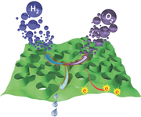

Graph shows the trifunctional activities (ORR, OER, and HER) of the porous carbon, adopted from Ref [36]

It is also recently, verified that the carbon nanostructure (3D) with tunable defects and porous structure like micro, meso, and macro possess extraordinary mass transport capability to facilitate metal-free electrocatalysis in energy conversion and energy storage applications [30-32]. Metal-free, nitrogen and phosphorus co-doped 3D graphitic carbon networks have recently been developed by using a scalable, one-step process involving the pyrolysis of a polyaniline aerogel synthesized in the presence of phytic acid, which were demonstrated to show remarkably high bifunctional electrocatalytic activities for ORR and OER simultaneously, and in primary and rechargeable Zn-air batteries as an air cathode as depicted in Figure 1 [33]. Further, the same group generate tri-doped graphene materials with nitrogen, phosphorus, and fluorine doping agents, followed by the thermal pyrolysis of polyaniline pre-coated graphene oxide in presence of ammonium hexafluorophosphate, and used as an efficient tri-functional electrocatalyst for OER and HER for electrochemical water splitting, powered by a Zn-air battery based on an air electrode with the same electrocatalyst for ORR, to generate oxygen and hydrogen gases [34].

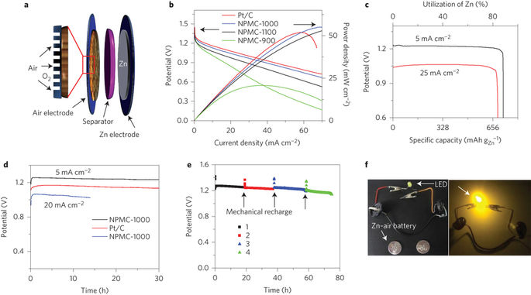

**Figure 1** a, Schematic illustration for the basic configuration of a primary Zn-air battery, in which a carbon paper pre-coated with NPMC is used as an air cathode and is coupled with a Zn anode, and a glassy fiber membrane soaked with aqueous KOH electrolyte as separator. The enlarged part illustrates the porous air electrode loaded with electrocatalyst, which is permeable to air and oxygen b, Polarization and power density curves of primary Zn-air batteries using Pt/C, NPMC-900, NPMC-1000, NPMC-1100 as ORR catalyst (mass loading of 0.5 mg cm-2) and 6 M KOH electrolyte (scan rate, 5 mV s-1). c, Specific capacities of the Zn-air batteries using NPMC-1000 as ORR catalyst are normalized to the mass of the consumed Zn. d, Discharge curves of the primary Zn-air batteries using Pt/C and NPMC-1000 as ORR catalyst and KOH electrolyte at various current densities (5 and 20 mA cm-2). The observed sudden drop in voltage at 0 h was caused by a sudden increase in current density after resting the battery at the open-circuit potential without current loading for the testing. e, Long-time durability of the primary Zn-air battery using NPMC-1000 catalyst at a current density of 2 mA cm-2. The battery is mechanically rechargeable. The Zn and electrolyte were mechanically replaced at the point where the color of the curve changes (the numbers represent the first, second, third and fourth charge cycles). Colored symbols above the curve are taken from the open-circuit potential by opening the battery for each mechanical recharge. f, Optical images of an LED (∼2.2 V) before and after being driven by two Zn-air batteries in series. Reproduced with permission from Ref [33]. Copyright (2015) by Nature Publishing Group.

On the other hand, the construction of an ideal electrocatalyst which works for ORR, OER, and HER simultaneously is also a crucial. Usually, the activities of catalysts vary with pH values [35]. This makes the development of integrated energy system difficult. A rationally-designed N, S co-doped graphitic sheets with stereoscopic holes, trifunctional metal-free electrocatalysts was developed for overall water-splitting. In this case, the multifunctional electrocatalytic activities for simultaneous ORR, OER and HER were ascribed to a synergistic effect of the N, S heteroatom co-doping and its unique stereoscopic holes structure, which provided a large surface area and efficient pathways for electron and electrolyte transports [36]. Therefore, these low-cost, metal-free, tri-functional electrocatalysts based on either tri-doped or co-doped carbon electrocatalysts hold great promise for a wide range of applications, particularly in integrated energy systems. Despite the progress that has been made in carbon based electrocatalysts in water splitting technologies in recent years, however, these techniques are still in nascent stage and facing several challenges to commercial utilization, including high capital costs related to expensive preparation process of materials and a high material consumption insufficient endurance of its main components, complex system design and time-consuming production technologies. However, there are still big rooms in metal-free electrocatalysts for further improvement in terms of combined experimental and theoretical approaches to understand the location and structure of active sites and their work functions. We hope this mini review will offer valuable insight to gain further knowledge in this area.

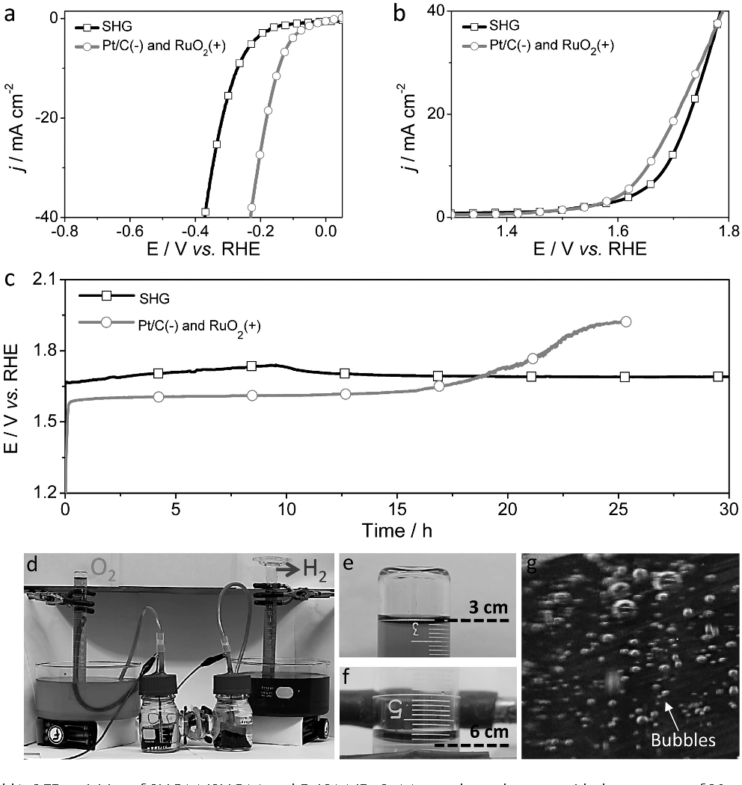

Figure 2 a) HER and b) OER activities of SHG(−)/SHG(+) and Pt/C(−)/RuO2(+) two-electrode setup with the scan rate of 10 mV s−1 ; the electrolyte: 1.0 m KOH. c) Chrono potentiometric curve of water electrolysis for SHG(−)/SHG(+) and Pt/C(−)/RuO2(+) with constant current density of 10 mA cm−2 in 1.0 m KOH. d) The demonstration of SHG in a homemade two-electrode water splitting device by chronopotentiometry at a given potential of 2 V. The carbon fiber woven mesh (3 × 2 cm) was used as an all-carbon electrode for deposition the SHG catalyst. e) Oxygen and f) hydrogen collection process with displacement of water. g) Bubbles generated from the electrode (e.g., H2 electrode) during the water splitting process. Reproduced with permission from Ref [36]. Copyright (2017) by John Wiley and Sons.

**References:**

[1] M. Caban-Acevedo, M. L. Stone, J. R. Schmidt, J. G. Thomas, Q. Ding, H. C. Chang, M. L. Tsai, J. H. He, S. Jin, Nat. Mater. 2015, 321, 1245-1251.

Nat. Mater. 2015, 321, 1245 – 1251; b) J. Q. Tian, Q. Liu, N. Y.

[2] M. K. Bates, Q. Y. Jia, N. Ramaswamy, R. J. Allen, S. Mukerjee, J. Phys. Chem. C 2015, 119, 5467-5477.

[3] A. Le Goff, V. Artero, B. Jousselme, P. D. Tran, N. Guillet, R. M_tay_, A. Fihri, S. Palacin, M. Fontecave, Science 2009, 326, 1384-1387.

[4] X. Liu, S. S. Cui, Z. J. Sun, P.W. Du, Chem. Commun. 2015, 51, 12954-12957.

[5] a) Y. Liang, Y. Li, H.Wang, J. Zhou, J.Wang, T. Regier, H. Dai, Nat. Mater. 2011, 10, 780 – 786; b) Y. Sun, S. Gao, F. Lei, J. Liu,L. Liang, Y. Xie, Chem. Sci. 2014, 5, 3976 – 3982; c) R. D. Smith,M. S. Pr_vot, R. D. Fagan, Z. Zhang, P. A. Sedach, M. K. J. Siu,S. Trudel, C. P. Berlinguette, Science 2013, 340, 60–63; d) A.Grimaud, K. J. May, C. E. Carlton, Y. L. Lee, M. Risch, W. T.Hong, J. Zhou, Y. Shao-Horn, Nat. Commun. 2013, 4, 2439; e) Z. Peng, D. Jia, A. Al-Enizi, A. Elzatahry, G. Zheng, Adv.Energy Mater. 2015, 5, 1402031; f) R. Subbaraman, D. Tripkovic,K. C. Chang, D. Strmcnik, A. P. Paulikas, P. Hirunsit, M.Chan, J. Greeley, V. Stamenkovic, N. M. Markovic, Nat. Mater.2012, 11, 550 – 557; g) T. L. Wee, B. D. Sherman, D. Gust, A. L.Moore, T. A. Moore, Y. Liu, J. C. Scaiano, J. Am. Chem. Soc.2011, 133, 16742 – 16745; h) J. Rosen, G. S. Hutchings, F. Jiao, J.Am. Chem. Soc. 2013, 135, 4516 – 4521; i) J. Ryu, N. Jung, J. H.Jang, H. J. Kim, S. J. Yoo, ACS Catal. 2015, 5, 4066 – 4074; j) Y. R. Zheng, M. R. Gao, Q. Gao, H. H. Li, J. Xu, Z. Y. Wu, S. H. Yu, Small 2015, 11, 182 – 188.

[6] L. H. Wu, Q. Li, C. H. Wu, H. Y. Zhu, A. Mendoza-Garcia, B. Shen, J. H. Guo, S. H. Sun, J. Am. Chem. Soc. 2015, 137, 7071-7074.

[7] a) V. Artero, M. Chavarot-Kerlidou, M. Fontecave, Angew. Chem. Int. Ed. 2011, 50, 7238- 7266; b) J. A. Koza, Z. He, A. S. Miller, J. A. Switzer, Chem. Mater. 2012, 24, 3567-3573.

[8] a) G. S. Hutchings, Y. Zhang, J. Li, B. T. Yonemoto, X. G. Zhou, K. K. Zhu, F. Jiao, J. Am. Chem. Soc. 2015, 137, 4223-4229; b) M. Hamdani, R. Singh, P. Chartier, Int. J. Electrochem. Sci. 2010, 5, 556-577; c) X. Lu, C. Zhao, J. Mater. Chem. A 2013, 1, 12053-12059.

[9] C. Z. Zhu, D. Wen, S. Leubner, M. Oschatz, W. Liu, M. Holzschuh, F. Simon, S. Kaskel, A. Eychmller, Chem. Commun. 2015, 51, 7851-7854.

[10] a) Y. Li, P. Hasin, Y.Wu, Adv. Mater. 2010, 22, 1926-1929; b) S. Chen, J. J. Duan, M. Jaroniec, S. Z. Qiao, Angew. Chem. Int. Ed. 2013, 52, 13567-13570.

[11] J. Wang, T. Qiu, X. Chen, Y. L. Lu, W. S. Yang, J. Power Sources 2014, 268, 341-348.

[12] a) L. Trotochaud, J. K. Ranney, K. N.Williams, S.W. Boettcher, J. Am. Chem. Soc. 2012, 134, 17253-17261; b) C. C. L. McCrory, S. H. Jung, J. C. Peters, T. F. Jaramillo, J. Am. Chem. Soc. 2013, 135, 16977-16987.

[13] M.W. Kanan, D. G. Nocera, Science 2008, 321, 1072-1075.

[14] Y. C. Wang, K. Jiang, H. Zhang, T. Zhou, J.W. Wang, W. Wei, Z. Q. Yang, X. H. Sun,W. B. Cai, G. F. Zheng, Adv. Sci. 2015, 2, 1500003.

[15] I. Nikolov, R. Darkaoui, E. Zhecheva, R. Stoyanova, N. Dimitrov, T. Vitanov, J. Electroanal. Chem. 1997, 429, 157-168.

[16] Z. B. Zhuang, W. C. Sheng, Y. S. Yan, Adv. Mater. 2014, 26, 3950-3955.

[17] M. Gong,W. Zhou, M. C. Tsai, J. Zhou, M. Guan, M. C. Lin, B. Zhang, Y. Hu, D. Y. Wang, J. Yang, S. J. Pennycook, B. J. Hwang, H. J. Dai, Nat. Commun. 2014, 5, 4695.

[18] J. Suntivich, K. J. May, H. A. Gasteiger, J. B. Goodenough, Y. Shao-Horn, Science 2011, 334, 1383-1385.

[19] R. D. L. Smith, M. S. Prevot, R. D. Fagan, S. Trudel, C. P. Berlinguette, J. Am. Chem. Soc. 2013, 135, 11580-11586.

[20] W. Zhou, X. J. Wu, X. Cao, X. Huang, C. Tan, J. Tian, H. Liu, J. Wang, H. Zhang, Energy Environ. Sci. 2013, 6, 2921-2924.

[21] M. Ledendecker, S. Krick Calder, C. Papp, H. P. Steinrck, M. Antonietti, M. Shalom, Angew. Chem. Int. Ed. 2015, 54, 12361 – 12365; Angew. Chem. 2015, 127, 12538-12542.

[22] M. R. Gao, X. Cao, Q. Gao, Y. F. Xu, Y. R. Zheng, J. Jiang, S. H. Yu, ACS Nano 2014, 8, 3970-3978.

[23] D. Merki, S. Fierro, H. Vrubel, X. Hu, Chem. Sci. 2011, 2, 1262-1267.

[24] a) Q. Li, P. Xu, B. Zhang, H. Tsai, J. Wang, H. L. Wang, G. Wu, Chem. Commun. 2013, 49, 10838 – 10840; b) Q. G. He, Q. Li, S. Khene, X. M. Ren, F. E. Lopez-Suarez, D. Lozano-Castello, A. Bueno-Lopez, G. Wu, J. Phys. Chem. C 2013, 117, 8697 – 8707; c) Q. Li, P. Xu, W. Gao, S. Ma, G. Zhang, R. Cao, J. Cho, H. L. Wang, G. Wu, Adv. Mater. 2014, 26, 1378 – 1386.

[25] a) S. Chen, J. J. Duan, J. R. Ran, M. Jaroniec, S. Z. Qiao, Energy Environ. Sci. 2013, 6, 3693 – 3699; b) M. Gong, Y. G. Li, H. L. Wang, Y. Y. Liang, J. Z. Wu, J. G. Zhou, J. Wang, T. Regier, F. Wei, H. J. Dai, J. Am. Chem. Soc. 2013, 135, 8452 – 8455; c) X. Long, J. K. Li, S. Xiao, K. Y. Yan, Z. L. Wang, H. N. Chen, S. H. Yang, Angew. Chem. Int. Ed. 2014, 53, 7584 – 7588; Angew.

Chem. 2014, 126, 7714 – 7718; d) X. E. Liu, W. Liu, M. Ko, M. Park, M. G. Kim, P. Oh, S. Chae, S. Park, A. Casimir, G. Wu, J. Cho, Adv. Funct. Mater. 2015, 25, 5799 – 5808; e) X. J. Fan,

Z. W. Peng, R. Q. Ye, H. Q. Zhou, X. Guo, ACS Nano 2015, 9, 7407 – 7418; f) M. Tavakkoli, T. Kallio, O. Reynaud, A. G. Nasibulin, C. Johans, J. Sainio, H. Jiang, E. I. Kauppinen, K. Laasonen, Angew. Chem. Int. Ed. 2015, 54, 4535 – 4538; Angew. Chem. 2015, 127, 4618 – 4621; g) T. N. Ye, L. B. Lv, M. Xu, B. Zhang, K. X. Wang, J. Su, X. H. Lin, J. S. Chen, Nano Energy

2015, 15, 335 – 342.

[26] Kuanping Gong, Feng Du, Zhenhai Xia, Michael Durstock, Liming Dai, Science, 2009, 323, 760-764.

[27] H. B. Yang, J. Miao, S-F Hung, J. Chen, H. B. Tao, X. Wang, L. Zhang, R. Chen, J. Gao, H. M. Chen, Liming Dai, B. Liu. Sci. Adv. 2016; 2: e1501122.

[28] a) L. M. Dai, Acc. Chem. Res. 2013, 46, 31 – 42; b) J. T. Zhang, L. M. Dai, ACS Catal. 2015, 5, 7244 – 7253; c) X. Sun, P. Song, Y. Zhang, C. Liu, W. Xu, W. Xing, Sci. Rep. 2013, 3, 2505; d) Z.Liu, F. Peng, H. Wang, H. Yu, J. Tan, L. Zhu, Catal. Commun. 2011, 16, 35 – 38; e) D. Geng, Y. Chen, Y. Chen, Y. Li, R. Li, X. Sun, S. Ye, S. Knights, Energy Environ. Sci. 2011, 4, 760- 764.

[29] a) R. S. Lee, H. J. Kim, J. E. Fischer, A. Thess, R. E. Smalley, Nature 1997, 388, 255 – 257; b) P. Avouris, Z. H. Chen, V. Perebeinos, Nat. Nanotechnol. 2007, 2, 605 – 615; c) J. J. Duan,

S. Chen, M. Jaroniec, S. Z. Qiao, ACS Catal. 2015, 5, 5207 –5234.

[30] Xue Y, Yu D, Dai L, Wang R, Li D, Roy A, Lu F, Chen H, Liu Y, Qu J: Three-dimensional B, N-doped graphene foam as a metal-free catalyst for oxygen reduction reaction. Phys Chem Chem Phys 2013, 15:12220–12226.

[31] Yu DS, Goh K, Wang H, Wei L, Jiang W, Zhang Q, Dai L, Chen Y: Scalable synthesis of hierarchically structured carbon nanotube-graphene fibres for capacitive energy storage. Nat Nanotechnol 2014, 9:555–562.

[32] Xue Y, Ding Y, Niu J, Xia Z, Roy A, Chen H, Qu J, Wang ZL, Dai L: Sci Adv, 1, 2015 e1400198.

[33] Zhang J, Zhao Z, Xia Z, Dai L: Nat Nanotechnol. 2015, 10:444-452.

[34] Zhang J, Dai L: Angew Chem Int Ed 2016, 55:2230–2234.

[35] L. Dai, Y. H. Xue, L. T. Qu, H.-J. Choi, J.-B. Baek, Chem. Rev. 2015, 115, 4823.

[36] C. Hu and L. Dai, Adv. Mater. 2017, 29, 1604942