Topological entropies of all 2907 convex 4- to 9-atomic polyhedral clusters

Yury L. Voytekhovsky

Geological Institute of the Kola Science Centre, Russian Academy of Sciences
14 Fersman Street, 184209, Apatity, Russia.

ABSTRACT
The topological entropy H_{S} of all 2907 convex 4- to 9-atomic polyhedral clusters has been calculated from the point of different symmetrical positions of the atoms. It shows a general trend to drop with growing symmetry of clusters with many local exceptions. The topological entropy H_{V} of the same clusters has been calculated from the point of different valences (chemical bonds) of the atoms. It classifies the variety of clusters in more details. The relationships between the H_{S} and H_{V} entropies are discussed.

Key words: Convex polyhedral clusters; automorphism group orders; symmetry point groups; chemical bonds; topological entropy

1. Introduction
A general theory of convex polyhedra is given in Grünbaum (1967). In the series of papers we consider a special problem on the combinatorial variety of convex n-hedra rapidly growing with n. In Voytekhovsky & Stepenshchikov (2008) and Voytekhovsky (2014) all combinatorial types of convex 4- to 12-hedra and simple (only 3 facets / edges meet at each vertex) 13- to 16-hedra have been enumerated and characterized by automorphism group orders (a.g.o.’s) and symmetry point groups (s.p.g.’s). Asymptotically, almost all n-hedra (and n-acra, i.e. n-vertex polyhedra, because of duality) seem to be combinatorially asymmetric (i.e. primitive triclinic). A method of naming any convex n-acron by a numerical code arising from the adjacency matrix of its edge graph has been suggested in Voytekhovsky (2016). The combinatorial types of convex n-acra with the min_{n} and max_{n} names and some asymptotical (as n → ∞) relations between the latter have been found in Voytekhovsky (2017 a, b). Here we consider the topological entropies as additional characteristics of convex n-acra.
Obviously, convex n-acra can also be interpreted as atomic clusters with atoms located in vertices and the edges considered as chemical bonds. It is interesting to know, if the topological entropy correlates with the a.g.o.’s of atomic clusters. If so, it can be taken as a continuous approximant of the discrete s.p.g.’s. On the other hand, there are convex n-acra with different numbers of edges, as a whole, and different valences of the vertices, in particular. It follows from the general theory of systems that their complexity mostly depends on relationships between the elements (e.g., chemical bonds of the atoms) rather than on the number of the elements themselves (e.g., the number of vertices equivalent under the automorphism group). Does the topological entropy effectively fix the complexity of the convex n-atomic clusters? The paper discusses these questions.
2. Statistical entropy and its properties
The concept of entropy has been suggested in thermodynamics by Clausius in 1865. Its statistical interpretation has been performed by Boltzmann in 1872. Afterwards, Shannon (1948) and Halphen (1957) have independently found the formula
$H_{} = − \sum_{i=1}^{n}{{ p}_{i} {\text{log} p}_{i}}$

in the framework of the mathematical theory of communication and population statistics, respectively. In any case, this is the convolution of some distribution of probabilities p_{i} with an obvious restriction p₁ + … + p_{n} = 1. The H function is bounded by H_{min} = 0, if one of p_{i} = 1 (the others are 0’s), and H_{max} = log n, if any p_{i} = 1/n. Its schematic graphs for two (arcs with H_{max} = lg 2) and three (surface with H_{max} = lg 3) probabilities are given over the barycentric diagram p₁ + p₂ + p₃ = 1 in Fig. 1. It is easy to see that small changes of the probabilities p_{i} at the corners of a diagram affect big changes of H, while the same changes of p_{i} in the central part of a diagram do not affect H that much.

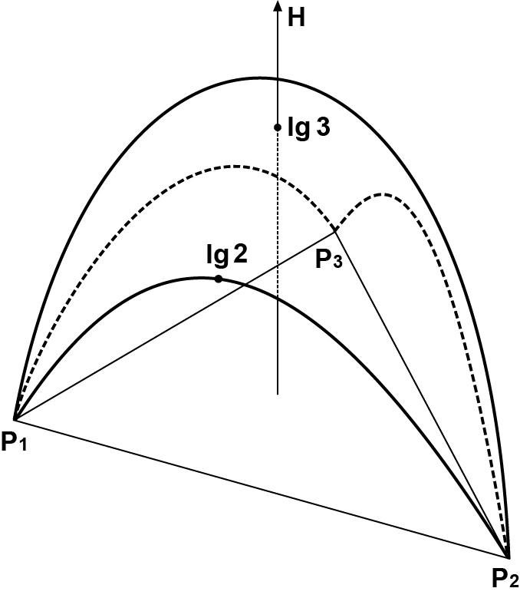

Figure 1. The graph of H(p₁, p₂, p₃). Hereinafter in nites, as decimal logarithms are used

2. Entropy HS of convex n-acra
The above formula allows us to characterize the topology of convex n-acra in different ways. For example, let us define the entropy H_{S} from the point of different symmetrical positions of the vertices. In this case, for any n-acron, numbers n_{i} of vertices in different symmetrical positions and, afterwards, the probabilities p_{i} = n_{i} / n = n_{i} / Σ n_{i} should be calculated. It follows from the above that, for given n, H_{S,max} is attained by n-acra with any two vertices non-equivalent under the automorphism group, for example, by combinatorially asymmetric n-acra (i.e. those, which cannot be transformed to symmetric convex n-acra by the continuous transformations), n ≥ 7. At the same time, H_{S,min} is attained by vertex-transitive n-acra. These include regular (Platonic) and semi-regular (Archimedian) polyhedra, as well as the infinite series of prisms and antiprisms. They have even number n ≥ 4 of vertices, precisely: 4, 6, 8, 12, 20 for Platonic solids, 12 (2 times), 24 (4 times), 30, 48, 60 (4 times), 120 for Archimedian solids, and any even n ≥ 6 for prisms and antiprisms (cube and octahedron are topologically equivalent to a tetragonal prism and a trigonal antiprism, respectively). The further question is how H_{S} depends on a.g.o.’s and s.p.g.’s of n-acra with growing n. The edge graphs of all 2907 convex 4- to 9-acra and their a.g.o. and s.p.g. statistics (Table 1) have been extracted from Voytekhovsky & Stepenshchikov (2008).

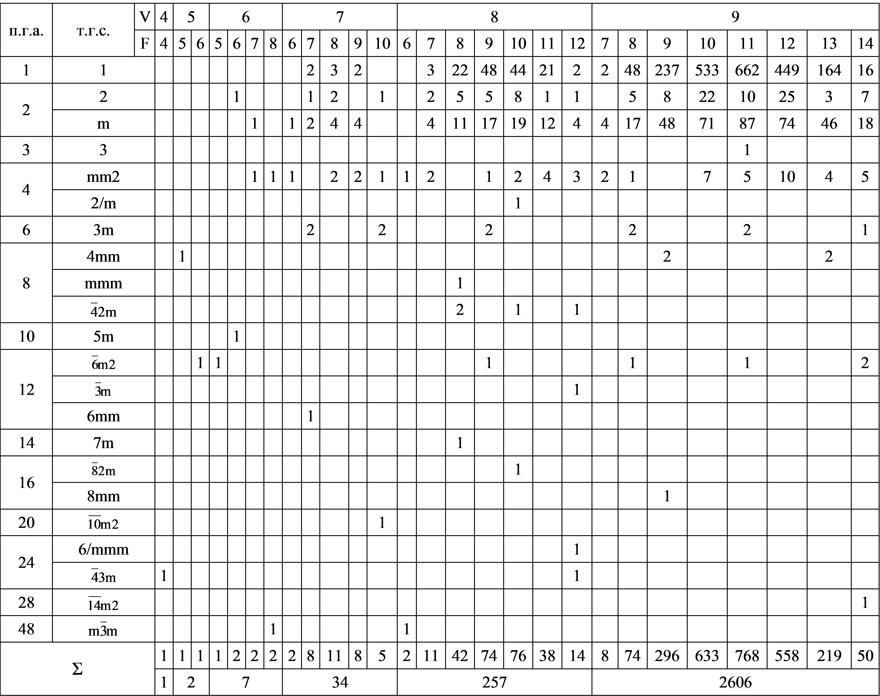
Table 1. Symmetry statistics of convex 4- to 9-acra, V – vertices, F – facets

The lexicographically ordered sequences of the vertices numbers in different symmetry positions for all convex 4- to 9-acra and related s.p.g.’s are as follows. 4-acron. 4: $\overline{4}\text{3m}$(tetrahedron). 5-acra. 14: 4mm (tetragonal pyramid), 23: $\overline{6}\text{m2}$ (trigonal bipyramid). 6-acra. 1122: m, 15: 5m (pentagonal pyramid), 222: 2, mm2, 6: $\overline{6}\text{m2}$ (trigonal prizm), $m\overline{3}m$ (octahedron). 7-acra. 1111111: 1, 11122: m, 1222: 2, m, mm2, 124: mm2, 133: 3m, 16: 6mm, 25: $\overline{\text{10}}\text{m2}$. 8-acra. 11111111: 1, 111122: m, 11222: 2, m, 1124: mm2, 1133: 3m, 2222: 2, mm2, 17: 7m, 224: mm2, 2/m, 26: $\overline{3}m$, $\overline{6}\text{m2}$, 6/mmm, 44: mmm, $\overline{4}2m$, $\overline{4}\text{3m}$, 8: $\overline{8}\text{2m}$, $m\overline{3}m$. 9-acra. 111111111: 1, 1111122: m, 111222: m, 12222: 2, m, mm2, 1224: mm2, 144: mm2, 4mm, 18: 8mm, 27: $\overline{\text{14}}\text{m2}$, 333: 3, 3m, 36: 3m, $\overline{6}\text{m2}$. The data have been used to calculate the entropy H_{S} (Fig. 2).
The entropy H_{S} shows the general trend: the higher a.g.o., the lower H_{S}. But, there are a lot of local exceptions. The two 5-acra contradict to the trend. Some n-acra with the same a.g.o.’s (and even s.p.g.’s) have different H_{S}, while some n-acra with the same H_{S} have different s.p.g.’s (and even a.g.o.’s). Moreover, some n-acra with higher a.g.o.’s also have higher H_{S}. For given n, an equation H_{S} = const is solvable over the p₁, …, p_{n}, if and only if const = 0 or lg n. For the case 0 < const < lg n, it is not (i.e., infinitely many points lie on the isoline H = const, see Fig. 1). In a discrete case, there is a finite number of probabilistic distributions p_{i} = n_{i} / n for given n, and, therefore, a finite number of H_{S} values, which can be calculated in advance. In this case, for given H_{S}, related probabilities can be found. It is impossible, if n is not fixed. For example, the probabilities (3/6, 3/6) for a 6-acron and (4/8, 4/8) for an 8-acron give the same H_{S}. For given n, the same H_{S} values are possible for n-acra with different s.p.g.’s and even a.g.o.’s mainly depending on whether the vertices lie on the planes and / or axes of symmetry.

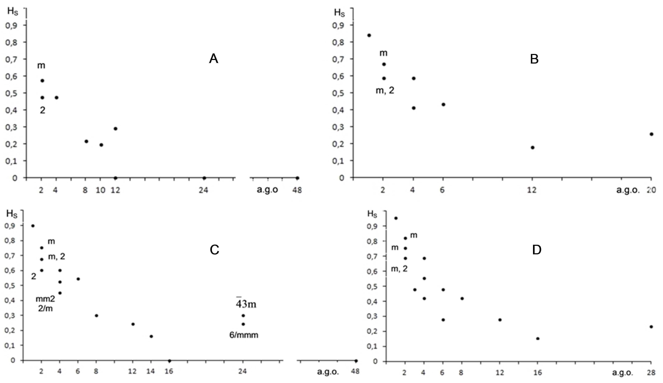

Figure 2. Entropy H_{S} of convex 4- to 6-acra (A, 10 in total), 7-acra (B, 34), 8-acra (C, 257), and 9-acra (D, 2606) vs. a.g.o. The s.p.g.’s are given to the dots if they do not follow from the Table 1.

3. Entropy HV of convex n-acra
It seems that the entropy H_{S} characterizes a ‘disorder’ more than a ‘complexity’ of n-acra. The first parameter is quite well characterized by s.p.g’s. From this point of view, combinatorially asymmetric n-acra are maximum disordered, while n-acra with H_{S} = 0 are maximum ordered. At the same time, there are n-acra with the same s.p.g.’s, but vertices of different valences. We presume them to be of different complexity, which is not fixed by H_{S}. To distinguish between them, we suggest the entropy H_{V} considering different valences of vertices of n-acra: p_{i} = v_{i} / n. For example, there are 7 combinatorially asymmetric 7-acra (Table 1) of the same entropy H_{S} = H_{max} = lg 7. But almost all of them are unique as for valences of their vertices (Voytekhovsky, 2016, Fig. 3): 232, 3211, 331 (two 7-acra), 412, 43, and 511. Hereinafter each sequence records the numbers v_{i} of i-valent vertices from v₃ to v_{max}. Obviously, the entropy H_{V} differs for the six classes. In the same way, the combinatorially asymmetric 8-acra (140 in total, Table 1) can be divided into 31 classes (see Figs in Voytekhovsky & Stepenshchikov, 2008). But, as 0’s and permutations of the indexes v_{i} do not change H_{V}, combinatorially asymmetric 8-acra can be divided into 12 classes of different H_{V}.
The lexicographically ordered sequences of the numbers of the vertices with different valences for convex 4- to 9-acra and related s.p.g.’s have been extracted from (Voytekhovsky & Stepenshchikov, 2008) and are as follows. 4-acron. 4: $\overline{4}\text{3m}$(tetrahedron). 5-acra. 23: $\overline{6}\text{m2}$ (trigonal bipyramid), 41: 4mm (tetragonal pyramid). 6-acra. 06: $m\overline{3}m$ (octahedron), 222: mm2, 24: mm2, 321: m, 42: 2, 501: 5m (pentagonal pyramid), 6: $\overline{6}\text{m2}$ (trigonal prizm). 7-acra. 052: $\overline{\text{10}}\text{m2}$, 133: 3m, 151: m, 2221: 2, 2302: mm2, 232: 1, mm2, 2401: mm2, 25: 2, mm2, 3031: 3m, 313: m, 3211: 1, m, 331: 1, m, 412: 1, 2, 4201: m, mm2, 43: 1, 2, m, 3m, 511: 1, m, 6001: 6mm, 61: m, mm2.
8-acra. 044: $\overline{4}2m$, 0602: 6/mmm, 062: mm2, 08: $\overline{8}\text{2m}$, 1331: m, 1412: m, 143: 1, m, 1511: 1, m, 161: 1, m, 206: $\overline{3}m$, 2141: mm2, 2222: 2, mm2, 22301: m, 224: 1, 2, m, mm2, 23111: 1, 2321: 1, m, 24002: mm2, 2402: 1, mm2, 24101: 1, 242: 1, 2, m, 2/m, 2501: 1, m, mm2, 26: 2, m, $\overline{6}\text{m2}$, 3113: m, 31211: 1, 3131: 1, m, 3212: 1, m, 32201: 1, m, 323: 1, m, 33011; 1, 3311: 1, 34001: m, 341: 1, m, 4004: $\overline{4}\text{3m}$, 4022: 1, mm2, 40301: m, 404: 1, mm2, $\overline{4}2m$, 4121: 1, m, 4202: 1, 2, 42101: 1, m, 422: 1, 2, m, mm2, 4301: 1, m, 3m, 44: 1, 2, m, mmm, $\overline{4}2m$, 503: 1, m, 3m, 5111: 1, 52001: m, 521: 1, m, 602: 2, m, 6101: 1, 62: 1, 2, m, mm2, 70001: 7m, 701: m, 8: mm2, $m\overline{3}m$.
9-acra. 036: $\overline{6}\text{m2}$, 0441: mm2, 0522: mm2, 054: m, 4mm, 0603: $\overline{6}\text{m2}$, 0621: 1, mm2, 07002: $\overline{\text{14}}\text{m2}$, 072: 2, mm2, 0801: mm2, 09: $\overline{6}\text{m2}$, 1251: m, 1332: 1, 135: 1, m, 1413: m, 14211: 1, m, 1431; 1, m, 15102: m, 1512: 1, m, 15201: 1, m, 153: 1, m, 16011: 1, m, 1611: 1, m, 17001: m, 171: 1, m, 2142: 2, m, 21501: m, 216: m, 2223: 2, m, 22311: 1, m, 224001: 2, 2241: 1, m, mm2, 2304: mm2, 23121: 1, m, 23202: 2, m, 232101: 1, m, 2322: 1, 2, m, mm2, 23301: 1, m, 234: 1, 2, m, mm2, 240201: 2, 2403: 1, m, 241011: 1, 24111: 1, 242001: 1, 2, m, 2421: 1, 2, m, 250002: mm2, 25002: 1, mm2, 250101: 1, 2502: 1, 2, m, 25101: 1, m, 252: 1, 2, m, 260001: mm2, 2601: 1, 2, m, mm2, 27: 1, 2, m, mm2, 3033: m, 3m, 3051: 1, m, 31221: 1, m, 31302: 1, 313101: 1, 3132: 1, 31401: 1, m, 315: 1, m, 32031: 1, m, 32112: 1, m, 321201: 1, m, 3213: 1, m, 322011: 1, m, 32211: 1, m, 323001: 1, m, 3231: 1, m, 33021: 1, m, 33102: 1, m, 331101: 1, 3312: 1, m, 33201: 1, m, 333: 1, m, 3, 3m, 340011: 1, m, 34011: 1, m, 341001: 1, m, 3411: 1, m, 35001: 1, m, 351: 1, m, 40212: 2, 402201: mm2, 4023: 2, m, 40311: 1, m, 404001: 4mm, 4041: 1, 2, m, mm2, 41022: m, 4104: 1, m, 41121: 1, m, 41202: 1, m, 412101: 1, 4122: 1, 2, m, mm2, 41301: 1, m, 414: 1, 2, m, mm2, 4203: 1, 2, m, mm2, 42111: 1, 422001: 1, 2, m, 4221: 1, 2, m, mm2, 43002: 1, 2, 430101; 1, m, 4302: 1, 2, m, 43101: 1, m, 432: 1, 2, m, mm2, 440001: 1, m, mm2, 4401: 1, 2, m, mm2, 45: 1, 2, m, 4mm, 50031: m, 5013: 1, m, 50211: 1, m, 503001: m, 5031: 1, m, 5112: 1, m, 51201: 1, m, 513: 1, m, 52011: 1, m, 521001: 1, m, 5211: 1, m, 53001: 1, m, 531: 1, m, 6021: 1, 2, m, 6102: 1, 2, m, 61101: 1, 612: 1, 2, m, 620001: m, mm2, 6201: 1, 2, m, 63: 1, 2, m, 3m, $\overline{6}\text{m2}$, 7011: 1, m, 71001: 1, m, 711: 1, m, 800001: 8mm, 8001: m, mm2, 81: 1, m, mm2.
The data have been used to calculate the entropy H_{V} (Fig. 3). The main feature of H_{V} is that it classifies the variety of convex 4- to 9-acra in more details than H_{S} with H_{S} ≥ H_{V} for any n and s.p.g.

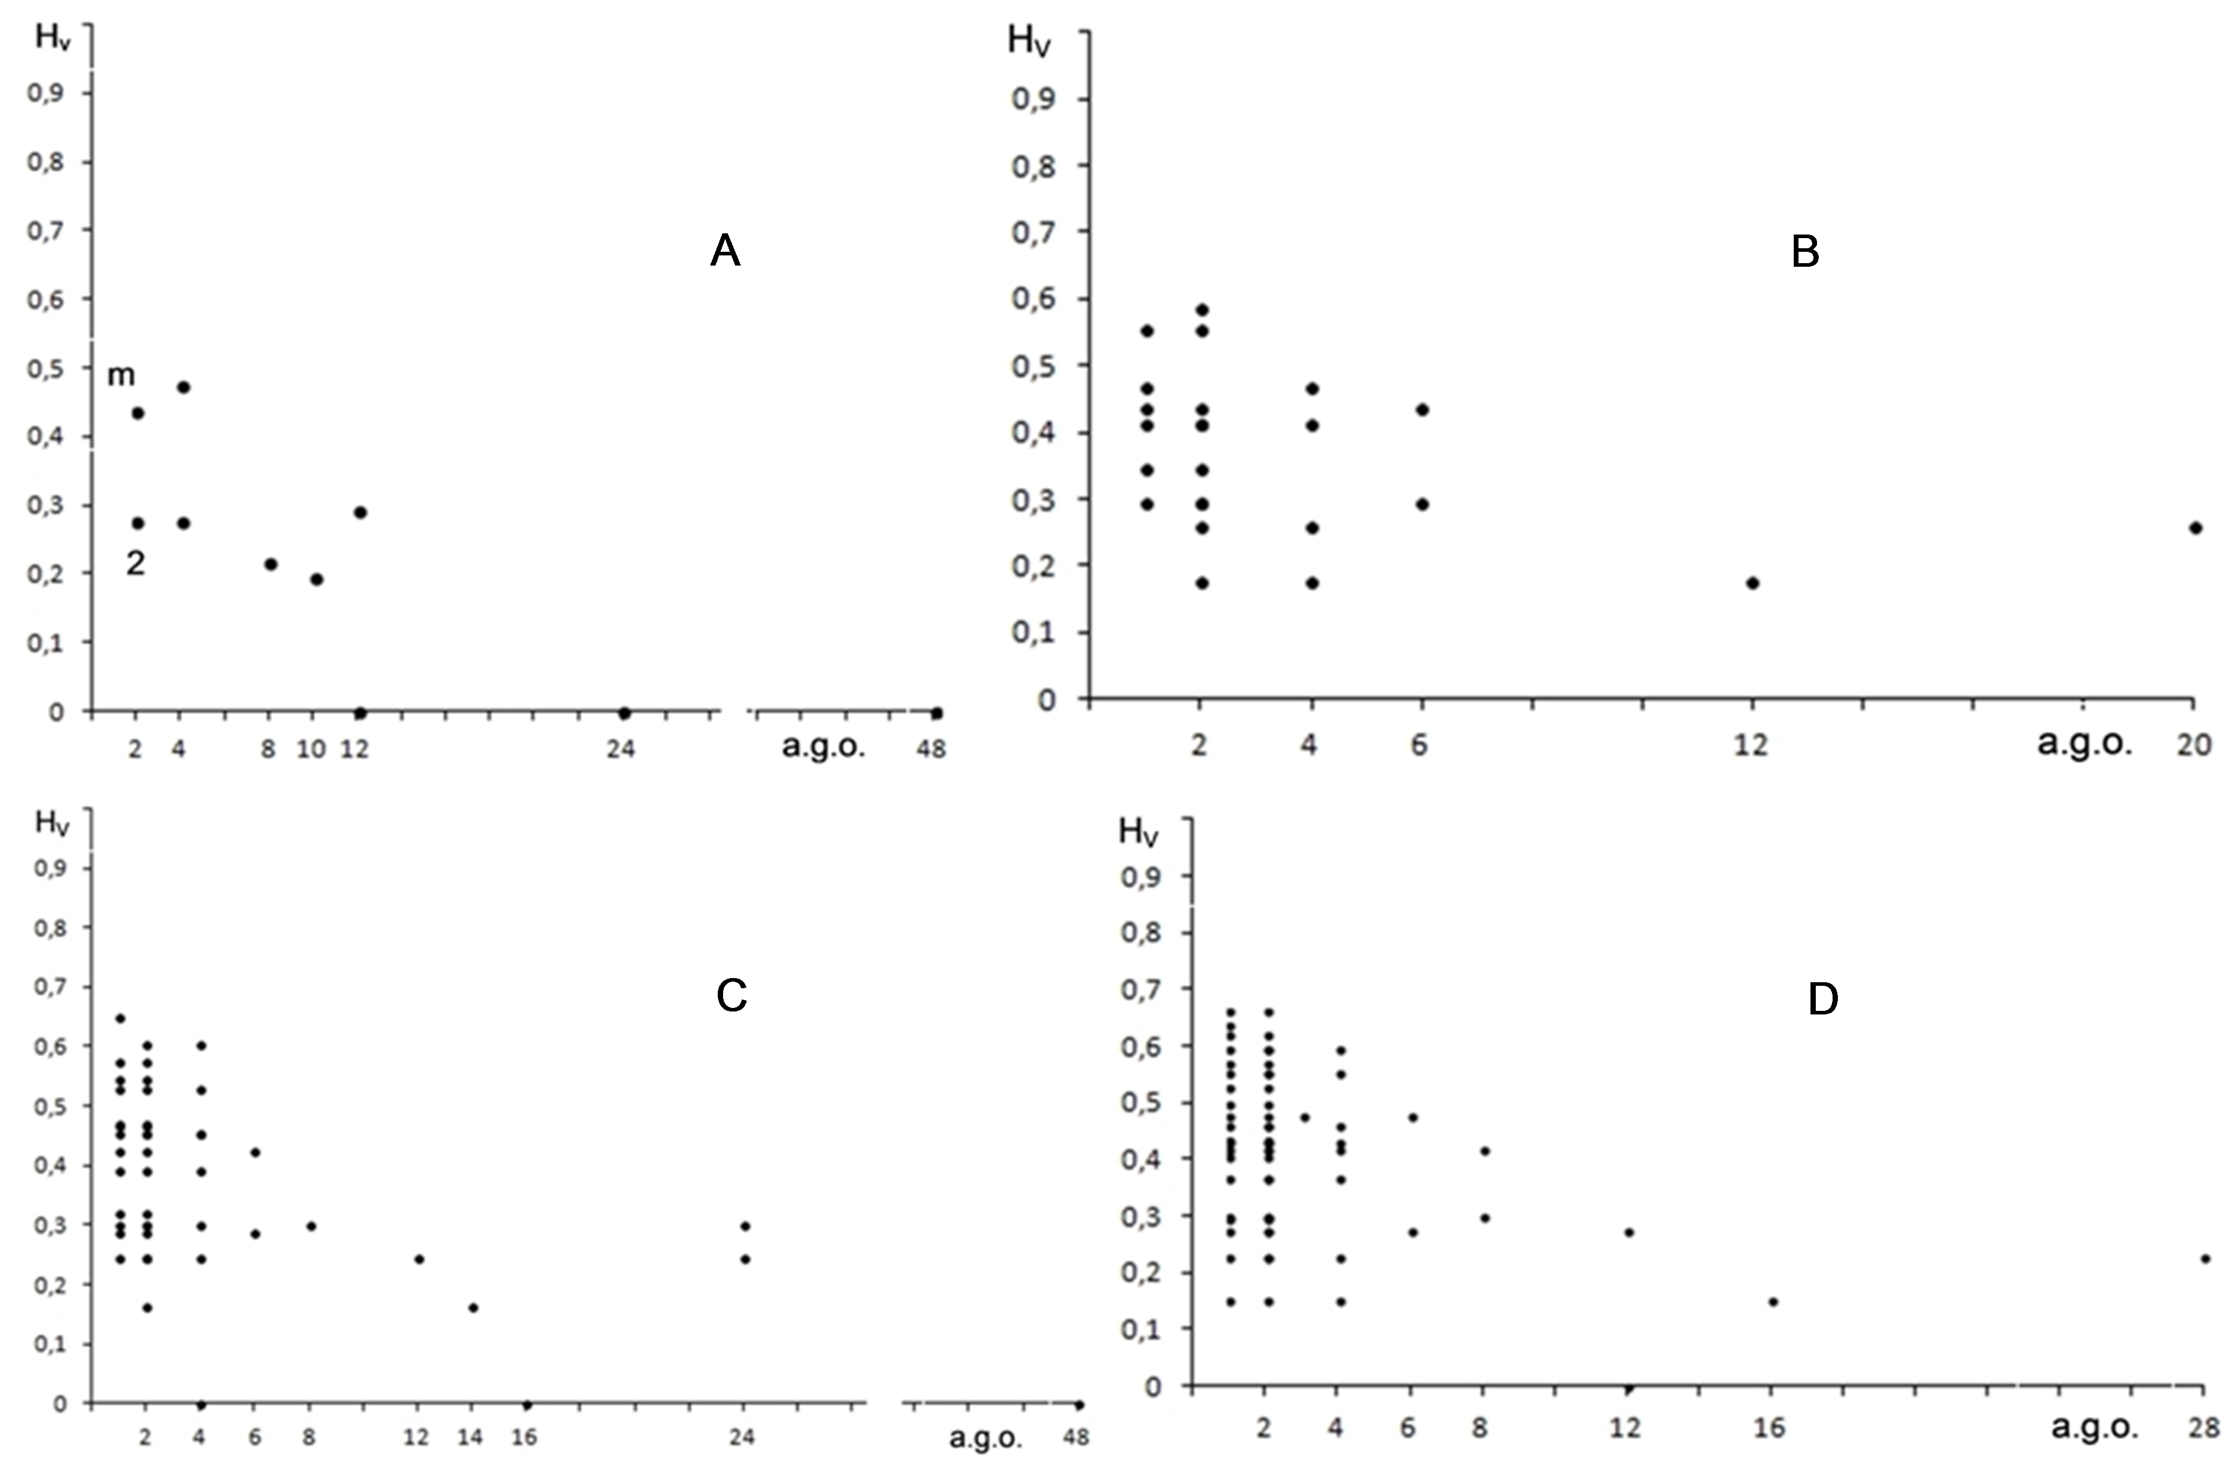

Figure 3. Entropy H_{V} for the same classes of convex n-acra as in Fig. 2

4. Discussion
The relationships beween the entropies H_{S} and H_{V} in a general case can be formulated in two statements.

Statement 1. H_{S} ≥ H_{V} for any convex n-acron, i.e. for any n and s.p.g.
Proof. First of all, the statement is true for all convex 4- to 9-acra (Table 2). H_{S} > H_{V} mostly for n-acra of low symmetry, while H_{S} = H_{V} mostly for n-acra of high symmetry with the transition classes of a.g.o.’s from 2 to 12. Сareful consideration of n-acra has allowed to establish the following. Let us take any n-acron with vertices of different symmetry positions. Obviously, vertices equivalent under the automorphism group have the same valences. The question is if the non-equivalent vertices have different valences or not. H_{S} = H_{V} if so, H_{S} > H_{V} if not. In the latter case, decrease in the variety of valences is resulted in reduction of H_{V} (if compared with H_{S}) in accordance with the general properties of the entropy H. The rigorous proof is given in Appendix 1.

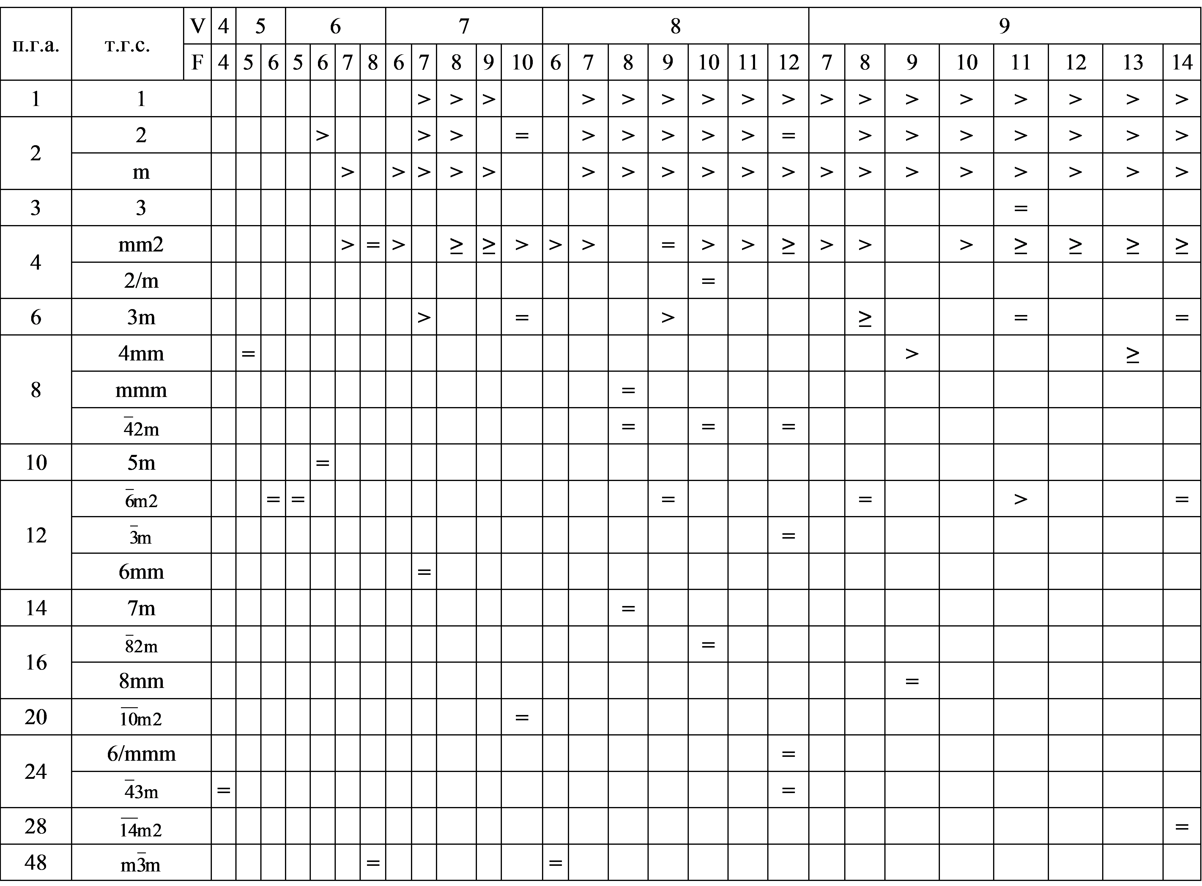
Table 2. Relationships between H_{S} and H_{V} for convex 4- to 9-acra. Note: > means H_{S} > H_{V} for all n-acra in the class; = means H_{S} = H_{V} for all n-acra in the class; ≥ means both types of n-acra are in the class.
Statement 2. Entropy H_{V} never reaches maximum lg n.
Proof. In other words, we should prove that there are no n-acra with all vertices of different valences. Actually, even more strict statement takes place: any convex n-acron has at least 4, or 3 and 2, or 3 pairs of vertices of the same valences. The rigorous proof is given in Appendix 2.

5. Conclusions
It follows from general considerations that the topological entropy H_{S} is hardly interpreted in initial terms (in our case, a.g.o.’s and s.p.g.’s of convex n-acra even for given n). The H_{S} value fixes any n-acron on a scale between H_{S,min} = 0 and H_{S,max} = lg n. But, small changes of the probabilities p_{i} at the corners of a field of definition (Fig. 1) affect big changes of H_{S}, while the same changes of p_{i} in the central part of the field of definition do not affect H_{S} that much. H_{S,max} = lg n is attained by, for example, combinatorially asymmetric convex n-acra (for n ≥ 7). H_{min} = 0 is attained by, for example, regular and semi-regular n-acra (all the cases are enumerated) as well as the infinite series of prisms and antiprisms (for even n ≥ 4). Between the two bounds, the entropy H_{S} of convex 4- to 9-acra shows a general trend: the higher a.g.o., the lower H_{S}. But, there are a lot of exceptions. For given n, the 0 < H_{S} < lg n values do not allow us to know a.g.o.’s (the more so s.p.g.’s) of n-acra.
The entropy H_{S} characterizes a ‘disorder’ rather than a ‘complexity’ of convex n-acra. The first one is quite well characterized by s.p.g’s. The second one should distinguish n-acra of the same s.p.g. and different numbers of edges, for example, the overwhelming majority of combinatorially asymmetric n-acra for given n ≥ 7. To do this, the topological entropy Н_{V} is suggested, which considers the valences of vertices of n-acra. It classifies the variety of convex 4- to 9-acra in more details. It is proved that H_{V} can reach 0 as minimum (for example, for regular and semi-regular polyhedra, as well as the infinite series of prisms and antiprisms), but never lg n as maximum, because there are no convex n-acra with all vertices of different valences. It is also proved that H_{S} ≥ H_{V} for any convex n-acron, i.e. for any n and s.p.g. H_{S} = H_{V} if the vertices non-equivalent under the automorphism group also have different valences, and H_{S} > H_{V} if not.

References
1. Grünbau B. Convex Polytopes. New York: Springer, 1967.
2. Halphen E. L’analyse intrinsèque des distributions de probabilité // Publ. Inst. Stat. Univ. Paris 6. 1957; 2, 77-159.
3. Shannon СE. The mathematical theory of communication // Bell Syst. Tech. J. 1948; 27, 379-423, 623-656.
4. Voytekhovsky YL. E.S. Fedorov’s algorithm of the generation of the combinatorial diversity of convex polyhedra: the latest results and applications // J. Struct. Chem 2014; 55. 1293-1307.
5. Voytekhovsky YL. How to name and order convex polyhedral // Acta Cryst. A 2016; 72, 582-585.
6. Voytekhovsky YL. Convex polyhedra with minimum and maximum names // Acta Cryst. A 2017; 73, 271-273.
7. Voytekhovsky YL. Accelerated scattering of convex polyhedral // Acta Cryst. A 2017; 73, 423-425.
8. Voytekhovsky YL., Stepenshchikov DG. Combinatorial Crystal Morphology. Book 4: Convex Polyhedra. Vol. 1: 4- to 12-hedra. Apatity: Kola Sci. Centre of RAS. Available at http://geoksc.apatity.ru/images/stories/Print/ monob /%D0%9A%D0%BD%D0%B8%D0%B3%D0%B0%20IV%20%D0%A2%D0%BE%D0%BC%20I.pdf 2008.
Appendix 1
Consider the sequences of numbers v_{i} of different valences for convex 5- to 9-acra (related H_{V} are in parentheses) ordered by the algorithm to follow: … p … q … (H₁) → … p-1 … q+1 … (H₂), where 1 ≤ p ≤ q.
5-acra. 23 (0,292) → 14 (0,217).
6-acra. (Hereinafter 0’s and permutations of v_{i} are omitted in the sequences as they do not affect H_{V}.) 222 (0,477) → 123 (0,439) → 24 (0,276) → 15 (0,196) → 6 (0).
7-acra. The main trend: 1222 (0,587) → 1123 (0,555) → 223 (0,469) → 133 (0,436) → 124 (0,415) → 34 (0,297) → 25 (0,260) → 16 (0,178); offshoot: 124 (0,415) → 115 (0,346).
8-acra. The main trend: 11123 (0,649) → 1223 (0,574) → 1133 (0,545) → 233 (0,470) → 224 (0,452) → 134 (0,423) → 44 (0,301) → 35 (0,287) → 26 (0,244) → 17 (0,164) → 8 (0); offshoots: 2222 (0,602) → 1223 (0,574); 1133 (0,545) → 1124 (0,527) → 1115 (0,466); and 134 (0,423) → 125 (0,391) → 116 (0,319).
9-acra. The main trend: 11223 (0,661) → 2223 (0,595) → 1233 (0,569) → 333 (0,477) → 234 (0,461) → 144 (0,419) → 135 (0,407) → 45 (0,298) → 36 (0,276) → 27 (0,230) → 18 (0,152) → 9 (0); offshoots: 11223 (0,661) → 11133 (0,636) → 11124 (0,620); 1233 (0,569) → 1224 (0,553) → 1134 (0,528) → 1125 (0,499) → 1116 (0,435); 234 (0,461) → 225 (0,432); and 135 (0,407) → 126 (0,369) → 117 (0,297).
The above sequences could be ordered in different ways. We have followed the rule of a “slow down” to include as many sequences in the main trends, as possible. With no exception, the above algorithm causes H₁ > H₂. To prove the inequality in a general case (for any 1 ≤ p ≤ q and n), we should show that

– (p/n) ln (p/n) – (q/n) ln (q/n) > – [(p-1)/n] ln [(p-1)/n] – [(q+1)/n] ln [(q+1)/n] .

If p → 1, then [(p-1)/n] ln [(p-1)/n] → 0. Hence, for p = 1 we get an obvious inequality (q+1) (1+1/q)^{q} > 1. For 2 ≤ p ≤ q we should prove the inequality

p^{p} / (p-1)^{p-1} < (q+1)^{q+1} / q^{q} = f(q) .

Consider f(q) as a continuous function and use a logarithmic derivative

df/dq = ln(1+1/q) × (q+1)^{q+1} / q^{q} > 0 .

That is, f(q) grows with the growing arguments q = p, p+1, p+2, etc.
Let us show that the above inequality takes place even for the minimum argument q = p, i.e.

p^{p} / (p-1)^{p-1} < (p+1)^{p+1} / p^{p} or 1 < (p+1)^{p+1} (p-1)^{p-1} / p^{2p} = f(p) .

Again, consider f(p) as a continuous function and use a logarithmic derivative

df/dp = ln(1-1/p²) × (p+1)^{p+1} (p-1)^{p-1} / p^{2p} < 0 .

That is, f(p) drops with the growing arguments p = 2, 3, 4, etc. Indeed, f(2) = 1,6875, f(3) = 1,404…, f(4) = 1,287…, f(5) = 1,223…, f(6) = 1,182…
Nevertheless, if p → ∞, then

lim f(p) = lim (p+1)^{p+1} (p-1)^{p-1} / p^{2p} = lim (1+1/p)^{p} (1-1/p)^{p} [1+2/(p-1)] = e × e⁻¹ × 1 = 1 .

That is, f(p) tends to 1 from above, i.e. f(p) > 1 for any p. Thus, H₁ > H₂ for any 1 ≤ p ≤ q and n.

Appendix 2

Assume that a convex polyhedron exists with all the facets being different (i.e. of different number of edges). Let us consider its Schlegel diagram on a facet with a maximum number of edges (k-lateral facet, Fig. 4 a). More precisely, let us consider how its corona (i.e. a set of facets touching it edge-to-edge) is built. After (k-1)-, (k-2)- … 4-, and 3-lateral facets being attached to k-lateral one in any order, 3 more edges are free. And we can conclude that our initial assumption that all facets are different is wrong. Obviously, in the above case, 3 same (i.e. of the same number of edges), or 2 and 1, or 3 different facets can be attached to them. As any (i.e. 3- to k-lateral) facet is used, 4 same, or 3 and 2, or 3 pairs of same facets will result on a polyhedron.
Assume that not all k-3 types of the facets are submitted in the corona. Then, after the facets of each type being attached by one to k-lateral facet, more than 3 edges are free. To complete the corona, one should choose more than 3 facets from their less than before (k-3) variety. Obviously, both reasons may not reduce the frequency of occurrence of the facets in the corona: 4 same, or 3 and 2, or 3 pairs of same facets. Finally, because of the duality, any convex n-acron has at least 4, or 3 and 2, or 3 pairs of vertices of same valences. The limit cases are: a tetrahedron, a trigonal dipyramid, and a 6-acron of mm2 s.p.g. (Fig. 4 b).

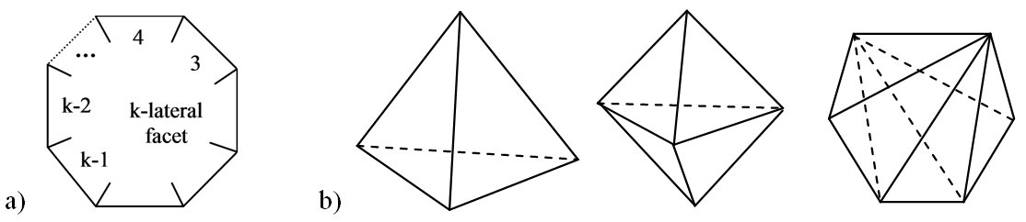

Figure 4. The Schlegel diagram on a k-lateral facet. b) The limit convex 4-, 5-, and 6-acra. See text.

