A post-stream based equation oriented modelling of complex distillation column: a dividing wall column case study
R. Idris¹, N. Harun¹, M.R. Othman^{*1}
¹Process Systems Engineering Research Group, FKKSA, Universiti Malaysia Pahang, 26300 Gambang, Pahang, Malaysia.
ABSTRACT
Dividing wall column (DWC) offers higher degree of freedom in comparison with the conventional column. Furthermore, the different sections configurations within the column are highly interacting with several recycle loops. Facing with such complex unit operation, describing its behaviour encourages the focal point on the resolution of ideal modelling approaches. Equation oriented (EO) modelling of DWC has been studied by several researchers involving complex algorithm and methodology. In this work, a new approach for modelling of DWC is presented. The modelling methodology involves variables connectivity based on ports and streams that is admissible to equation-oriented flow sheet. To verify the functionality of the proposed method, the modelled DWC is validated with two case studies depicted from experimental literature data to separate alcohol mixture and fatty acid fractionation. The model development was performed in MOSAIC, a web-based modelling tool and run in gPROMS. The model shows good convergence and has less than 10% error when compared to the abovementioned case studies. To furthermore extend the model capability, relative gain array (RGA) analysis was conducted for the fatty acid fractionation to determine the best control configuration in DWC. Result shows that L-S-V and L-S-B configurations are the best control configurations. Our analysis also shows that reflux flowrate, side flowrate and vapor boilup are best to control distillate product, side product and bottom product respectively.
Keywords: Dividing wall column; Process modelling; Relative Gain Array
Introduction
Dividing wall column (DWC) is an intensified design of Petlyuk column which provide a good alternative to conventional distillation column due to possible saving in both energy and capital cost around 30% [1]. A DWC possesses a vertical partition that splits the column shell into a pre-fractionator and main column section as shown in Figure 1. Such configuration, compensates the impurity of the side product from being mixed with the distillate and bottom products. For ternary mixtures, applying DWC able to cut down a column thus reduce the number of condenser and reboiler with reliable product quality achievement. Regardless of its potential advantages, industrial implementation of dividing wall columns was often restricted due to the design, control and operational concern.
Figure 1. (Left) Conventional distillation column (Middle) Petlyuk column and (Right) Dividing wall column (DWC) configuration
Often modelling of DWC were done through sequential modular (SM) based model compared to equation oriented (EO) based model. In SM modelling a two or three column configuration were often used. Four column configurations however are more accurate to represent the four sections of DWC (Illner and Othman, 2014). However, with the existence of internal recycle streams in DWC due to the interconnecting stream on all four column sections caused serious convergence problems. EO on the other hand, offers good solution over SM especially when dealing with design and optimization problems, solving heat integrated or recycled processes and model tuning analysis. EO modelling compensate the convergence problem by accumulating all model equations together and solves them at the same time. Modelling of DWC via first principle EO modelling is not an easy task as it is considered as complex nonstandard distillation column. One main reason is due to the interconnectivity of input/output variables especially on the pre-fractionator section and main column section.
Work on EO modelling of DWC is however limited due to its modelling complexity. Dunnebier and Pantelides (1999) had considered the modelling of DWC using so called detailed column superstructures based on the State Operator Network formulation. Due to the complexity of the models and mathematical problems, determination of the optimal structure referring to the suggested approach encountered some obstacles in optimization. Pattison et al. (2015) also presented a new modelling approach based on the Pseudo-transient method. They reformulated the steady-state MESH (material, equilibrium, summation, and heat) equations of DWC as differential-algebraic equation (DAE) system which has the same steady state solution as the original system. These works applied a complicated EO approach to DWC modelling which is time-consuming to comprehend. As such, we introduced a much simpler and systematic modelling approach. The proposed method solves the input/output variables connectivity of different equation systems by introducing a port and stream concept. Generally, the approach presents an equation system which functionally similar to a unit operation i.e. column, reboiler, condenser, with a presence of ports to identify the standardization of input and output variables. And in addition, the existence of streams in connecting another individual equation system together. To aid the model development, a MOSAIC modelling software will be used as modelling tools and gPROMS to solve the equation systems.
Modelling Methodology
This section describes details of the proposed method. For better understanding, this section starts with definition of equations systems and variables involved in modelling of DWC.
Equation system and variables of DWC
Equation system is combination of fundamental principle of the underlying process or unit operation under considerations by reformulating the MESH (material, equilibrium, summation, and heat) equations. The DWC models in this work were based on the conventional equilibrium-based models of the distillation column. In this work we are focusing on the product composition and composition along the DWC. Energy balance will be our future work. The following assumptions had been taken into account for the model development:
- Steady-state equilibrium stage model
- Average phase equilibrium constant
- Material balance
- Constant vapour split ratio as it is fixed by column design
For the rectifying section, pre-fractionator section, main section, and stripping section the component material balance for component i at stage j is given as: -
(1)
Where S represents a side stream flow rate. Summation equations is given in equation 2 whereas equilibrium relationship is given in equation 3.
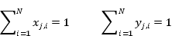 | (2)
 | (3)
For the condenser, the material balance is
 | (4)
Whereas the summation equation:
(5)
For the reboiler,
Material balance:
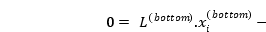 | (6)
Equilibrium relationship:
(7)
Summation equation is
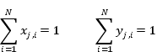 | (8)
At the intersection of rectifying section with pre-fractionator and main column the vapor mixing is represented by,
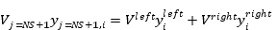 | (9)
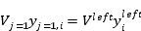 | (10)
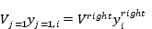 | (11)
Whereas liquid splitting is represented by,
 | (12)
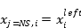 | (13)
 | (14)
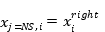 | (15)
 | (16)
On the other hand, at the intersection of pre-fractionator and main with stripping sections vapor splitting is represented by,
 | (17)
 | (18)
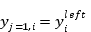 | (19)
 | (20)
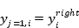 | (21)
And liquid mixing is represented by,
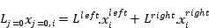 | (22)
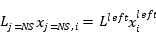 | (23)
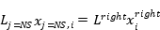 | (24)
The connection between rectifying and condenser unit are given by,
(25)
(26)
Meanwhile stripping and reboiler connectivity is given by,
(27)
(28)
The subscripts NS and NS+1 indicate that liquid and vapour flow on the last stage of each section will be connected to other section. The superscripts in and out are known to be the inlet and outlet flow which happens between stripping/reboiler and rectifying/condenser. While superscript of upper, left, right, and bottom are referring to rectifying, pre-fractionator, main, and stripping section respectively. Next, α indicates a liquid splitting factor and β is for vapour split factor.

Unit Block and Ports
The challenge in modelling of DWC is to accommodate the internal flows between the partition walls. In this work, we treated rectifying section, pre-fractionator, main, and stripping section as individual unit block along with the condenser and reboiler. A unit block model consists of sets of mathematical equation systems to describe the phenomenon occurring inside the unit. This creates a convenient way to model the DWC as a group of 6 sub-unit bocks with underlying equation systems. indicates the underlying classification of equation system involved in the respective unit block.
Unit block | Equation systems involved
Rectifying | 1, 2, 3, 9, 12, 13, 14, 15, 25, 26
Pre-fractionator | 1, 2, 3, 10, 16, 17, 23
Main | 1, 2, 3, 16, 17, 24
Stripping | 1, 2, 3, 18, 19, 20, 21, 22, 27, 28
Condenser | 4, 5
Reboiler | 6, 7, 8
Table 1. Unit block and its associated equation systems
In order to properly connect different unit blocks together, the application of port is introduced into the unit block. Port is used to provide reconciliation of different input and output variables of a unit block to or from another unit block. To further describe the concept, an example to rectifying unit is considered (refer Figure 2). Rectifying unit is located at the top section of the DWC internal configuration. Vapour from the pre-fractionator section and main section will be mixed at the last stage of the rectifying unit whereas liquid flow at the last stage will be split into both side of pre-fractionator section and main section. To describe this phenomenon, Equation (9) represents the vapour mixing occurred at the last stages of the rectifying section. Port 1 (P1) signify the vapour flow from the first stage of the pre-fractionator section (Equation 10) whereas P5 signify the vapour flow from the first stage of the main section (Equation 11). Thus, the input variables involved for the vapour mixing are 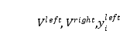 and 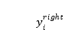. Equation (12) to equation (15) on the other hand signify the splitting of liquid flow flowing down from the last stage of rectifying section into pre-fractionator section and main section. P2 denotes the liquid split to the pre-fractionator represented by equation (12) and equation (13) whereas P4 denotes the liquid split to the main section represented by equation (14) and equation (15). Therefore, the output variables for the liquid split are 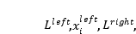 and 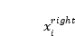. In addition, P6 denotes the liquid flow from condenser to the first stage of the rectifying unit which describe by equation (26). P3 on the other hand denotes the vapour flow from the first stage as describe by equation (25). Therefore, 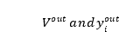 are the output variables of the vapour flow whereas 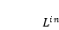, and 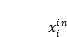 are the input variables of the condenser.
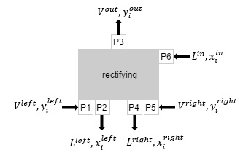
Figure 2. Rectifying Unit Block Model with Ports
For the port to be reconciled it need to have an interface variable. An interface consists lists of identified independent variables to restrict the accessibility of the other unrelated variables in the overall equation system. In this example, 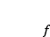 and 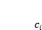 were used as interface variable to represent vapour/liquid flowrate and composition of component i respectively. Overall, will represent variables 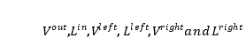 whereas will represent variables 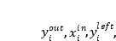 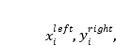 and 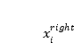. The port and interface application are visualized in Figure 3.
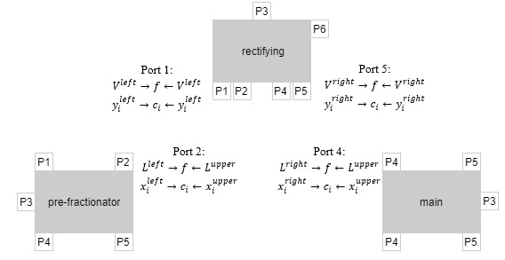
Figure 3. Port and interface application in DWC sub-units block
Unit Block Connectivity Using Stream
When all the unit blocks and its associated ports have been created, they are then ready to be connected to each other using streams. The purpose of stream is to connect two different units block that provides ports to work jointly in a flowsheet. The implementation of a stream requires list of identified variables in the interface along with ports in order to be combined together. The flow direction of the stream, either “output” port and “input” port indicator need to be specified for smooth connectivity. The output port represents the start of the stream while input port indicates the end of the streams, depending on how the flow direction works. Figure 4 exhibits the complete model of DWC with ports and streams application. The dotted and solid lines indicate the flow of liquid and vapor respectively inside DWC.
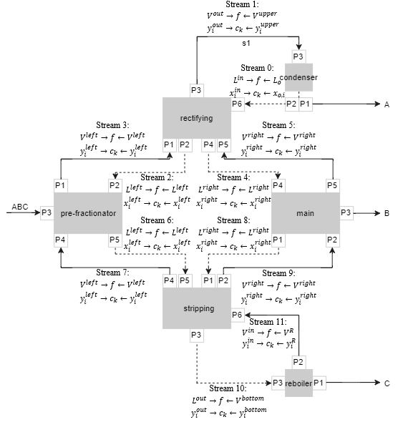
Figure 4. Model of DWC with port-stream application

Model Development
The DWC development based on the proposed methodology were performed in MOSAIC. MOSAIC is a web-based equation oriented modelling environment for modelling of chemical processes, which developed by the Process Dynamics and Operations Group at Technische Universitaet Berlin. One of the MOSAIC features is modelling at the documentation level (Kuntsche, Barz, Kraus, Arellano-Garcia, & Wozny, 2011). The model equations in MOSAIC are entered using LaTeX style and saved in MathML which provide higher readable model to the user. MOSAIC additionally work as a code generator which able to export the developed model into certain programming language code.
Variable Specification and Classification
One of the important feature of EO modelling are the variables specification required as input data and generated as output predictions. Each variable in the equations will be specified by fixing the value or enabling the modeling tool to manipulate the value (Marchetti, Rao, & Vickery, 2001). Those variables are classified as design and iteration values. Design variables indicate the fixed value variables whereas iteration variables mean calculated variables in the equation systems.
Those variables can be changed either from iteration variables to design variables or vice versa until the DOF become zero. For the case of the DWC model, the vapor composition, constant phase equilibrium, liquid and vapor flow in respective unit are assigned as design variables. Meanwhile, the liquid composition and products stream composition are set to be iteration variables. Another important issue to be considered is the initial value for the iteration variables. It should be noted that, in modeling solving, good initial values are crucial since the developed model would work well when all variables near the solution (Pantelides et al., 2015). One may used SM software i.e. Aspen Plus to aid initilization values estimation for a good convergence.
DWC Model Structural Analysis
To guarantee that the equation systems of DWC model are well formulated, the degree of freedom (DOF) analysis is carried out to determine if the equation systems are well, under, or over determined. Figure 5 shows the structural analysis of mixed DOF of the DWC model. The consequences of inaccurate choosen of design variables in the DWC system leads to the insufficient structure analysis (Refer Figure 5), and unsolve problem in the compiler or solver. The insufficient structure analysis generates three different colours of rectangle/line which are green, blue, and red. Under-determined which represented in blue rectangle line is due to more equations being provided than calculated variables. While the red rectangle line which exhibits under-determined equation system is caused by less equation being provided than variables to be calculated. From the figure the equation systems for pre-frac and middle are well determined. Stripping section and reftifying equation systems on the other hand are under-determined and over-determined respectively.
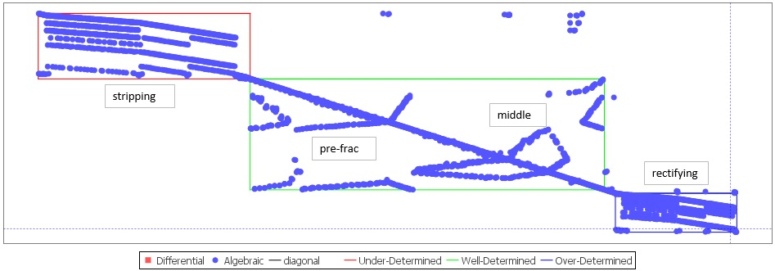
Figure 5. Unstable structure analysis of DWC system

From the figure 5, it visualized that the structure of the equation systems is affected by the chosen degree of freedom (Gani, Cameron, Lucia, Sin, & Georgiadis, 2012). In other word, to achieve a well-posed problem, the need in change of design variable and calculated variable specifications are compulsory to preserve DOF. To ensure that all equation systems are well determined selection of design and iteration variables are important in order to solve the given problem which is to identify the product stream compositions. Based on the whole structure analysis of DWC, further observation shows that some of the design variables on rectifying equation system are set as iteration variables and likewise some of the iteration variables on stripping equation system are set as design variables. Therefore, to fix this problem, the classification of design and iteration variables should be restructured.
After proper assignments of design and iteration variables, Figure 6 shows the overall six sub-equation systems of DWC model are ‘well determined’ which means the model is solveable. Other than that, the structure analysis also give the information on the type of equations. In this case, the structure analysis indicate that the whole equations system of DWC involved with algebraic equations with non-existing of ordinary differential equations (ODEs) as well as non-existing differential algebraic equations (DAEs).
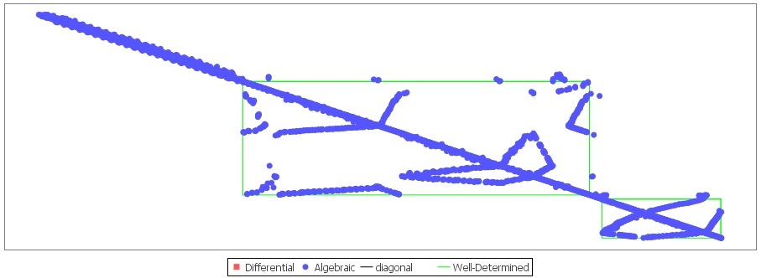
Figure 6. Well determined structure analysis of DWC system
Model Validation
The completed DWC model simulation in MOSAIC was exported to gPROMS ModelBuilder to solve the compositions in the column. To demonstrate the capability of the modelling approach and to increase the acceptance of the model, the modelled DWC is validated with two case studies. Case Study 1 refer to open literature experimental data depicted from Nguyen et al. (2016) whereas Case Study 2 refer to fatty acid fractionation from Illner and Othman, (2014). For Case 1, the model will be compared with the second data set of the experimental work. Furthermore, in Case 2, the model will be compared to a simulated case study for fractionating fatty acid in DWC.
Case Study 1: Separation of Ternary Mixture: Methanol/ 1-Propanol/ 1-Butanol
The verification data were based on the experimental work by Nguyen et al. (2016). Their work involved separation of ternary mixtures of alcohol namely methanol, 1-propanol, and 1-butanol using DWC pilot plant. According to the volatilities of the components, methanol is withdrawn as a distillate product, while 1-propanol and 1-butanol are collected as side stream and bottom product respectively. The column structure consists of 15 stages on the rectifying and the stripping section, and 10 stages on the pre-fractionator and main section. The schematic configuration is shown in . The liquid split was set up to be 0.5 and so does with vapor split as cross sectional areas of pre-fractionator and main column are the same. Table 2 indicates the operating parameter used in the experimental work.
Parameter | Specification
Feed flowrate (kg/h) | 5.77
Feed temperature (ºC) | 85.4
Feed composition (wt%)  - Methanol  - 1-propanol  - 1-butanol | 0.29  0.46  0.25
Liquid split | 0.5
Vapor split | 0.5
Reboiler duty (kW/h) | 5.1
Table 2. Operating parameter of alcohol ternary mixture for data set 2

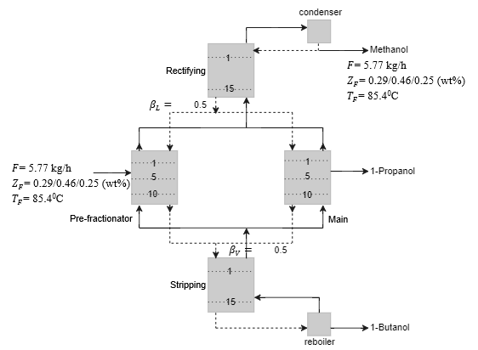
Figure 7. Schematic DWC configuration for the alcohol fractionation
Initialization Value
A good initial values are crucial since the developed model would work well when all variables near the solution (Pantelides et al., 2015). Therefore, to aid the initialization value estimation, Aspen Plus were used in this work. Figure 8 shows a DWC configuration in Aspen plus flowsheet. A DWC model does not exist in Aspen Plus library due to its customized model. Therefore, an equivalent model of DWC with four rigorous RADFRAC model, two units of mixer and splitter for liquid and vapor internal mixing and splitting purpose were implemented. The results of simulation generated in Aspen Plus was used to provide the initial value of all the unknown variables in the DWC equation systems to gain a good convergence of output value prediction. Once the initialization value was given the model is ready to be translated into gPROMS code.
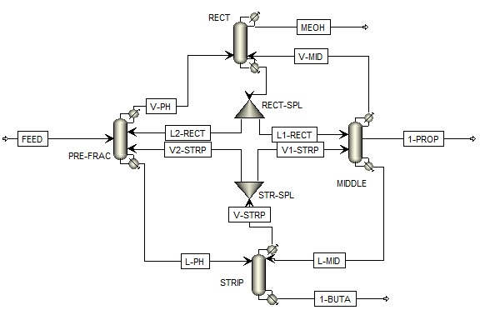
Figure 8. Column configuration of DWC for alcohol mixture

Model Solver
The complete process model of DWC involved large sets of nonlinear algebraic equation (NLE) and was numerically solved using differential-algebraic solver (DASolver) in gPROMS solution algorithm. This include Block Decomposition Non-Linear Solver (BDNSOL) and SPARSE solver which able to solve the restricted iteration variables that lie within speified lower and upper bound. BDNSOL solver resolve the non-linear equation according to an individual unit block of rectifying, pre-fractionator, main, stripping, condenser, and reboiler. The variables in each unit blocks were solved using SPARSE through Newton-type iterative method which resulted on a prediction of component variable in each stage.
Value Comparison
The relative error between EO simulation results and literature data was calculated as follows:
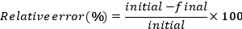 | (29)
In this study, the relative error which is less than 10% is considered reasonable due to small value of the experimental data from Nguyen et al. (2016). Moreover, the process characteristic of DWC, such as pressure, energy, and heat transfer were not considered in the modeling work. The verification results are shown in Table 3. Relative error between literature data and EO simulation results for data set 2
Parameters | Unit | Literature data | EO simulation | Relative error (%)
Distillate flowrate | (kg/h) | 2.00 | 2.00 | 0
Methanol composition | (wt%) | 0.85 | 0.93 | 9.41
Side stream flowrate | (kg/h) | 2.17 | 2.17 | 0
1-propanol composition | (wt%) | 1.00 | 1.00 | 0
Bottom stream flowrate | (kg/h) | 1.70 | 1.69 | 0.58
1-butanol composition | (wt%) | 0.89 | 0.90 | 1.12
Table 3. Relative error between literature data and EO simulation results for data set 2
For distillate product stream, the result acquired from EO simulation for Methanol composition was 0.93 wt% which differ about +0.08 wt% from reference literature data and led to 9.41% relative error. The side product stream, 1-propanol demonstrates an equivalent of convergence value with literature data in regards to product flowrate and composition. For bottom stream flowrate, a different about +0.1 kg/h in comparison to literature experimental data was recorded which resulted in 0.58% relative error. Whereas the composition of 1-butanol generated from EO simulation appeared to have a slightly different about +0.01 wt% and makes the relative error of 1.12%. Therefore, from the table, the proposed model shows a good convergence in term of products flowrate and compositions and had less than 10% relative error which shows applicability of the proposed approach.
Case study 2: Fatty Acid Fractionation
The validated DWC model was then tested to a fatty acid (FA) fractionation. By far, in the oleo-chemical industry particularly for FA, the mixture had only been studied by (Illner & Othman, 2014) since most of the industry still using a conventional distillation columns to separate FA mixture (Aly & Ashour, 1992; Chemtech et al., 2017; IPS Engineering, 2014). The configuration of the dividing wall column for fatty acid fractionation was designed similarly using four columns sequence proposed by the authors. Fatty acid fractionation was separated into three cuts light-cut (LC), middle-cut (MC), and heavy cut (HC) according to their boiling points. The boiling point of LC which represented by C₁₀ is 269 ºC. While the boiling point of MC (C₁₄) and HC (C₁₆) are 326 ºC and 350 ºC respectively. Since C₁₀ is the most volatile component, thus it will be withdrawn as a distillate product. The least volatile component (C16) will be withdrawn at the bottom of the column due to high boiling point. While the side stream goes to component C₁₄. The The design parameter input was based on the simulation work done by (Illner & Othman, 2014) but with slide modification that suits the pilot plant design capacity of 5kg/hr.
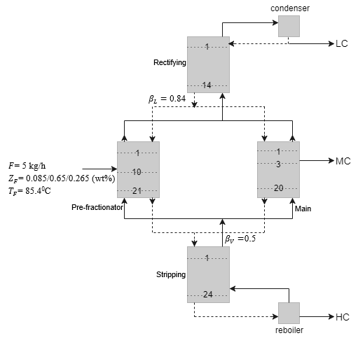
Figure 9. Schematic DWC configuration for fatty acid fractionation
Figure 9 shows the schematic DWC configuration for fatty acid fractionation. The rectifying section consists of 14 stages, while pre-fractionator section has 21 stages, main section and stripping section have 20 and 24 stages respectively. The condenser is at stage 0 and reboiler at the last/bottom stage of the column. Feed stream enters at stage 10 from the top in the pre-fractionator section and the side product is withdrawn at stage 3 in the main section. The liquid split ratio is 0.84 and, and the vapor split ration is 0.5. Thus the wall is located at the middle of the column.
Using the same relative error calculation in Equation 29, Table 4. Comparison between specified product value in Aspen Plus and EO simulation.. Result shows that the highest relative error is 0.88% for bottom stream flow rate. The bottom flowrate from model was -0.01 lower than the initial reference data which is 1.13 kg/h. While for the HC composition, the model shows 0.999 wt% which led to 0% of relative error. For both side stream flowrate and MC product composition, the value indicates zero difference between initial reference data and the model which was 3.451 kg/h and 0.942 wt%, respectively. Same goes to distillate flowrate composition which represented by LC, where the initial input data and final value output prediction was identical. The results conclude the applicability of the developed model.
Parameters | Unit | Aspen Plus | EO simulation | Relative error (%)
Distillate flowrate | (kg/h) | 0.420 | 0.420 | 0
LC composition | (wt%) | 0.999 | 0.999 | 0
Side stream flowrate | (kg/h) | 3.451 | 3.451 | 0
MC composition | (wt%) | 0.942 | 0.942 | 0
Bottom stream flowrate | (kg/h) | 1.130 | 1.120 | 0.88
HC composition | (wt%) | 0.999 | 0.999 | 0
Table 4. Comparison between specified product value in Aspen Plus and EO simulation.

FA Composition Trend in DWC
Figure 10 gives the composition profiles in the rectifying, main, and stripping sections. Figure 10(a) shows the composition trend for the rectifying section. It can be seen that the highest composition of LC was at stage 1 and remain consistent up to stage 10 with 0.999 to 0.995 wt%. At stage 11 up to stage 13, the composition begins to decrease gradually and became 0.076 wt% at stage 14. Meanwhile, the side component, MC starts to increase slowly from stage 11 at 0.037 wt% to 0.867 wt% at stage 14. While the HC product almost remains almost at 0.0 wt% at the last stage of rectifying column.
Figure 10Error: Reference source not found shows the trend for LC, MC, and HC product composition in main section. From the graph, as LC component starts to enter the first stage of the main column, the composition indicate 0.0 wt%. On the contrary, MC composition remain constant around at composition of 0.93 wt% at stage 15 until it reached stage 31 and starts to decrease to 0.645 wt% at the last stage of the main column. For HC component, the composition remain constant at stage 15 up to stage 31 with 0.057 wt% and increase slowly at 0.355 wt% when reached the last stage of the main section.
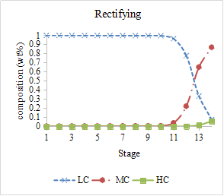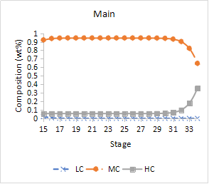

- (b)

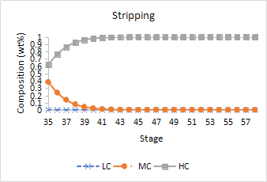
(c)

Figure 10. Components trend along (a) Rectifying, (b) Main, and (c) Stripping section
Figure 10Error: Reference source not found shows the composition trend in the stripping column. From the graph, LC component composition remains at 0 wt% along the stripping column, which means zero existence of distillate product on the stripping section. While for MC component, it starts to decrease steadily as it enters the first stage from 0.237 wt% to almost 0.0 wt% until the the last stage of stripping section. On the other hand, the composition of HC component begins to increase slowly starting from the stage 35 up to stage 41, and reached the highest composition with 0.999 wt% at the last stage of the stripping section. Therefore, these graphs clearly shows that LC and MC components are separated at the upper stage of the main column, meanwhile MC and HC components are separated at the bottom stage of the main column.
Relative Gain Array (RGA)
To further exploit the developed model, RGA analysis was conducted to the DWC FA fractionation model. Based on the model, RGA analysis could be used to determine suitable control scheme at steady-state. For DWC, a multi-input-multi-output (MIMO) control scheme were used due to the possibility of multiple interaction between manipulated and controlled variables (Sankaranarayanan & Deepakkumar, 2015).
According to Koko and Barakat, (2015) there are seven DOF corresponding to seven manipulated variables in DWC. However, the liquid split (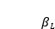) and vapor split (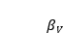) are not suggested to be a manipulated variables because it could cause a serious problem in the operation and controllability of DWC (Mutalib and Smith, 1998; Cho et al., 2009). Therefore, five available manipulated variables namely reflux flowrate (L_{o}), distillate flowrate (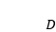), side flowrate (S), bottom flowrate (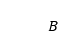), and vapor boilup (V) were used to analysed its interaction to the controlled variables which are distillate, side, and bottom product compositions. For DWC, a combination of three manipulated variables were chosen. Thus, based on the five manipulated variables there a four possible control scheme configuration namely L-S-V, D-S-V, L-S-B, and D-S-B. To determine the best control scheme configuration, the four control schemes were analysed.
Table 5 consists the base case values for the FA fractionation. The open-loop gain was calculated from the step changes on each manipulated variables. The step changes were carried out by changing one manipulated variables at a time while putting the rest of manipulated variables constant at their base case value. For each control schemes configuration, a 10% step change of the base case value on each manipulated variables were applied. The results of the steady-state gain array and its calculated RGA value are presented from Table 6 up to .
Manipulated variables | Value | Controlled variables | Value
Reflux flowrate, L_{o} (kg/h) | 25.74 | LC (wt%) | 0.999
Distillate flowrate, (kg/h) | 0.42 | MC (wt%) | 0.942
Side flowrate, S (kg/h) | 3.45 | HC (wt%) | 0.999
Bottom flowrate, (kg/h) | 1.13
Vapour boilup, V (kg/h) | 35.13
Table 5. FA fractionation base case values

CV | Steady state gain |  |  | Relative Gain Array (RGA),
CV | MV₁= L | MV₂= S | MV₃= V
 | -0.03559  -0.00081  0 | 0  -0.01151  0.00006 | 0.00006  -0.00081  -0.00070 | 0.99999  0.00001  0 | 0  0.99421  0.00579 | 0.00001  0.00578  0.99421
Table 6. Steady state gain matrix and RGA for L-S-V scheme
CV | Steady state gain |  |  | Relative Gain Array (RGA),
CV | MV₁= D | MV₂= S | MV₃= V
 | 0.04524  0.02143  -0.00095 | -0.00551  -0.01206  -0.00009 | -0.00077  0.00032  -0.00075 | 1.22945  -0.26089  0.03143 | -0.26012  1.25206  0.00807 | 0.03067  0.00883  0.96050
Table 7. Steady state gain matrix and RGA for D-S-V scheme

CV | Steady state gain |  |  | Relative Gain Array (RGA),
CV | MV₁= L | MV₂= S | MV₃= B
 | -0.03561  0.00042  -0.00059 | 0  -0.05197  0.00672 | 0  0.00531  0.02513 | 1.00000  0  0 | 0  0.97339  0.02661 | 0  0.02661  0.97339
Table 8. Steady state gain matrix and RGA for L-S-B scheme

CV | Steady state gain |  |  | Relative Gain Array (RGA),
CV | MV₁= D | MV₂= S | MV₃= B
 | 0.10476  0.12976  0.00714 | -0.00029  -0.00490  0.00075 | 0  0.01142  -0.00779 | 1.11392  -0.10542  -0.00851 | -0.11392  1.43829  -0.32437 | 0  -0.33288  1.33288
Table 9. Steady state gain matrix and RGA for D-S-B scheme

According to the RGA priciples, it is strongly recommended to choose the value of relative gains array ( which are positive and closed to one (Chansom wong et al., 2011; Koko and Barakat, 2015). This shows that the control loop between controlled variable, i and manipulated variable, j have a strong interaction and did not effected by the other control loops.
and shows the RGA value for D-S-V and D-S-B configurations. The value of 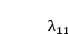 are 1.22945 and 1.11392 respectively. For the first manipulated variable, it indicates that the manipulation of distillate flow did not only affected the distillate composition (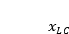), but also experience an interaction with other controlled variables (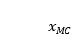 and 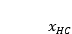) as well. For the second manipulated variables which is side flowrate, these configurations shows the value of 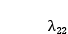 equals to 1.25206 for D-S-V and 1.43829 for D-S-B. This shows that the interaction between side flowrate on side composition (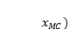 does have an interference from other controlled variables ( and ) too. Finally for the third manipulated variable, the interaction between vapor boilup in D-S-V and bottom flowrate in D-S-B on bottom composition () give the 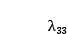 value of 0.96050 and 1.33288. It means that the interaction of control loop under consideration was provoked by the other control loops ( and ).
The other two configurations; L-S-V and L-S-B, on the other hand were selected due to small interaction between the loops. Based on Table 6 and , for L-S-V and L-S-B configurations, the value of equals to 0.9999 and 1.0000 which show that distillate composition () only respond to the manipulation of distillate flowrate and did not respond with other manipulated variables ( and 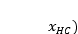. For the second manipulated variable for both configurations which is side flowrate, the value of are 0.99421 and 0.97339, which is close to unity and these indicate that the side flowrate can control the side composition () with a very small interference from other controlled variables ( and ). Same goes to , the effect of manipulated variables of vapor boilup in L-S-V and bottom flowrate in L-S-B on bottom composition 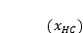 are substantial compared to other controlled variables with the value of 0.99421 and 0.97339 respectively.
Based on the RGA analysis results, the effect of interaction in the D-S-V and D-S-B configurations was higher than unity compared to the L-S-V and L-S-B configurations. In other words, it can be concluded that L-S-V and L-S-B configurations are the best options. With regards to manipulated and controlled variable pairings, the RGA analysis shows that no cross pairing should be implemented on the L-S-V and L-S-B configurations. As a result, the reflux flowrate will control the distillate product (), side flowrate will be controlling the side product (), and bottom vapor boilup would control the bottom product ().

Conclusion
In this paper, a systematic approach of modelling complex distillation column with port and stream connectivity was introduced. The method has been applied to modelling of DWC. The proposed method provides a simpler way to model an EO based process by defining the input/output variables of the unit block and standardizing the variables through the existing unit block equation system. However, some aspects should be thoroughly reviewed particularly in solving a large mathematical problem such as verification/classification of variables, DOF, and model structure. Failure to do so led to errors and unsolved problems. The developed approach had been compared with two case studies for verification and validation purpose and shows good convergence. This approach can be applied on other process system and does not only applicable on DWC. The model were also extended to RGA analysis. For the fatty acid fractionation L-S-V and L-S-B configurations are the best control configurations. The analysis also shows that reflux flowrate, side flowrate and vapor boilup are best to control distillate product, side product and bottom product respectively.
References
1. Aly G, Ashour I. Applicability of the perturbed hard chain equation of state for simulation of distillation processes in the oleochemical industry. Part I: Separation of Fatty Acids. Separation Science and Technology 1992; 27(7): 955–974. http://doi.org/10.1080/01496399208019735
2. Chansomwong A, Zanganeh KE., Shafeen A, et al. A decentralized control structure for a CO2compression, capture and purification process: an uncertain relative gain array approach. IFAC Proceedings Volumes (IFAC-PapersOnline) 2011; 18, 8558–8563. http://doi.org/10.3182/20110828-6-IT-1002.00663
3. Chemtech S, Acid A, Separation A, et al. Separation Technology for the Chemical Process Industry. Switzerland. 2017. Available from https://www.sulzer.com
4. Cho Y, Kim B, Kim D, et al. Operation of divided wall column with vapor sidedraw using profile position control. Journal of Process Control 2009; 19(6): 932–941. http://doi.org/10.1016/j.jprocont.2008.12.003
5. Dunnebier G, Pantelides CC. Optimal Design of Thermally Coupled Distillation Columns, 1999, 162–176.
6. Gani R, Cameron IT., Lucia A, et al. Process Systems Engineering , 2 . Modeling and Simulation. Ullmann’s Encyclopedia of Industrial Chemistry. 2012. http://doi.org/10.1002/14356007.o22_o06
7. Illner M, Othman MR. Modelling and Simulation of a Dividing Wall Column for Separation of Fatty Acid in Oleochemical Industries, 2014; 1–9.
8. IPS Engineering. Oleochemical Processing Plant. 2014. Available from https://www.ips.engineering.it
9. Koko IOM., Barakat TAM. Modelling and Control Analysis of Dividing Wall Distillation Columns 2015; 5(1), 18–25.
10. Kuntsche S, Barz T, Kraus R, et al. MOSAIC a web-based modeling environment for code generation. Computers & Chemical Engineering 2011; 35(11): 2257–2273. http://doi.org/10.1016/j.compchemeng.2011.03.022
11. Marchetti M, Rao A, Vickery D. Mixed mode simulation - Adding equation oriented convergence to a sequential modular simulation tool. Computer Aided Chemical Engineering 2001; 9, 231–236. http://doi.org/10.1016/S1570-7946(01)80034-1
12. Mutalib MIA., Smith R. Operation and Control of Dividing Wall Distillation Columns. Chemical Engineering Research and Design 1998; 76(3): 319–334. http://doi.org/10.1205/026387698524965
13. Nguyen TD., Rouzineau D, Meyer M, et al. Design and simulation of divided wall column: Experimental validation and sensitivity analysis. Chemical Engineering and Processing: Process Intensification 2016; 104, 94–111. http://doi.org/10.1016/j.cep.2016.02.012
14. Pattison RC., Gupta AM., Baldea M. Equation-Oriented Optimization of Process Flowsheets with Dividing-Wall Columns, 2015. http://doi.org/10.1002/aic
15. Sankaranarayanan D, Deepakkumar G. Implementing the Concept of Relative Gain Array for the Control of MIMO System : Applied To Distillation Column, 2015; 4648–4653.

