Ion-Specific effects on equilibrium adsorption layers of ionic surfactants

Stoyan I. Karakashev1

1Department of Physical Chemistry, Sofia University, 1164 Sofia, Bulgaria

**ABSTRACT**

This review article reports on the effect of the counter-ions on the ionic surfactant adsorption layer and its relation to the stability of foams and emulsions. The adsorption theory of Davies about the ionic surfactant monolayer was revisited and it is shown how to account for the type of the counter-ions. The experimental validation of this theory on thin liquid films was shown as well, thus explaining the effect of Hofmeister. However their effect on foams and emulsions is more complex. Furthermore, it is shown how the counter-ions affect in complex way the stability of foams and emulsions via the surfactant adsorption layer in the light of the newest theory. To elucidate the nature of this effect further investigation is called for.

***Keywords:*** Ionic surfactants; ion specific effects; effect of Hofmeister

Corresponding author:

address: 1 J. Bourchier Blvd., Sofia 1164, Bulgaria

tel.: +359-2-8161-283

# 1. Introduction

Hofmeister was the first to report how the solubility of the proteins depends on the added salt[1-7]. Hence, he established that some salts are stronger precipitators than other ones. He found out that both cations and anions act together but the effect of the anions is stronger. Thus, the anions and cations were ordered according to their precipitation abaility:



The ion sequence in the above series is independent of the protein, but their precipitation strength depends on the sign of the protein’s net charge as well. Since that time, it was established that the salts precipitate in the same manner surfactants, colloidal particles and other more complex systems[8]. Evidently, the difference between the ionic parameters (size, polarizability, and ionization potential)[9] make them act differently on proteins, surfactants, colloidal particles, *etc.* A more detailed analysis on the effect of Hofmeister reveals that the ions adsorb on the surfaces of the colloids on different levels, thus affecting differently the interaction between the colloids (protein molecules, solid particles, surfasctants, bubbles, oil droplet, *etc.*). For example, Ninham et al.[10-12] accounted for the van der Waals interaction between inorganic ions and the bubble, thus determing concentration profiles of the different ions, but further met difficulties[13-15]. Tavares et al[16] studied theoretically the Hofmeister effect on the interaction of charged proteins and established that van der Waals interaction causes strong attraction between the molecules. Warszynski et al[17-19] and Aratono et al[20-22] clearly showed experimentally the specific effect of the counter-ions on the state of the adsorption layer of ionic surfactants, but Davies[23, 24] and Borwankar and Wasan[25] showed the way for their theoretical interpretation. Later on Ivanov et al[26-28] combined the approaches of Ninham[10-12] and Davies[23, 24] to produce a relatively simple theory on the specific adsorption of counter-ions within adsorption layer of ionic surfactant. This theory accounts for KCl major factors controlling the ion specific adsorption: the ion polarizability and ionization potential, the radius of the hydrated ion and the possible deformation of the hydration shell upon ion adsorption at the interface. Ref[29] successfully applied this theory to model disjoining pressure of thin liquid films, and emulsion stability between the film surface. We will present here after the basis of this theory along with its attempt to predict the foam and emulsion stability.

# 2. Ion-Specific Effects on the Adsorption Layers of IonicSurfactants from Dilute Solutions

## 2.1 Adsorption in the absence of ion specific effects

It is well known that adsorption of nonionic surfactant with concentration *C*s in scarce adsorption layer is described by Henry adsorption isotherm:

 (1)

Accordingly the Henry equation of state is as follows:

 (2),

where and are the surface tensions of the surfactant solution and the solvent, *R* and *T* are the gas constant and the temperature.

If we assume that the adsorption layer becomes ionized Eq. (1) gets the form:

 (3),

where *F* and are the Farady constant and the surface potential of the adsorption layer with excluded counter-ions.

Next, we regard to Poisson-Boltzmann equation in rectangular reference of state along the axis z:

 (4),

where  is valency of the ion of species *i* , and  and  are dielectric permitivities of the aqueous medium and the free space, while  is the electrolyte concentration of type *i*.

In this equation, the variables  and  (electric field) can be separated, by using the identity 2d2*Ψ*/d*z*2 = d(*E*2)/d*Ψ* . This leads to:

 (5)

A first integral of the Poisson-Boltzmann equation is obtained by integrating Eq. (5) in limits *z* = ∞ to *z*, using as a first boundary condition *E* = 0 and *Ψ*= 0 at *z* = ∞:

 (6)

The second boundary condition (at *z* = 0) is the electro neutrality condition:

. (7)

We will denote the surface potential *Ψ*(0) by *Ψ0s*. Setting *z* = 0 and *ΨΨ0s* into Eq. (6), and eliminating *E*(*z* = 0) from the electroneutrality condition (7), the Gouy equation is obtained :

 (8)

Here

 (9)

is the concentration independent part of Debye parameter:  In the case of 1:1 electrolyte, Gouy equation (7) simplifies to:

 (10)

Here *C*t is the total electrolyte concentration (in units [m–3]) and

 (11)

is the dimensionless positively defined surface potential. At high surface potentials (**s >> 1), a good approximation of Gouy Eq (10) is

 (12)

The ion distribution in the electrical double layer depends on the local potential *Φ*(*z*). Hence, the ion adsorption  of any ion *i* in the diffuse layer can be calculated by using Gibbs definition of adsorption as an excess :

 (13)

where the superscript “DL” indicates counter-ions, co-ions and surfactant ions in the diffuse layer only. Generally, the total surfactant adsorption is a sum of  and the surface concentration **s (adsorption in the adsorption layer). The surfactant ions in the diffuse layer are repelled by the interface since they have the same charge and the surface potential *Φs* is enough high. Hence, the surfactant concentration in the diffuse layer tends to zero and can be neglected. The same refers to the co-ions. Therefore, only the adsorption of the counter-ions in the diffuse layer is important. In order to calculate the integrals defined by Eq. (13), it is convenient to change the integration variable to *Φ*, by using the relation, and neglecting the co-ions in DL, Eq. (13) can be reduced to

. (14)

By using Poisson-Boltzmann equation (4) to obtain expression for d*Φ*/d*z*:

 (15)

One can obtain explicit expression for the adsorptions:

 (16)

To calculate the surface tension, the Gibbs isotherm is used. If only one counterion of concentration *C0i* is present in the system, and the bulk solution is assumed ideal, one has

. (17)

For high surface potential one has = **s. Then, the Gibbs isotherm (17) simplifies to

, (18)

where *C* is the mean ionic activity of the surfactant [30, 31], defined by:

 (19)

If the solution is not ideal, the mean ionic activity *C* in Eq. (19) will include activity coefficient **:

 (20)

Meanwhile the combination of equations (3) (Henry adsorption isotherm for ionic surfactants) and (12) (Gouy equation) produce the following important relation[23, 28]:

. (21)

Eq. (21) shows that the surface potential **s increases with *C*s and *K*s (due to the increased adsorption) and decreases with the total electrolyte concentration *C*t (due to the additional screening effect of the electrolyte on the surface charge). Inserting back the surface potential (21) into the isotherm (3), one obtains a generalization of Henry isotherm for adsorption of ionic surfactants:

, (22)

where *C* is given by Eq. (19), and *K*0 is adsorption constant of the ionic surfactant. It is related to Henry constant *K*s:

. (23)

The fact that according to Eq. (22) **s depends only on the mean ionic activity *C* is an explicit formulation of what is known as salting out effect on ionic surfactant adsorption[31]. Eq. (22) has been first derived and confirmed by experimental data for CnH2n+1SO4Na at air/water interface by Davies[23]. We will refer to it as Davies isotherm. By using the procedure of Borwankar and Wasan[25], and Ivanov et al derived Eq. (22) and obtained the explicit expression (23) for *K*0. According to Eq (23), *K*0 should not depend on the electrolyte concentration, at least for moderate concentrations. Substituting Eq. (22) in the Gibbs isotherm (18) and integrating, one obtains Davies equation of state[32]:

 (24)

Equation (24) does not account for the specific effect of the counter-ions. Hence, according to this equation if the counter-ion of one ionic surfactant is replaced by another counter-ion its surface activity will not change. The latter controversies to the experimental data[33]. For this reason the real equilibrium adsorption constant *K*, in which the specific adsorption of counter-ions is accounted for, has been modelled[26] by the following relation:

 (25),

where *kB* is the Boltzmann constant, and *u0* is the specific adsorption energy of the surfactant’s counter-ion.

## 2.2 Adsorption in the presence of ion-specific effects

To account for the specific adsorption of the counter-ions into the surfactant adsorption layer, one should account for the correction, which they cause to the electric potential in the Poisson-Boltzmann equation:

 (26)

where *ui*(*z*) is the specific interaction between the ion and the interface[26, 28] given by the relation:

. (27)

Here *Ri* is the ionic radiusand *ui*0 is the van der Waals energy of an ion in the plane *z* = 0 situated at distance *Ri* from the interface as shown in Fig.1. This equation can be integrated by analogy with the derivation of Gouy equation (10), by using 2d2*Φ*/d*z*2 = d(*E*2)/d*Φ* and Gauss condition (7):

 (28)

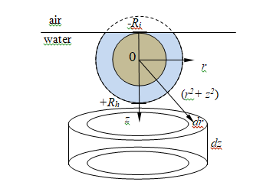

**Figure 1.** Illustration of the integration procedure applied to derive the energy of interaction of surface ion with the whole bulk of water[26].

At high surface potentials, only the counterions need to be taken into account in the sum in the right-hand side of this equation. This approximation is of crucial importance for this theory for it simplifies all following calculations. It can be used also in the case of ionized proteins and polymers as well, but not for the adsorption of simple electrolytes. In such a case, both cations and anions have comparable participation in the diffuse layer whose local potential depends, in fact, on the small difference of their local concentrations. With this approximation, the integrals in the right hand side of Eq. (28) can be reduced to a generalized Gouy equation , accounting for the ion specific effect:

 (29),

where **0 isthe Debye parameter is given by Eq (9), andis surface potential of adsorption layer situated on the phase boundary not containing counter-ions. If only one counterion is present in the system, Eq. (29) simplifies to

 (30)

Substituting here the expression for , Eq.(23), one obtains expression of Davies adsorption isotherm (22), **s0 = *K*0*C*2/3, accounting for ion specific interactions:

 (31)

Here *C* is the mean activity. Therefore, one can obtain the following expression for the equilibrium adsorption constant accounting for the ion-specific effects:

 (32)

This procedure allows also the determination of the first iteration for the real surface potential **s. To do so, the equation of state (3) is used, with **s given by Eq. (31). After solving the result with respect to *Φs*, one obtains

. (33)

Considering the above equations, one can obtain the following relations:

, . (34),

where  and are surfactant adsorption containing and not containing counter-ions, and and dimensionless surface potentials containing and not containing correction from the adsorption of counter-ions. Hence, Eq. (24) gets the form:

 (35)

Eq. (35) is valid for liquid expanded state of the adsorption layer, which is medium term level of occupation of the latter. Moreover, the constant is not anymore the surface tension of the solvent (water), but cohesion constant.

The next step is modelling the specific adsorption energy of the counter-ions onto the air/water interface.

## 2.3 Theory on adsorption of ions on the air/water interface

The adsorption of inorganic ion on the air/water interface may seem inappropriate at first glance due to the image repulsion[34], but one should account for the displaced surface water molecules by the adsorbed inorganic ion. The latter can make this adsorption energetically favorable. For this reason the effect of Ray-Jones[35] appears at small salt concentrations (up to 0.1 M).

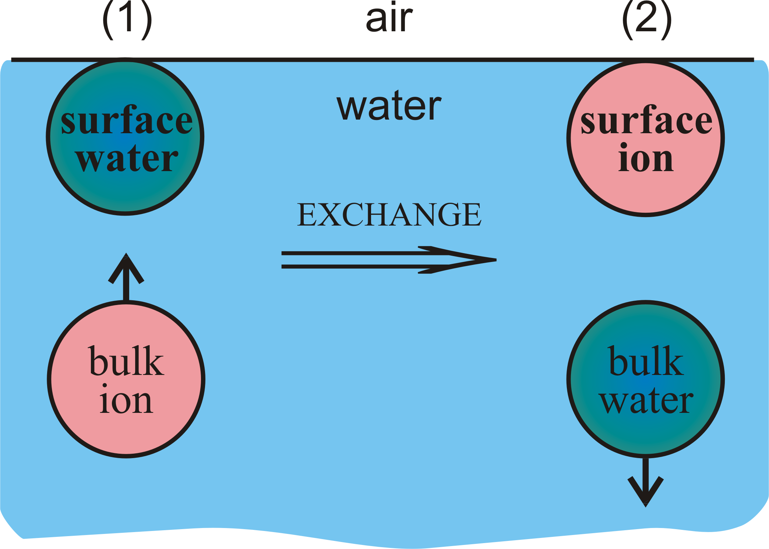

**Figure 2.** Energetical states prior and after the adsorption of ion on air/water interfaceWe assume that one ion displaces *Nw*  water molecules from the air/water interface, and the latter dive into the bulk. Shown in Fig. 2 are the energetical states 1 and 2 of the adsorption of inorganic ion on the air/water interface. Energetical state 1 consists of inorganic ion in the bulk and *Nw* water molecules at the air/water interface. Both of them interact with the whole bulk of water molecules. Energetical state 2 consists of inorganic ion at the air/water interface and the displaced *Nw* water molecules being already into the bulk. Again both of them interact with the whole bulk of water molecules. The energy of the very process is the difference between the energies of the two states:

 (36),

where is the energy of interaction of the surface ion with the whole bulk of water, is the energy of interaction of *Nw* water molecules located in the bulk with the whole bulk of water molecules, is the energy of interaction of one inorganic ion located in the bulk with the whole bulk of water, is the energy of interaction of *Nw* water molecules located on the air/water interface with the whole bulk of water,  is the difference between energetical states of ion on the surface refered to the bulk, and finally is the difference of the energetical states of *Nw* water molecules on the surface referred to the bulk. To calculate the specific energy of adsorption  of one ion on the air/water interface, one need to calculate each one of the above mentioned quantities[26,28]. Moreover, a special accent[26,30] is put on the compressibility of the hydration shells – there are certain ions, called kosmotrops[36,37] (or structure making, e.g. Li+, Na+, F-), whose hydration shell do not deform upon their adsorption on the air/water interface, while the hydration shells of all the other ions, called chaotrops[36,37] (or structure breaking, e.g. K+, Cl-, Br-, NO3-, *etc.*), redistribute in such a way during their adsorption on the air/water interface that the upper part (toward air) of the ion becomes bare, while the lower part (toward the bulk) becomes over-occupied with hydrated water molecules (see Fig.3). The calculation of the energy *ui*0 was performed, using the London expression for the intermolecular potential *uij* between molecules of type *i* and *j* at a distance *rij* [34]:

, (37)

where the London constant *Lij* is related to the static polarizbilities *α*p,*i* and *α*p,*j* and the ionization potentials *Ii* and *Ij* of the interacting species:

 (38)

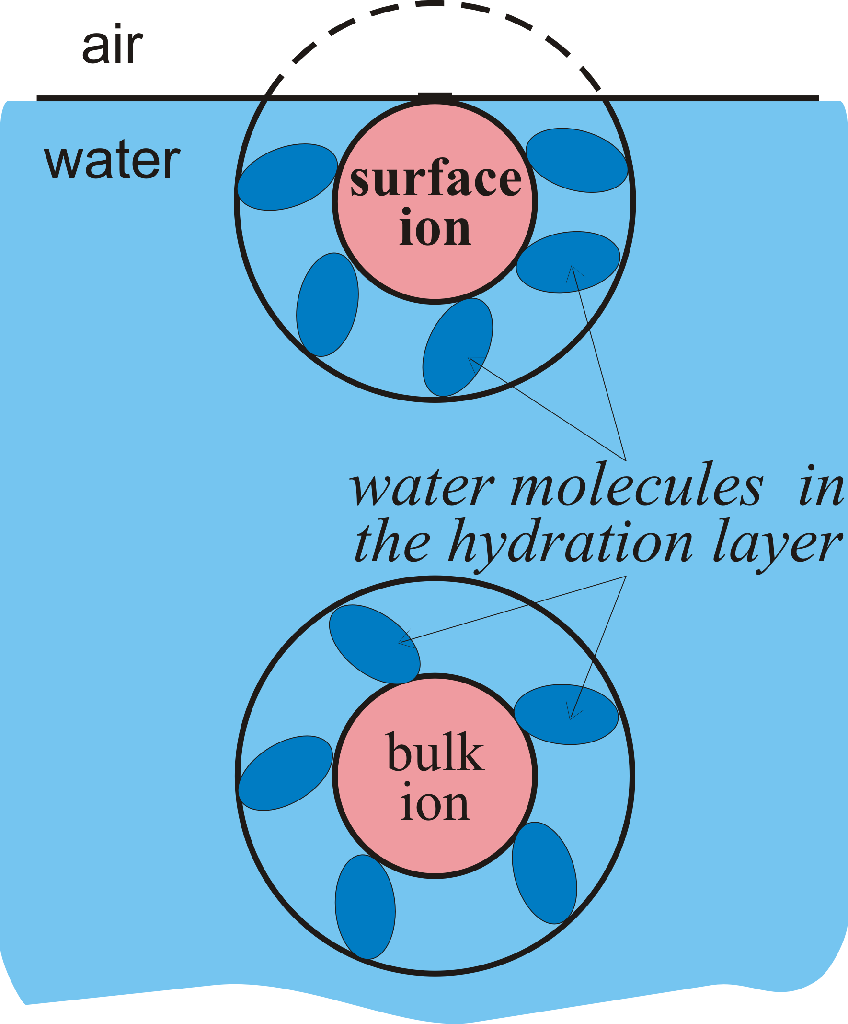

**Figure3.** Redistribution of the hydration shell during the adsorption of ion on the air/water interface. Reprinted with permission from ref`. Copyright 2007 Elsevier;

We will calculate first the energy of interaction  of the chaotropic type of ions situated on the air/water interface with the whole bulk of water. Toward this aim, the London potential (36) is integrated over the volume of the water phase excluding the hydration shell, with *rij* being the distance between the volume element d***r*** and the ion positioned at *r* = 0, *z* = 0 (that is, the integration is over *z* > –*R*b and *r*2 + *z*2 <). The integration is performed in cylindrical coordinates (see Fig.1):

 (39)

here **w is the particle density of water. Similarly, the energy  of interaction of ion located in the bulk with the whole bulk of water (integration in spherical coordinates)

 (40)

The respective energies of the ensemble of water molecules (assumed a sphere of radius *R*h, or a part of it) are:

;  (41)

Substituting Eqs. (39)-(41) into the expression (34) for *ui*0, one obtains an explicit relation of the adsorption energy of the chaotropic ions (called here ions of type I):

. (42)

To calculate *ui*0 for the kosmotrops (called here ions of type II), one must set *R*h = *R*b in Eq. , which simplifies the expression to

. (43)

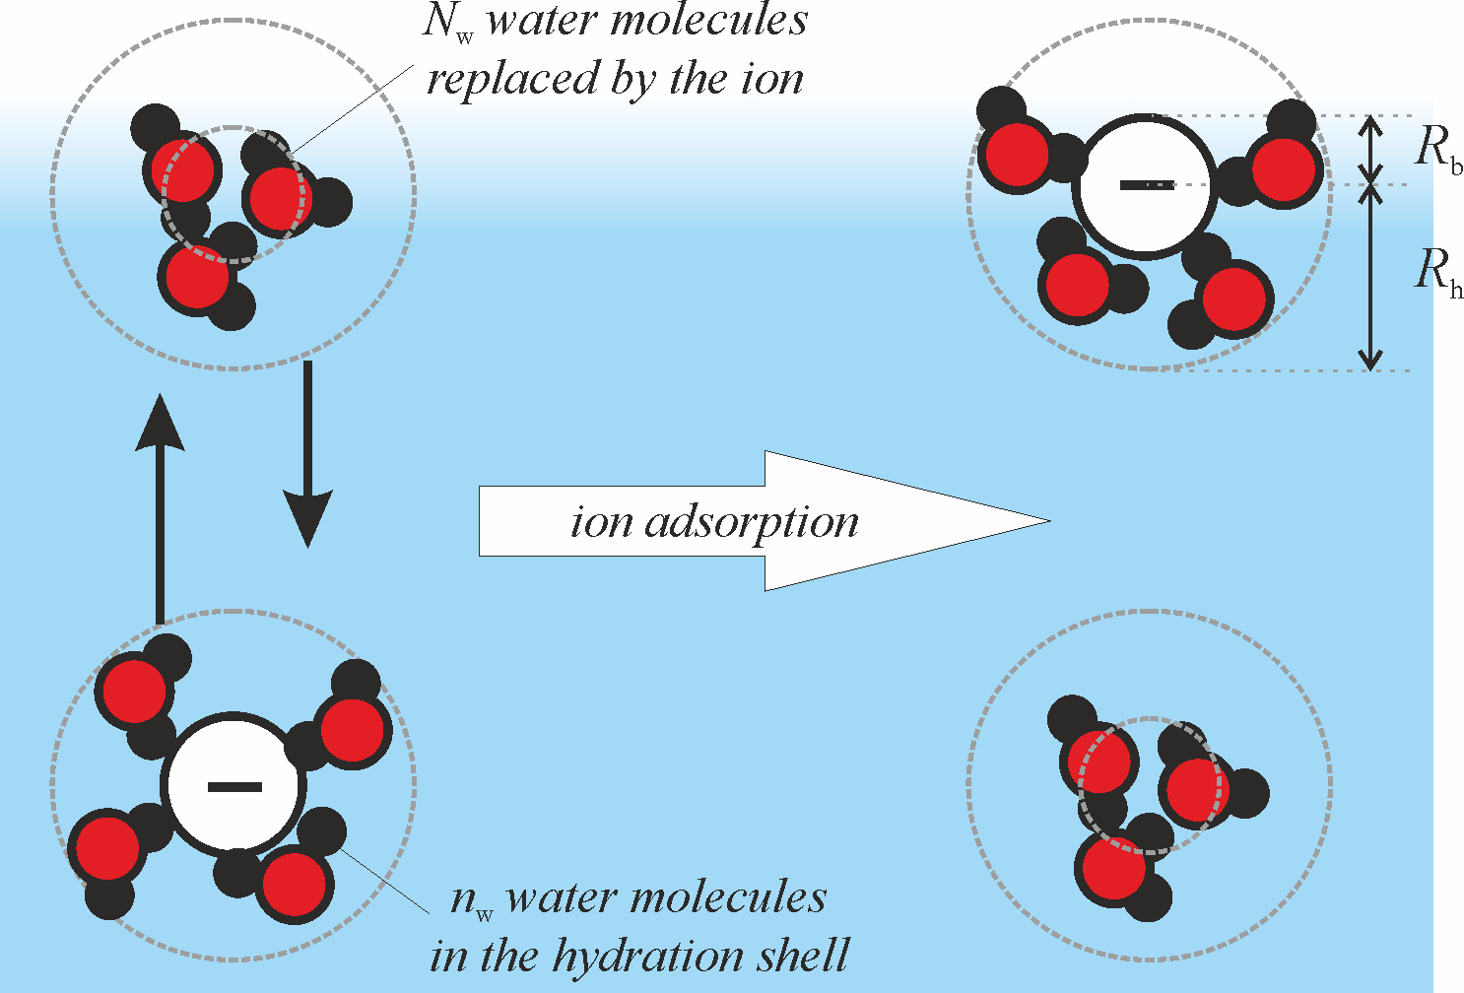

**Figure 4.** Scheme of the process of adsorption of a type I ion. *Left*: ion in the bulk. *Right*: ion at the surface. The *n*w hydrating water molecules might be pushed away by the interface, so that the shortest distance of approach of the ion to the interface is the bare ion radius *R*b. Upon adsorption, the ion replaces an ensemble of *N*w water molecules. For type II ions, the shortest distance of approach of the ion to the interface is the hydrated ion radius *R*h.

For monovalent ions, Marcus[38] found that the hydration number *n*w of the ions can be represented by the empirical relation

*n*w = *Av*/*Ri*, (44)

where *Av* = 3.6 Å for all ions. He further assumed that the hydrating *n*w water molecules, considered as spheres with radius *R*w = 1.38 Å and volume *v*w = 11 Å3, are squeezed around the ion, forming a layer of thickness *R*h – *R*b and volume:

 (45)

The last relation can used to calculate *R*h. The values of *n*w and *R*h calculated in this way[26,38,39] are shown in Table 1. Robinson and Stokes[30] used similar approach, but with water molecular volume *v*w = 30 Å3, which follows from the density of water. They also used different values of the hydration number *n*w, which were calculated from the ion diffusivity

The London constants *L*iw for the interaction ion-water molecule, and *L*ww for the interaction of *N*w water molecules with a single water molecule are calculated directly from Eq :

, . (46)

For the calculation of *L*ww, the ensemble of *N*w water molecules is regarded as a sphere with polarizability *N*w**p,w[26]. The number *N*w was assumed equal to the ratio between the volume of the bare ion and the volume of one water molecule[40]:

, (47)

where *R*w is the radius of the water molecule. For the value of *R*w, two possibilities were tested in Ref[26]: (**i**) the average volume per molecule (30 Å3), based on the water density, yields *R*w = 1.93 Å; and (**ii**) the proper volume of a water molecule, 11 Å3, corresponds to *R*w = 1.38 Å. Better agreement with the experimental data was obtained with the second option, *R*w = 1.38 Å. The used value of the static polarizability of water was *α*p,w = 1.48 Å3 and of the ionization potential was *I*w = 2.0210-18 J[41].

For the cations, we used the second ionization potential, since the first one corresponds to ionization of the respective atom, not ion. Since the anions have already accepted one extra electron, their ionization potential must be equal to the negative value of the electron affinity.

|  |  |  |  |  |  |  |  |  |  |  |
| --- | --- | --- | --- | --- | --- | --- | --- | --- | --- | --- |
| **cation** | ***R*b[Å]** | ***n*w**  **Eq** | ***R*h[Å]**  **Eq** | ***N*wEq** | ***L*ww**  **Eq**  **[m6J] ×1080** | ****p,*i***  **[Å3]** | ***Ii***  **[J] ×1018** | ***L*w*i***  **Eq**  **[m6J] ×1080** | ***ui*0*/k*B*T***  **type I**  **Eq** | ***ui*0*/k*B*T***  **type II**  **Eq** |
| Li+ | 0.691 | 5.22 | 2.41 | 0.13 | 41.5 | 0.031 | 12.12 | 11.5 |  | –0.09 |
| Na+ | 1.021 | 3.53 | 2.18 | 0.40 | 134 | 0.153 | 7.582 | 53.1 | –0.33 |
| NH4+ | 1.534 | 2.35 | 2.14 | 1.36 | 453 | 1.641 | 2.132 | 378 | –0.61 |  |
| K+ | 1.411 | 2.55 | 2.12 | 1.07 | 354 | 0.793 | 5.072 | 253 | –0.90 |
| Rb+ | 1.655 | 2.18 | 2.17 | 1.71 | 568 | 1.41 | 4.412 | 431 | –0.98 |
| NMe4+ | 2.801 | 1.29 | 2.94 | 8.36 | 2770 | 9.081 | 2.432 | 2220 | –1.05 |
| **anion** | ***R*b[Å]** | ***n*w** | ***R*h[Å]** | ***N*w** | ***L*ww**  **[m6J] ×1080** | ****p,*i***  **[Å3]** | ***Ii* [J] ×1018** | ***L*w*i***  **Eq**  **[m6J] ×1080** | ***ui*0*/k*B*T***  **type I** | ***ui*0*/k*B*T***  **type II** |
| Ac– | 1.651 | 2.18 | 2.17 | 1.71 | 568 | 5.501 | 0.5441 | 545 |  | –0.185 |
| OH– | 1.331 | 2.71 | 2.11 | 0.90 | 297 | 2.041 | 0.3451 | 134 | –0.736 |
| F– | 1.331 | 2.71 | 2.11 | 0.90 | 297 | 1.042 | 0.5451 | 99.1 | –0.891 |
| Cl– | 1.641 | 2.20 | 2.17 | 1.68 | 557 | 3.592 | 0.5801 | 359 | –1.43 |  |
| Br– | 1.951 | 1.85 | 2.31 | 2.82 | 937 | 5.072 | 0.5401 | 480 | –2.32 |
| NO3– | 2.001 | 1.80 | 2.33 | 3.05 | 1010 | 3.931 | 0.6311 | 420 | –2.83 |
| N3– | 1.951 | 1.85 | 2.31 | 2.82 | 937 | 4.451 | 0.4441 | 360 | –2.93 |
| ClO4- | 2.401 | 1.50 | 2.61 | 5.26 | 1750 | 5.252 | 0.7581 | 642 | –3.28 |
| BF4- | 2.301 | 1.57 | 2.53 | 4.63 | 1540 | 2.801 | 0.9021 | 388 | –3.84 |

## **Table 1.** Specific adsorption energies of the considered ions (*T* = 25°C). *R*b – bare ion radius; *n*w – hydration number, Eq. (44); *R*h – hydrated ion radius, Eq. (45); *N*w – number of water molecules in the ensemble, replaced by the ion upon adsorption, Eq. (47); *L*ww – London constant of this ensemble, Eq. (46); **p,*i* – polarizability of the ion; *Ii* – second ionization potential of the cations and negative electron affinity of the anions; *ui*0 – ion specific adsorption energy, Eq. (42) for type I ions (no deformation of the hydration shell) and Eq. (43) for type II ions (with deformation of the hydration shell). The ions in the Table are ordered by increasing absolute values of *ui*0. The sequence of both cations and anions is the same as in Hofmeister series, but for the cations this order corresponds to increasing efficiency as opposite to the series. Source data: 1 Marcus[38]; 2 Nikolskij[41]; 3 Tavares[16]; 4 Dietrich[42]; 5 Lide[43].3. Comparison with experiment

### 3.1 Experimental verification of the theory of *K*

Experiment on surface tension isotherms of 0.5 mM sodium dodecyl sulfate (SDS) [44] at varying excess concentration of LiCl, NaCl and KCl showed significant differences due to the specific adsorptions of Li+, Na+, and K+ counterions.

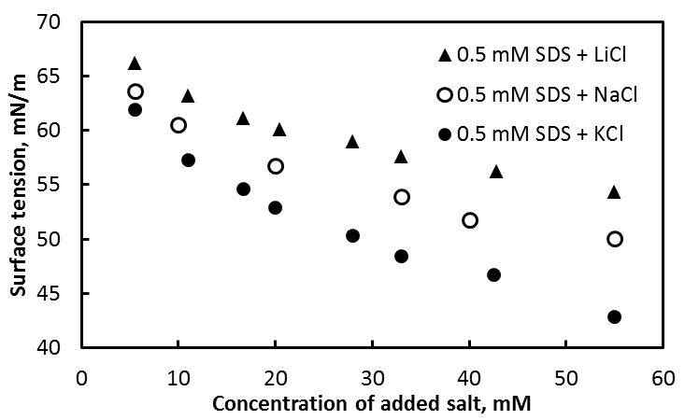

**Figure 5.** Surface tension isotherms of 0.5 mM SDS + added salts; The relative experimental error is ±0.2 mN/m.

The first experimental check will be the linearity of Eq. (35). We present hereafter the three adsorption isotherms in the scale of Eq. (35) and in CGS system. The concentration is converted in activity as well. The mean concentration is converted in mean activity.

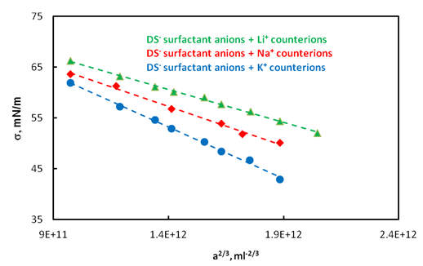

**Figure 6.** Surface tension isotherms of 0.5 mM SDS + added salts; The relative experimental error is ±0.2 mN/m.

One can see that Fig.6 shows linear dependencies of the surface tension on the mean activity on 2/3 power (a2/3). Therefore Eq. (35) () is validate by the experiment. Moreover, one can calculate the equilibrium adsorption constants *K* for each one of the cases from the slope (see Eq. (35)). Furthermore, Eq. (32) can be presented in the form

 (48).

As far as the equilibrium adsorption constant  can be obtained experimentally by means of Eq. (35) and experimental surface tension isotherm, and can be calculated independently by means of Eqs. (42) and (43) (see Table 1), ln*K* can be presented as a function of . Figure 7 shows that ln*K* depends linearly on the specific adsorption energy of the counterions  and the slope is close to ½, which is validation of Eq. (48).

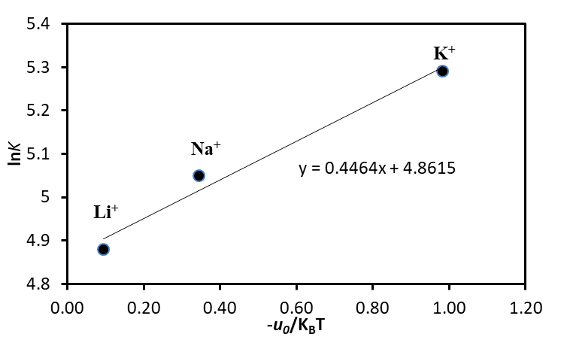

**Figure 7.** lnK as a function of for the cases SDS + LiCl, SDS + NaCl and SDS + KCl. In all of the cases the salt is added in great excess.

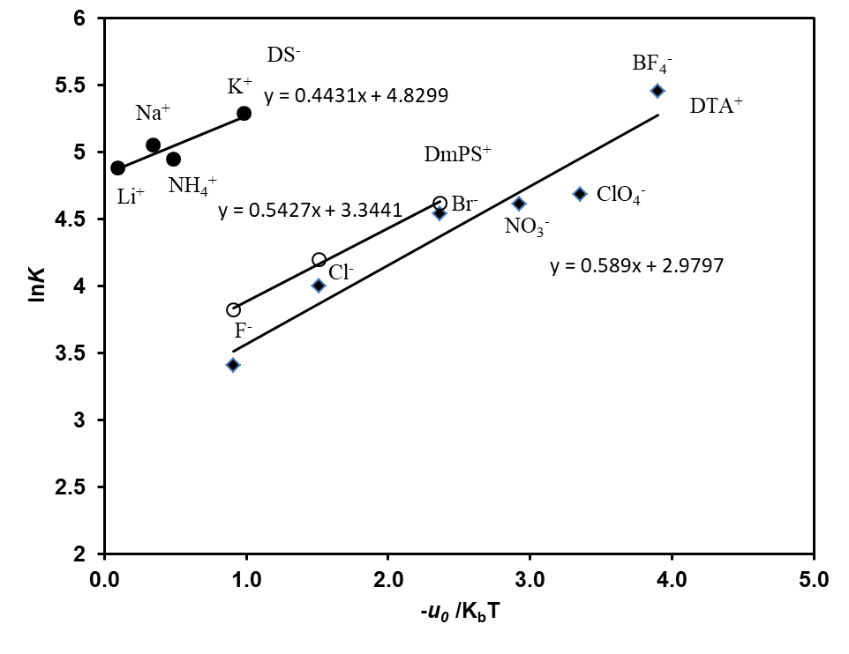

**Figure 8.** lnK as a function of for the cases (1) SDS + LiCl, SDS + NaCl, SDS + NH4Cl, SDS + KCl; (2) DmPSCl + NaF, DmPSCl + NaCl, and DmPSCl + NaBr; and (3) DTAB + NaF, DTAB + NaCl, DTAB + NaNO3, DTAB + NaClO4, and DTABF4[28].

Shown in Fig.8 is presented ln*K* vs.  for three types of surface active ions in presence of different counterions. In all of the cases the slope of the line is close to ½, which validates well the presented above theory. The main question, remaining is if this theory can predict the stability of dispersed systems.

## 3.2 Ion-Specific Effects on the Stability of Dispersed Systems and Relation to State of the Adsorption Layer[29, 44]

3.2.1 Ion-Specific effects on thin films and emulsionsThe ion-specific effects on the state of the adsorbed surfactant layer influence the stability of foams and emulsions. This section is devoted to the investigation of the type of the surfactants counter-ion on the stability of the dispersed systems. It presents the experimental data of Ref.[29] and such one conducted in the present work.

Ref.[29] presents experimental data on the disjoining pressure of water films in air (foam films) stabilized by 1 mM solutions of hexadecyltrimethylammonium bromide (C16H33NMe3Br) and 9 mM added salt (NaF, NaCl, NaBr).

The disjoining pressure, stabilizing the films, was measured on a thin film pressure balance by using the Mysels-Jones porous plate technique (see Fig. 9)

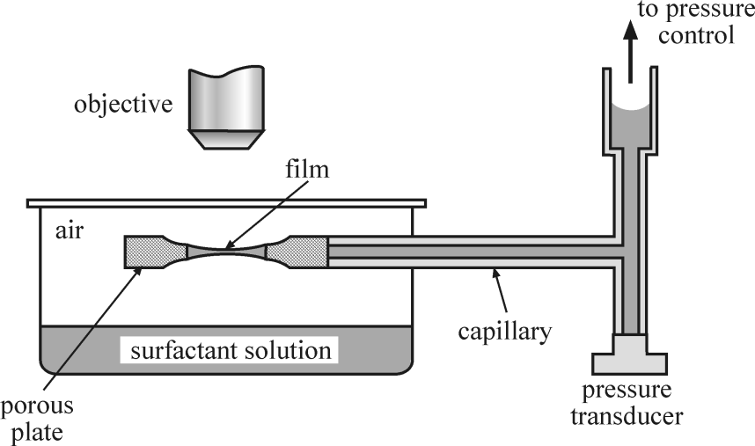

**Figure 9.** Schematic presentation of the porous plate cell

The main question, which we raise is how the type of the counter-ions affect the stability of foams and emulsions. We know from the previous sections that the counter-ions with a higher absolute value of the specific adsorption on air/water or oil/water interfaces are integrated onto the surfactant adsorption layer in larger degree and vice versa. Hence, at a higher level of counter-ion adsorption the surface potential should be decreased more and vice versa. The theory of the electrostatic disjoining pressure has been developed by many authors, above all by Derjaguin and associates. Their results are summarized in the excellent book of Churaev et al.[45]. According to their theory (neglecting the ion specific effects) the electrostatic disjoining pressure, *el*, in a planar film of low surface potential or large thickness is given by the following expression:

 (49)

where *Ct*is total salt concentration, κ is the Debye constant and *h* is the thicknss of the thin liquid film. Since during the derivation of Eq. (49) in Ref.[45] no other assumptions about the surface potential were done, we decided that in order to account for the specific effects it should be sufficient merely to replace  with by means of the following equation:

 (50)

Eq. (49) suggests that the dependence of the experimental disjoining pressure Π on the thickness *h* should be close to linear in coordinates ln Π vs. *h*. Fig. 10 shows that indeed this is the case. Since the films are rather thick, one can disregard the contribution of the van der Waals disjoining pressure (direct numerical calculations confirmed this). This permits identifying  with *el* and using Eq. (49) for the calculation of , but with replacing. The lines in Fig. 10 are almost parallel and obey the equation

 (51)

The obtained intercepts ln0 and slopes κ are shown in Table 2



**Figure 10.** Plot of ln  vs. h for foam films stabilized with C16H33NMe3Br and NaX (X = F–, Cl–, Br–).

|  |  |  |  |
| --- | --- | --- | --- |
| Ion | F– | Cl– | Br– |
| ln 0 [Pa] | 8.79 | 8.25 | 7.65 |
| κ [nm-1] | 0.0485 | 0.0451 | 0.0386 |

**Table 2.** Intercepts, ln 0, and slopes, κ, of the lines in Fig. 10

The almost parallel, but shifted, lines suggest that the specific ion interactions (if any) are affected mostly the surface potential . By means of Eq. (49) we calculated the experimental values of  from the obtained data for 0 (see Table 3) and plotted in Fig. 11 the results as vs. –*u*0*/k*B*T*. The relatively good linearity and close value of the experimental slope, 0.4, to the theoretical one, ½, (cf. Eq.(50)) seem to confirm the role of the ion specific effect.



**Figure 11.** Combined surface potential vs. –u0/kBT for foam films stabilized with C16H33NMe3Br + NaX (X = F–, Cl–, Br–). The slope is –0.4.

The Hofmeister effect on the surface potential and the disjoining pressure, Π, is by no means negligible. To setimate it for films closer to reality, in Fig. 12 we present the results (obtained in Ref.[26]) for the total disjoining pressure Π*total* (including also the van der Waals contribution with Hamaker constant *A*H = 4×10−20 J) of foam films with 0.5 mM of the halide counterions. The maxima of Π(*h*) around *h* = 5 nm control the stability and the coalescence of the bubbles. The maximum is more than 4 times lower in the presence of only 0.5 mM Br than it would have been with the same electrolyte concentration if the ion specific effects were disregarded.



0.91, F–

1.49, Cl–

0.00

2.33, Br–))

**Figure 12.** Total disjoining pressure Πtotal calculated with Hamaker constant AH = 4×10−20 J for 0.5 mM counterions F–, Cl– and Br– (from Ref.[26]).

Ref.[29] reports on the emulsion stability measured by means of two types of techniques – Film Trapping Technique (FTT) and Centrifugation. They used the same surfactant (C16H33NMe3Br) and salts (NaF, NaCl or NaBr). The concentrations of the surfactant and the added salts for FTT were the same as in the thin film studies described here above, but for the centrifugation the emulsions with 1 mM salts were too unstable, so that the concentrations of the added salts were increased to 30 mM. Soybean oil, purified by passing it through a glass column filled with Silicagel 60 adsorbent, was used as oil phase.

The film trapping technique (FTT), developed in Refs.[46-49] is a useful method for determining the coalescence stability of single emulsion drops. The principle of the FTT is the following: A vertical capillary, partially filled with oil, is held at a small distance above the flat bottom of a glass vessel, Fig. 13. The lower edge of the capillary is immersed in the working solution, which contains dispersed micronsize oil drops. The capillary is connected to a pressure control system, which allows one to vary and to measure precisely the difference, Δ*P*A, between the air pressure in the capillary, *P*A, and the atmospheric pressure, . The pressure is measured by a pressure transducer connected to a personal computer. Upon the increase of *P*A the oil-water meniscus in the capillary moves downward against the substrate. When the distance between the oil-water meniscus and the glass substrate becomes smaller than the drop diameter, some of the drops remain entrapped in the formed glass-water-oil layer. The pressure *P*A is increased until the coalescence of the entrapped oil drops with the upper oil phase is observed. The capillary pressure in the moment of drop coalescence, , represents the coalescence barrier and is called *critical capillary pressure*. It is related to Δ*P*A in the moment of drop breakage and can be calculated from the equation:



**Figure 13.** Scheme of the film trapping apparatus and of the droplets trapped between the oil-water and the substrate (see the magnification lens), from Ref[49].

, (52)

where Δ*P*OIL is the pressure jump across the oil column in the capillary. It includes contributions from the hydrostatic pressure of the oil column and the capillary pressure of the air|oil meniscus. It is measured after filling the FTT capillary with oil but before immersing the capillary into the water pool. In the hydrostatic term *z* is the depth of the water (see Fig. 13), ρ is the water mass density and *g* is gravity acceleration. The trapped oil drops and the coalescence process were observed from above with an optical microscope.

#### The test of the emulsion stability by means of centrifugation in described in details in Ref.[29]. Oil-in water emulsions were prepared by stirring for 4 min a mixture of 40 mL water phase and 10 mL soybean oil (20 vol. % SBO) with a rotor-stator homogenizer, Ultra Turrax T25 (Janke & Kunkel GmbH & Co, IKA-Labortechnik), operating at 13 500 rpm. The drop size d32 was determined by optical microscopy of specimens of the studied emulsions in transmitting light with a microscope. After 30 min storage the fresh emulsions were transferred into several centrifugal tubes and centrifuged at 25 °C in 3K15 centrifuge. The emulsion stability is characterized by the critical osmotic pressure, , at which a continuous oil layer is released at the top of the emulsion cream in the centrifuge tube. is calculated from the experimental data by using the equation :

 (53)

where Δρ is the difference between the mass densities of the aqueous and the oil phases; gk is the centrifugal acceleration (gk = Lω2, where L is the distance between the axis of rotation and the center of the cream, ω is the angular velocity); VOIL is the total volume of oil used for preparation of the emulsion; VREL is the volume of released oil at the end of centrifugation; and A is the cross-sectional area of the centrifuge test tube.

The results from both tests are presented in Table 3 and Fig. 14.

|  |  |  |  |  |  |  |
| --- | --- | --- | --- | --- | --- | --- |
| *Ct* [mM] | *Cs*[mM] | *Cel* [mM] | Electrolyte | *d*32 [m] | FTT,  [Pa] | Centrifuge,  [Pa] |
| 10 | 1 | 9 | NaF | 25.2 | 360 | - |
| 10 | 1 | 9 | NaCl | 28.5 | 1100 | - |
| 10 | 1 | 9 | NaBr | 27.0 | 1320 | - |
| 31 | 1 | 30 | NaF | 20.7 | - | 360 |
| 31 | 1 | 30 | NaCl | 22.4 | - | 640 |
| 31 | 1 | 30 | NaBr | 21.5 | - | 917 |

**Table 3.** Critical pressures and drop sizes of SBO-in-water emulsions, stabilized with 1 mM C16H33NMe3Br with added NaF, NaCl and NaBr.

The systems parameters and the measured values of the critical pressures  and  are tabulated in Table 3 and plotted in Fig. 14 as  (solid line) and  (dashed line) vs. –*u*0*/k*B*T*. These critical pressures are proportional to Π and the higher their values are, the more stable the emulsions.



**Figure 14.** Critical pressures  (by FTT, solid line) and  (by centrifugation, dashed line) vs. –u0/kBT of oil-in-water emulsions stabilized by C16H33NMe3Br + NaX (X=F–, Cl–, Br–). () of oil-in-water emulsion films stabilized by 10-3 M C16H33NMe3Br + 9×10-3 M NaX (X=F–, Cl–, Br–) obtained by FTT (slope = 0.85); (•)  of oil-in-water emulsion films stabilized by 10-3 M C16H33NMe3Br + 3×10-2 M NaX (X=F–, Cl–, Br–) obtained by centrifuge (slope=0.63).



**Figure 15.** Total disjoining pressure *total* in the maxima in Fig. 12 vs. –*u*0/*k*B*T.*  This is in fact the coalescence barrier, according to DLVO theory.

We do not dispose of enough information to carry out the same detailed analysis of these phenomena as we did with the electrostatic disjoining pressure. For example, we have no idea what the film thickness is; it is not quite clear whether a planar film forms or how much the disjoining pressure is affected by the curvature of the very small drops-these effects make problematic the calculation of the electrostatic disjoining pressure by means of Eq. (49). Still, some qualitative conclusions are possible. The linear dependence of  and  on –*u*0*/k*B*T* confirms the presence of specific effects. However, instead of decreasing with the increase of –*u*0*/k*B*T* (as the electrostatic disjoining pressure does) the critical pressures are increasing. Therefore, the electrostatic disjoining pressure Πall is not the repulsive pressure to be overcome in order for the coalescence to occur. But then, what is the reason for the ion specific effect, demonstrated in Fig. 14? It is not possible to answer with certitude this question without detailed studies of the phenomena accompanying the coalescence process. Nevertheless we dare suggesting a hypothesis. The role of the specific effect of the counterions is twofold. On one side, it decreases the height of the maxima of the disjoining pressure (see Fig. 15) thus making easier for the thin film to avoid the electrostatic repulsive pressure and to thin to thinner (metastable) Newton black film, where another, short range repulsive disjoining pressure (most probably steric or osmotic) might be operative. It must be overcome for the thin film to rupture. On the other side, no matter what the nature of this disjoining pressure is, it must increase with the surfactant adsorption, Γ. However, unlike the electrostatic disjoining pressure, the surfactant adsorption, Γ, increases (for a given bulk surfactant concentration) with –*u*0*/k*B*T* .This brings us to the second role of the ion specific effects – it is to increase the short range repulsive pressure created by the surfactant, thus stabilizing the thin film. This explains why the slopes of the lines in Fig. 14 are positive. They should have been negative if only the electrostatic disjoining pressure Π*el* were stabilizing the film. To support this opinion in Fig. 15 we have plotted the maxima of Π*total* from Fig. 12 (which are in fact the coalescence barriers) vs. –*u*0*/k*B*T* –indeed, the slope is negative. This means that the short range repulsive pressure involved in the stability of the emulsion drops is not directly related to ion specific effects. The theoretical and experimental verification of this hypothesis is feasible, but it is time consuming and beyond the scope of this paper.

### 3.2.2 Ion-Specific effects on foams

We have established that the stability of the emulsions increases upon enhancing the specific adsorption energy of the counter-ions. This tendency was not expected.

For this reason, we were challenged to investigate this scientific “intrigue” deeper. We have chosen another system – foam stabilized by sodium dodecyl sulfate (SDS) and LiCl, NaCl and KCl as salts, which were meant to be added in an amount significantly exceeding this one of the surfactant.

We clearly showed hereafter that the electrostatic repulsion between the bubbles, which is controlled by the added counter-ions, is only one of the factors contributing to foam stabilization. The counter-ions strongly affect the level of surfactant adsorption as well. The latter appear to be decisive for the stabilization of the foam and the foam films. We show as well some new effects originating from the counter-ions, which have practical significance.

Sodium dodecyl sulfate (SDS) with molecular weight Mw = 288.38 Da, an anionic surfactant, lithium chloride (LiCl) with molecular weight Mw = 42.29 Da, sodium chloride (NaCl) with molecular weight Mw = 58.44 Da, and potassium chloride (KCl) with molecular weight Mw = 74.55 Da were purchased from Sigma Aldrich. The surfactant was purified by threefold re-crystallization in ethanol.

SDS salt mixture solutions were prepared as follows. Initially, using SDS, 0.5 mM aqueous solution was prepared. Then, LiCl, NaCl and KCl, were added, thus forming salt solutions with concentrations in the range of 2.5 mM, to 50 mM. As far as the foaming ability of every surfactant solution is expressed in both the initial foam volume upon the very generation of foam and the lifetime of the latter, we chose to work with the ratio between the two values, called foam production[50]. The foam was produced by means of the Bartsch method expressed in energetical tenfold shaking of Bartsch column containing 50 ml of the surfactant solution. Each experiment was repeated at least 3 times for statistical certainty an the averaged initial foam volume and lifetimes were determined. Thus, the foam production for every particular case was calculated. The basic results are presented in Fig. 16.

One can see that the foam production increases linearly upon the increase of the specific energy of counter-ions adsorption in the range of 2.5 mM to 11 mM added salt (see Fig.16A). Moreover, this linear dependence is violated by K+ counter-ion at concentrations of added salt above 11 mM (see Fig.16B, 16C, 16D). The foam production decreases significantly abruptly at 25 mM KCl. This low value of the foam production remains at a larger concentration of KCl. They correspond to both low initial foam volume and fast foam decay.

This abnormal effect of KCl on the foam production is worthy of further investigation. Possible way for such an investigation to explore the properties of single foam films with the same contents as these ones in Fig.16. Moreover, it is curious to know if the critical concentration at which the K+ ion acts as de-foamer depends on the method of foam generation.

The experimental data presented in Fig. 16A are in line with the experimental data reported in Ref.[29]. The the stability of the dispersed system increases upon the increase of the absolute value of the specific adsorption energy of the counter-ions on the air| water interface. Most possibly this is due to the increased level of the surfactant adsorption when more counter-ions are integrated in the surfactant adsopertion layer. However, to investigate this effect on deeper level further investigations are needed.

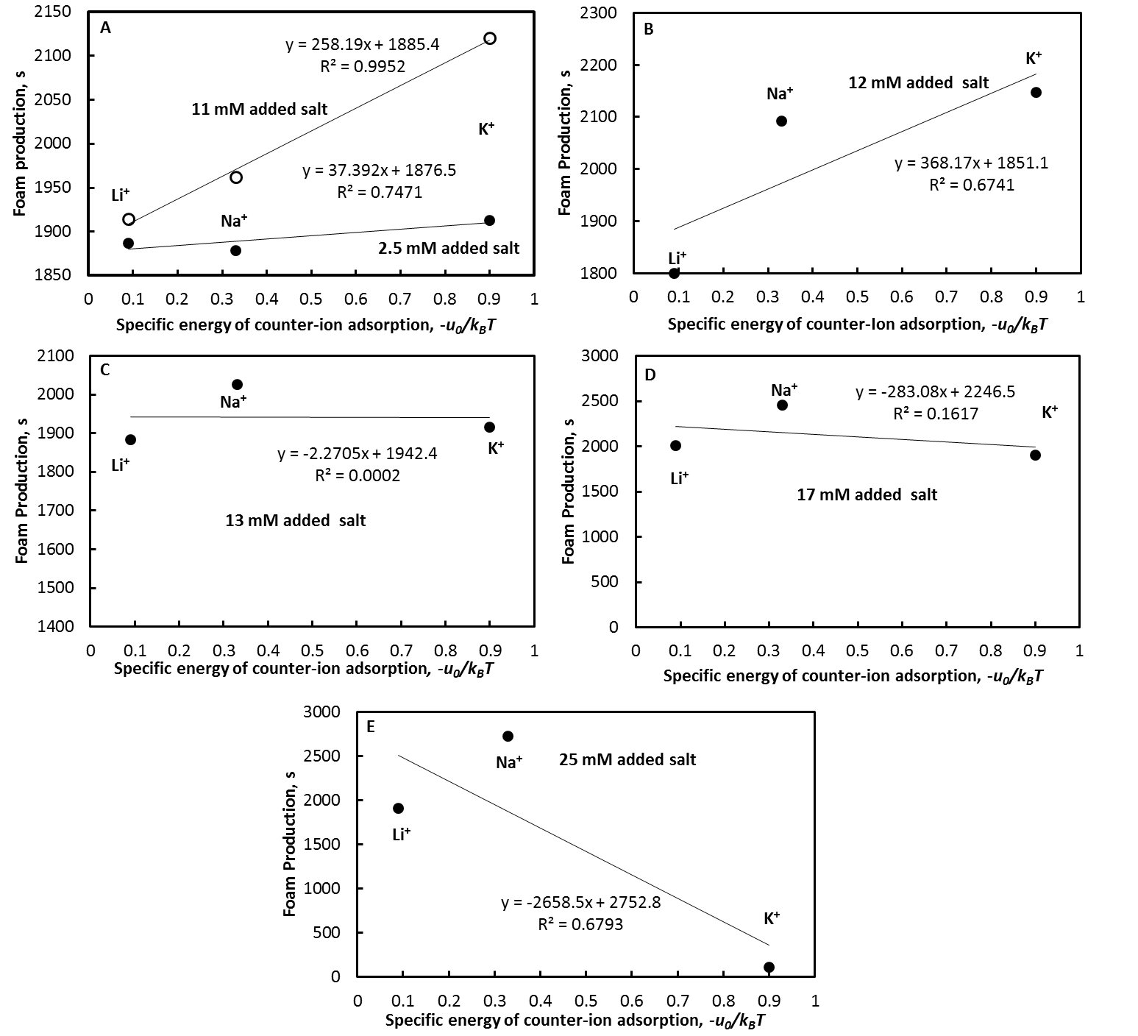

**Figure 16.** Foam production versus specific energy of counter-ion adsorption at concentrations of added salt in the range of 2.5 mM – 25 mM.

## 4. Conclusions

The ion-specific effects on the adsorption of ionic surfactants are known effect. There is a large body of literature on this topic, but it is spread out in many papers and books at present. It is known as well that the counterions affect the state of the adsorbed layers, which influences the stability of the colloidal dispersions, but the effect is not studied completely. This manuscript gathers together a detailed description of the theory on the ion-specific effects on the adsorption of ionic surfactants in its first approximation (Davies adsorption isotherm) and some initial experimental studies of the Hofmeister effect on the stability of foams and emulsions. Thus, we show the nature of the effect of the counter-ions on the state of the equilibrated surfactant adsorption layer, while we stress that their effect on the stability of colloidal dispersions can be can be non-equilibrated, thus giving an origin of new tendencies. It was shown that the counter-ions can have a dual effect on the stability of foams and emulsions depending on the concentration of the added salt. We call for further investigations on this interesting effect, which might be used for controlling the stability of foams and emulsions for industrial needs.

**Acknowledgment:**

This work was supported by the project Materials Networking H2020.

## References

1. Lewith S. The behaviour of the proteins in the blood serum in the presence of salts. Archiv fuer experimentelle Pathologie und Pharmakologie 1887; XXIX: 1-16.

2. Hofmeister F. About regularities in the protein precipitating effects of salts and the relation of these effects with the physiological behaviour of salts. Archiv fuer experimentelle Pathologie und Pharmakologie 1887; XXIV: 247-60.

3. Hofmeister F. About the water withdrawing effect of the salts. Archiv fuer experimentelle Pathologie und Pharmakologie 1888; XXV: 1-30.

4. Limbeck Rv. About the diuretic effect of salts. Archiv fuer experimentelle Pathologie und Pharmakologie.1888; XXV: 69-86.

5. Hofmeister F. Investigations about the swelling process. Archiv fuer experimentelle Pathologie und Pharmakologie 1890; XVII: 395-413.

6. Hofmeister F. The contribution of dissolved components to swelling processes. Archiv fuer experimentelle Pathologie und Pharmakologie 1991; XXVIII: 210-38.

7. Muenzer E. The general effect of salts. Archiv fuer experimentelle Pathologie und Pharmakologie 1898; XLI: 74-96.

8. Kunz W. Specific ion effects in colloidal and biological systems. Curr Opin Colloid Interface Sci 2010; 15: 34-9.

9 Kunz W, Lo Nostro P, Ninham BW. The present state of affairs with Hofmeister effects. Curr Opin Colloid Interface Sci.2004; 9: 1-18.

10. Ninham BW, Yaminsky V. Ion binding and ion specificity: The Hofmeister effect and Onsager and Lifshitz theories. Langmuir 1997; 13: 2097-108.

11. Bostrom M, Williams DRM, Ninham BW. Specific ion effects: Why DLVO theory fails for biology and colloid systems. Phys Rev Lett 2001; 87.

12. Bostroem M, Williams DRM, Ninham BW. Surface tension of electrolytes: Specific ion effects explained by dispersion forces. Langmuir 2001; 17: 4475-8.

13. Bostrom M, Kunz W, Ninham BW. Hofmeister effects in surface tension of aqueous electrolyte solution. Langmuir 2005; 21: 2619-23.

14. Moreira LA, Bostrom M, Ninham BW, Biscaia EC, Tavares FW. Hofmeister effects: Why protein charge, pH titration and protein precipitation depend on the choice of background salt solution. Coll Surf A 2006; 282: 457-63.

15. Bostroem M, Ninham BW. Contributions from Dispersion and Born Self-Free Energies to the Solvation Energies of Salt Solutions. J Phys Chem B 2004; 108: 12593-5.

16. Tavares FW, Bratko D, Blanch HW, Prausnitz JM. Ion-specific effects in the colloid-colloid or protein-protein potential of mean force: Role of salt-macroion van der Waals interactions. J Phys Chem B 2004; 108: 9228-35.

17. Warszynski P, Lunkenheimer K, Czichocki G. Effect of counterions on the adsorption of ionic surfactants at fluid-fluid interfaces. Langmuir 2002; 18: 2506-14.

18. Para G, Jarek E, Warszynski P. The Hofmeister series effect in adsorption of cationic surfactants - theoretical description and experimental results. Adv Colloid Inreface Sci 2006; 122: 39-55.

19. Para G, Jarek E, Warszynski P. The surface tension of aqueous solutions of cetyltrimethylammonium cationic surfactants in presence of bromide and chloride counterions. Coll Surf A 2005; 261: 65-73.

20. Li HH, Imai Y, Yamanaka M, Hayami Y, Takiue T, Matsubara H, *et al*. Specific counterion effect on the adsorbed film of cationic surfactant mixtures at the air/water interface. J Colloid Interface Sci 2011; 359: 189-93.

21. Shimamoto K, Onohara A, Takumi H, Watanabe I, Tanida H, Matsubara H, *et al*. Miscibility and Distribution of Counterions of Imidazolium Ionic Liquid Mixtures at the Air/Water Surface. Langmuir 2009; 25: 9954-9.

22. Hayami Y, Ichikawa H, Someya A, Aratono M, Motomura K. Thermodynamic study on the adsorption and micelle formation of long chain alkyltrimethylammonium chlorides. Coll Polym Sci 1998; 276: 595-600.

23. Davies JT. Adsorption of long-chain ions I. Proc R Soc London, Ser A 1958; 245: 417-28.

24. Davies JT, Rideal EK. Interfacial Phenomena, 2nd ed. New York: Academic Press 1963.

25. Borwankar RP, Wasan DT. Equilibrium and dynamics of adsorption of surfactants at fluid-fluid interfaces. Chem Eng Sci 1988; 43: 1323-37.

26. Ivanov IB, Marinova KG, Danov KD, Dimitrova D, Ananthapadmanabhan KP, Lips A. Role of the counterions on the adsorption of ionic surfactants. Adv Colloid Interface Sci 2007; 134-135: 105-24.

27. Ivanov IB, Ananthapadmanabhan KP, Lips A. Adsorption and structure of the adsorbed layer of ionic surfactants. Adv Colloid Interface Sci 2006; 123-126: 189-212.

28. Slavchov RI, Karakashev SI, Ivanov IB. Ionic Surfactants and Ion-Specific Effects: Adsorption, Micellization, Thin Liquid Films. In: Romsted LS, editor. Surfactant Science and Technology: Retrospects and Prospects: Taylor & Francis Group 2014; 593.

29. Ivanov IB, Slavchov RI, Basheva ES, Sidzhakova D, Karakashev SI. Hofmeister Effect on Micellization, Thin Films and Emulsion Stability Adv Colloid Interface Sci 2011; 168: 93-104.

30. Robinson RA, Stokes RH. Electrolyte Solutions. 2nd ed1959.

31. Lucassen-Reynders EH. Surface equation of state for ionized surfactants. J Phys Chem. 1966; 70: 1777-85.

32. Davies JT. Study of foam stabilizers using a new (\"viscous-traction\") surface viscometer. Proc Intern Congr Surface Activity, 2nd, London 1957; 220-4.

33. Lu JR, Marrocco A, Su T, Thomas RK, Penfold J. Adsorption of dodecyl sulfate surfactants with monovalent metal counterions at the air-water interface studied by neutron reflection and surface tension. J Colloid Interface Sci 1993; 158: 303-16.

34. Israelachvili JN. Intermolecular and Surface Forces. New York: Acad. Press 1985.

35. Jones G, Ray WA. The surface tension of solutions of electrolytes as a function of the concentration. III. Sodium chloride. J Am Chem Soc 1941; 63: 3262-3.

36. Collins KD. Charge density-dependent strength of hydration and biological structure. Biophys J 1997; 72: 65-76.

37. Marcus Y. Effect of Ions on the Structure of Water: Structure Making and Breaking. Chem Rev 2009; 109: 1346-70.

38. Marcus Y. Ion properties. New York: Marcel Dekker 1997.

39. Marcus Y. Thermodynamics of Ion Hydration and Its Interpretation in Terms of a Common Model. Pure Appl Chem 1987; 59: 1093-101.

40. Kunz W, Belloni L, Bernard O, Ninham BW. Osmotic coefficients and surface tensions of aqueous electrolyte solutions: Role of dispersion forces. J Phys Chem B 2004; 108: 2398-404.

41. Nikolskij BP. Handbook of the Chemist (In Russian). Moscow: Khimia 1966.

42 Dietrich B, Kintzinger JP, Lehn JM, Metz B, Zahidi A. Stability, Molecular-Dynamics in Solution, and X-Ray Structure of the Ammonium Cryptate [Nh4+-Subset-of-2.2.2]Pf6. J Phys Chem 1987; 91: 6600-6.

43. Lide DR. CRC Handbook of Chemistry and Physics, 83rd Edition 2002.

44. Sett S, Karakashev SI, Smoukov SK, Yarin AL. Ion-specific effects in foams. Adv Colloid Interface Sci 2015; 225: 98-113.

45. Churaev NV, Derjagiun BV, Muller VM. Surface Forces: Springer 1987.

46. Ivanov IB, Hadjiiski A, Denkov ND, Gurkov TD, Kralchevsky PA, Koyasu S. Energy of adhesion of human T cells to adsorption layers of monoclonal antibodies measured by a film trapping technique. Biophysical Journal 1998; 75: 545-56.

47. Hadjiiski A, Dimova R, Denkov ND, Ivanov IB, Borwankar R. Film Trapping Technique - Precise Method for Three-Phase Contact Angle Determination of Solid and Fluid Particles of Micrometer Size. Langmuir 1996; 12: 6665-75.

48. Hadjiiski A, Tcholakova S, Ivanov IB, Gurkov TD, Leonard EF. Gentle film trapping technique with application to drop entry measurements. Langmuir 2002; 18: 127-38.

49. Tcholakova S, Denkov ND, Ivanov IB, Campbell B. Coalescence in beta-lactoglobulin-stabilized emulsions: Effects of protein adsorption and drop size. Langmuir 2002; 18: 8960-71.

50. Karakashev SI, Georgiev P, Balashev K. Foam production – ratio between foaminess and rate of foam decay. J Colloid Interface Sci 2012; 379: 144-7.