Study on the physical properties of Cu₂ZnSnS₄thin films deposited by pneumatic spray pyrolysis technique

Miriam M. Nicolás¹, MaykelCourel*² and Osvaldo Vigil-Galán¹

¹Escuela Superior de Física y Matemáticas-Instituto Politécnico Nacional (IPN), C.P. 07738, CDMX, México.
²Instituto de Energías Renovables, Universidad Nacional Autónoma de México, Temixco, Morelos 62580, Mexico

ABSTRACT

The acquisition of new materials for the manufacturing of high efficiency and low-cost photovoltaic devices has currentlybecome a challenge. Thin films of CuInGaSe and CdTe have been widely used in solar cell of second generation, achieving efficiencies about 20 %; however, the low abundance of In and Te as well as the toxicity of Cd are the primary obstacles to their industrial production. Compounds such as Cu₂ZnSnS₄, Cu₂ZnSnSe₄ and Cu₂ZnSn(SSe)₄ have emerged as an important and less costly alternative for efficient energy conversion in the future. In addition, these compounds have the required characteristics to be used as an absorber material in solar cells (band-gap close to 1.4 eV, an absorption coefficient greater than 10⁴ cm⁻¹ and a p-type conductivity). In this work, we present a study of the structural, compositional, morphological and optical properties of Cu₂ZnSnS₄ thin films deposited by spray pyrolysis technique as well as their dependence on temperature.

Keywords: CZTS; thin films; solar cells; structural; morphological; compositional and optical properties

1. Introduction
Currently, solar cells have not yet been able to replace fossil fuels.To obtain a greater contribution of photovoltaic energy in the energy market, it is necessary to reduce production costs as well as increase the efficiency of the cells. Within the field of photovoltaics, solar cells of second generation have reduced production costs. Among the most used materials, CdTe and CuInGaSe have been able to achieve efficiencies greater than 18%^{[1].} However, the shortage of In and Te and the high toxicity of Cd have been major obstacles to industrial production.For this reason, it is necessary to search for new materials with adequate physical properties for their application in photovoltaics.An alternative that has been studied is the kesteritecompound Cu₂ZnSnS₄ (CZTS), which meets the requirements to be used as an absorber, that is, a band gap of 1.4 eV, p-type conductivity, in addition to having anabsorption coefficient greater than 10⁴ cm^{-1[2-6]}.
Different deposition techniques have been considered toCZTS thin films deposition for solar cells application. In particular, thermal evaporation^{[7]},co-evaporation^{[8]}, magnetron sputtering^{[9,10]}, screen printed^{[11]}, sol gel^{[12]}, electrodeposition^{[13]}, photochemical deposition ^{[14]}, and spray pyrolysis^{[15-20]} are among the most used ones. These techniques offer an easy and cheap route for thin film processing. Particularly, spray pyrolysis constitutes an easy, economical and versatile technique which is potentially attractive to reduce cost of solar cell processing. In regardless of the deposition method used to obtain the kesterite, it has been shown that film compositions must meet certain non-stoichiometric conditions to achieve high efficiencies in cells (Cu/(Zn + Sn)≈ 0.85 and Zn/Sn ≈1.25)^{[21]}. Therefore, this consideration must be taken into account for the deposition of the films.
In this work a study of the dependence of the structural, morphological and optical properties of CZTS thin films deposited by the chemical spray pyrolysis method as a function of temperature is presented. In addition, the relationship of these properties with the Cu / (Zn + Sn) and Zn / Sncompositional ratios will be presented.

2. Experimental Details
CZTS films were deposited by the chemical spray pyrolysis method. The method consists of mixing different reagents in a solution and then spraying it. The substrate is placed on heated plate where the reaction is carried out. The temperature of the heated plate is controlled by a thermocouple. Once the substrate is heated, the solution is sprayed with the help of a compressor using air as carrier gas. The temperature of the substrate stands out as one of the most important parameters to be taken into account.

- Solutionpreparation
For the deposition of CZTS films by means of the chemical spray pyrolysis technique, the precursor salts (CH₃COO)₂Zn * 2H₂O, CuCl₂, SnCl₄ * H₂O and thiourea were considered. All the salts are dissolved in 50 ml of deionized water. The masses of the salts to be diluted were calculated to obtain the optimal composition ratios^{[21]}, resulting: 132.8 mg of Cu, 107.6 mg of Zn, 87.9 mg of Sn and 134.7 mg of S. 50% of the solution is extracted of each salt, adding 100ml of deionized water, obtaining in this way a 200ml solution, which is the one used for the deposition.

- Thin Film Deposition
A flow rate of 5 ml / min, a pressure of 10 Psi, with a separation distance between the nozzle and the substrate of approximately 30 cm and a temperature range of 400-440 ° C were considered. More specifically, we worked with 400 ° C, 420 ° C and 440 ° C. All films were deposited under the same growth conditions mentioned above, with a deposition time of 20 minutes for each sample.

- Characterization
CZTS thin films processed by spray pyrolysis were submitted to the following characterizations: X-ray diffraction (X'PertPRO-MRD (PW3050/65) diffractometer from Panalytical using CoKαradiation), Transmittance (Lambda 35 UV/VIS Perkin–Elmer) and SEM and EDS by Jeol JSM-7800F with an accelerating voltage of 30 keV. By means of these characterizations, it is possible to find the type of structure, the atomic composition as well as the band gap.

3. Results
3.1 X-RAY Diffraction Results

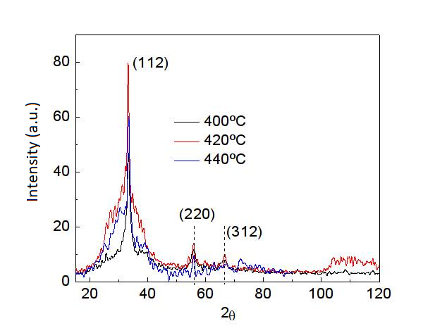
Figure1. XRD patterns of CZTS compound where the contribution of 3 planes can be observed
Figure 1 shows the results of X-ray diffraction for films grown at temperatures of 400 ° C, 420 ° C and 440 ° C. The measurements were made with the help of a cobalt source (Kα). We know from Bragg's law on X-ray diffraction that^{[4]}:
(1)
With the help of equation 1 we can find the interplanar distances (d). Taking into account that the CZTS compound has an orthorhombic structure with lattice parameters: a = b = 5.427Å and c = 10.848Å, with the help of equation (2), the Miller indices of the planes (h, k, l) can be calculated.
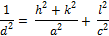 (2)
2θ | Miller indices
33.3 | (112)
55.7 | (220)
66.8 | (312)
Table 1. Miller indices
The results for different temperatures are shown in table1. The main planes that contribute to X-ray diffraction are (112), (220) and (312) which can be attributed to the compound CZTS^{[17,22]}. Although the film grown at 420 ° C showed a greater contribution to the diffraction of the plane (112) in figure 1, the film grown at 400 ° C has a better crystalline quality. As an important result, figure 1 showed that the grown films are not amorphous with the formation of the CZTS compound, which will be corroborated by the optical absorption measurements. Degradation in both peak intensity and crystalline quality is observed from Figure 1 when temperature is increased from 420 to 440°C, which could be a result of re-evaporation of some elements such as Sn and S under a relatively higher growth temperature.

3.2 EDS and SEM Results
- Film deposited at 400 ° C
For this case, a sulfur composition (S) of 29.6% is obtained, which is lower than the required for the compound stoichiometry, while Cu/(Zn+Sn) and Zn/Sn compositional ratios were:
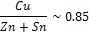 (3)
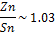 (4)
It is also important to highlight the fact that compositions close to the stoichiometric are obtained for the temperature of 400 °C. Despite Cu-poor samples are obtained, the condition of Zn-rich samples is not fulfilling which could result in the formation of poor crystalline quality as previously demonstrated^{[22]}. Therefore, for this temperature the optimum compositions relationships were not achieved.
- Film deposited at 420°C
At this temperature, 39% sulfur composition was achieved, while Cu/(Zn+Sn) and Zn/Sn compositional ratios were:
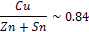 (5)
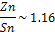 (6)
It is important to note that an increase in the composition of S was obtained with respect to the film deposited at 400°C. Also, compositional ratios close to optimal ones were obtained;therefore, 420°C could be more suitable as the substrate temperature for depositing CZTS films in order to be applied in solar cells.

- Film deposited at 440°C
With the increase of the temperature to 440 ° C, it is obtained that the concentration of S decreased to 35.1%, for which more losses of this element are obtained with respect to the film deposited at 420 ° C, which could be a result of sulfur losses for higher temperatures. In addition, Cu/(Zn+Sn) and Zn/Sn compositional ratiosare found to be out of the optimum as shown below:
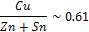 (7)
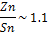 (8)
In particular, it is observed that for this temperature the sample is much poorer in Cu than the value corresponding to the optimum.
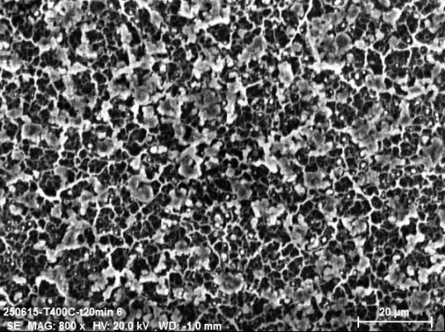
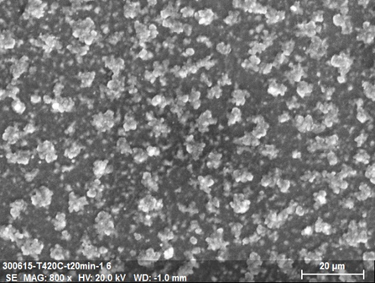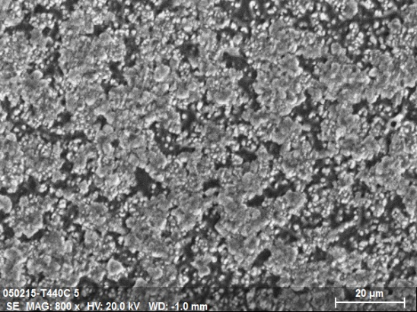
Figure 2. Morphological comparison (800x) of the films at 400 ° C (a), 420 ° C (b) and 440 ° C (c)

Figure 2 shows the comparison of the morphology of the three films that were deposited at 400 ° C, 420 ° C and 440 ° C. The morphology is highly dependent on temperature. The film deposited at 400 ° C illustrates the formation of some porous, while increasing the temperature favors the formation of clusters bigger in size.
3.3 Transmittance
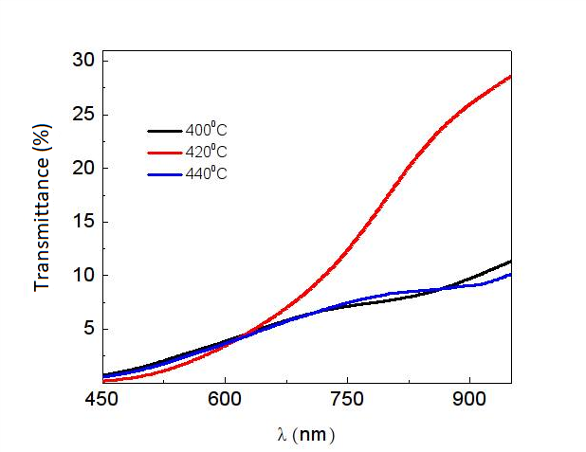
Figure 3. Transmittance of thin films deposited at temperatures of 400 °C, 420 °C, 440 °C
Figure 3 shows results of the measured transmittances of the films. The transmittance value in all cases was less than 30%, which confirms the potential of the Cu₂ZnSnS₄ material as an absorber.Figure 4 shows the band gap calculated from the derivative of transmittance. The possible contributions of secondary phases to absorption are illustrated for samples deposited under 400 and 440 °C. For the substrate temperature of 420 °C, a greater contribution of the CZTS material is obtained which corroborates the results obtained in composition and XRD.

4. Discussion
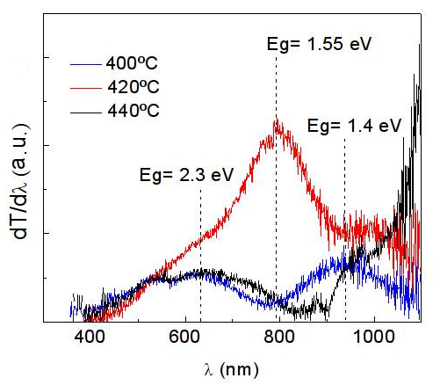
Figure 4. Derivative of transmittance measurements as a function of wavelength for band-gap estimation
From XRD, EDS and transmittance results, it is found that sample deposited under a substrate temperature of 420 °C is more adequate for solar cell applications. When depositing the CZTS compound starting from precursors containing the four salts (Cu, S, Sn, Zn), in addition to forming the desired compound Cu₂ZnSnS₄, other secondary phases can be formed, which lower the efficiency of the cells. The formation of secondary phases can explain the other contributions to absorption obtained in Figure 4. In particular, a band gap value close to 2.3 eV is commonly associated with secondary phases of Cu-S compounds^{[23].} Therefore, the film grown at 420 °C has a lower contribution of secondary phases.The Cu₂ZnSnS₄ must have an atomic composition of 50% in Sulfur, but because there are some losses due to its high volatility, this composition is always less than 50% unless samples were submitted to a post-thermal annealing under S atmosphere. Therefore, according to the SEM study, the most optimal film is the one that was grown at a temperature of 420 °C and not only because of the percentage of sulfur but also because of Cu/(Zn+Sn) and Zn/Sn compositional ratios that correspond to an optimized efficiency for this compound as previously demonstrated. On the other hand, the higher the uniformity of the film, the greater the efficiency of the cell. According to figure 2, the uniformity increases when the temperature is higher; therefore, for the temperature of 440 °C there are fewer holes (graph 2c) than with the temperature 400 °C (figure 2a) and 420 ° C (figure 2b). However, it was already discussed that for this temperature (440 °C), sample is very Cu-poor and therefore the Cu/(Zn+Sn) and Zn/Sn compositional ratiosare out of the optimum which will reduce solar cell efficiency.In addition, the samples showed a transmittance of less than 30% which, due to being an absorbing material, it is expected to have a low transmittance (see figure 3). Among the three temperatures, the 420 °C has a better behavior in the transmittance with the wavelength since the derivative (see figure 4) has a peak that corresponds to a band gap of 1.5eV corresponding to the CZTS^{[23,24]}.

4. Conclusions
In this work, a study of the structural, compositional, morphological and optical properties of CZTS films deposited under different substrate temperatures was presented, demonstrating the high dependence of these properties with substrate temperature. It was shown that when working with 4 elements to form the compound Cu₂ZnSnS₄, there is a high probability of the formation of secondary phases. Therefore, it is necessary to study the conditions under which these secondary phases are minimized, since the lower the contribution of these phases, the greater the efficiency of the solar cell.The results showed that the film deposited at a temperature of 420 ° C has better properties to be applied in solar cells (band gap of 1.5eV, a composition of sulfur of 39% as well as Cu/(Zn+Sn) and Zn/Sn compositional ratios close to the optimum).

Acknowledgments
O. Vigil thanks support from COFAA and EDI of IPN.

References
1. Green MA., Emery K, Hishikawa Y, et al. Prog. Photovoltaics Res Appl 2014; 22, pp1.
2. Lee YS., Gershon T, Gunawan O, et al. Adv. Energy Mater 5, 1401372, 2015. doi: 10.1002/aenm.201401372.
3. Gunawan O, Todorov TK., Mitzi DB. Appl. Phys. Lett 2010; 97, 233506.
4. Siebentritt S. Thin Solid Films 2013, 535, 1.
5. Gokmen T, Gunawan O, Todorov TK., et al. Appl. Phys. Lett 2013; 103, 103506.
6. Polizzotti A, Repins IL., Noufi R, et al. Energy Environ. Sci 2013; 6, 3171–3182.
7. Tanaka T, Kawasaki D, Nishio M, et al. Phys. Status Solidi C 2006; 3, 2844–2847.
8. Suresh Babu G, Kishore Kumar YB., UdayBhaskar P, et al. Sol. Energ. Mater. Sol. C 2010; 94, 221–226.
9. Fairbrother A, FontanéX, Izquierdo-Roca V, et al. Chem. Phys. Chem 2013; 9, 1836–1843.
10. Katagiri H, Jimbo K, Shwe Maw WIN., et al. Thin Solid Films 2009; 517, 2455–2460.
11. Zhou Z, Wang Y, Xu D, et al. Sol. Energ. Mater. Sol. C 2010; 94, 2042–2045.
12. Moritake N, Fukui Y, Oonuki M, et al. Phys. Status Solidi C 2009; 6, 1233–1236.
13. Scragg JJ., Dale PJ., Peter LM., et al. Phys. Status Solidi B 2008; 245, 1772–1778.
14. K., J. Watabe, K. Tanaka, H. Uchiki, Phys. Status Solidi C 3, 2848–2852 (2006).
15. Moriya M, Courel E, Valencia-Resendiz FA., et al. Solid StateElectron. 2016; 118, 1–3.
16. Courel M, Valencia-Resendiz E, Andrade-Arvizu JA., et al. Sol. Energy Mater. Sol. Cells 2017; 159, 151–158.
17. Courel M, Andrade-Arvizu JA., Guillén-Cervantes A, et al. Mater. Des 2017; 114, 515–520.
18. Nakayama N, Ito K. Appl. Surf. Sci 1996; 92, 171–175.
19. Kamoun N, Bouzouita H. Thin Solid Films 2007; 515, 5949–5952.
20. Madarász J, Bombicz P, Okuya M, et al. Solid State Ionics 2001; 141–142, 439–446.
21. Katagiri H, Jimbo K, Tahara M, et al. Materials Research Society Symposium Proceedings, 1165 (2009), pp. M01–M04
22. Courel M, Picquart M, Arce-Plaza A, et al. Mater. Res. Express 5 015513, 2018.
23. Vigil-Galan O, Courel M, Espindola-Rodriguez M, et al. Journal of Renewableand Sustainable Energy 5, 053137, 2013.
24. Kumar YBK. Phys. Status Solidi A 2010, 207, 149.

List of table
Table I.-Miller indices
2θ | Miller indices
33.3 | (112)
55.7 | (220)
66.8 | (312)

List of figure captions

Figure 1.-XRD patterns of CZTS compound where the contribution of 3 planes can be observed

Figure 2.- Morphological comparison (800x) of the films at 400 ° C (a), 420 ° C (b) and 440 ° C (c)

Figure 3.-Transmittance of thin films deposited at temperatures of 400 °C, 420 °C, 440 °C.

Figure 4.-Derivative of transmittance measurements as a function of wavelength for band-gap estimation.

Fig. 1
c)
b)
a)
Fig.2
Fig. 3
Fig. 4

