**Mixed mode oscillations in an electrochemical reactor**

Zdzislaw Trzaska,

University of Ecology and Management, 00-792 Warsaw, Poland

**ABATRACT**

The paper subject is focused on modelling electrochemical processes during a deposition of nanostructured materials on a metallic substrate. Fundamentals of electrocrystallization processes and parameters influenced the final quality of resulting products are considered. To quantify the evolutions of the electrochemical reactor processes with respect to time an equivalent electric circuit has been established. Two types of periodic supplying currents were taken into considerations: bipolar pulse current and sinusoidal rectified current. Results of performed computer simulations of electrocrystallization processes with the focus on mixed mode oscillations (MMOs) as the dynamical switches between small amplitude oscillations (SAOs) and large amplitude oscillations (LAOs) are presented. The established circuit model can lead to methods for fast treating large quantities of electrocrystallizator data and extracting from them kinetic parameters importantly influenced the structure of the produced materials.

**Keywords:** Electrochemical reactor; redox reactions; mathematical model; circuit model; mixed mode oscillations

**1. Introduction**

During the last twenty years, electrochemical processes have become the basis for techniques comprehensively being relevant for the production of nanostructured materials or nanostructured surface layers, which are widely applied in many industries that use the top technologies. This has a bearing mainly to such industries as the aerospace, automotive, military, microelectronics, computers, energy, biotechnology and related others. Presently, challenges in relations to electrochemical processes used in the practice are becoming more and more expressive in terms of better adapting them to the special technological requirements with meeting the directives for reducing negative impacts on the surrounding environment. It should be emphasized that electrochemical methods are receiving recently increasing attention in rapidly growing fields of science and technology, mainly in such domains as nanosciences (nanoelectrochemistry) and life sciences (organic and biological electrochemistry). Electrochemical processes not only represent interesting cases of phase formation and crystal growth but are also powerful methods for various technological applications because the driving force of the process can be easily controlled by the current density, the electrodes potential and composition of the bath solution. Characterization, modification, and understanding of various electrochemical interfaces or electrochemical processes at the nanoscale have led to a huge increase of scientific interest in electrochemical mechanisms as well as in application of electrochemical methods to novel technologies. It is worth pointing out that nowadays nanomaterials are extensively used as important development factor in the fields of porous semiconductor, deposition into templates, electrodeposition of multilayers and superlattices, as well as self-organized growth of transition metal oxide nanotubes and to modify sensor surfaces giving improved analytical characteristics [1]. The electrocrystallization method is exceptionally suitable for preparations of specific materials, mainly the protective layers, and in the near future may be more effective than previously involved methods in surface modification technologies of known materials, as well as newly produced materials. These layers can be used together with their substrates or as separated from them.

It is well known that an efficient way to produce nanocrystalline materials is the application of an electrochemical method based on electrocrystallization processes generated as a result of oxidation and reduction reactions which occur at the electrodes: anode and cathode, respectively, in accord to the relations

(1)

+ne-(Reduction)

Mene+  Me

(Oxidation) -ne-

Oxidation-reduction reactions also known as redox reactions describe all chemical processes in which there is a net change in atomic charge. In balanced redox reactions the number of electrons lost by the reducing agent equals the number of electrons gained by the oxidizing agent. Electrocrystallizations are normally associated with a growth process where the nuclei formed on the electrode surface are highly dependent on the supplied current.

Taking into account the specificity of electrochemically produced materials, it is possible the formation of such structures of the materials and their properties that cannot be obtained by other technologies. The possibility of conscious control of the structures in the nanometric scale leads up to producing the useful materials with new properties and overcome previously insurmountable barriers to the development of technology. Nanomaterials possess at least one dimension sized from 1 to 100 nm[4], [6] and not only unique geometric, mechanical, electronic and chemical properties, but also properties different from macroscopic materials, such as quantum effect, surface effect, small size effect, etc. These properties have greatly prompted a broad range of applications of nanomaterials in medicine, electronics, biotechnologies, environmental science, energy production and biosensors. The nanostructures of the electrochemically produced materials can lead to novel properties, and hence to novel applications of conventional materials as well as new commercial applications, among other things, the graphene[7]. Because such products as, for instance, sunscreens, cosmetics, clothing, upholstery, paint, bodywork of vehicles, computer components utilize nanotechnologies, it is not strange at present as well as in near future that the nanotechnology will infiltrate consumer products holistically. For these among other reasons the progress in science and engineering at the nanoscale appears now as a critical factor for society’s security, prosperity of the economy, and enhancement of the quality of life. However, this advantage carries a price: electrochemical interfaces are more complex, because they include the solvent and ions. This poses a great problem for the modelling of these interfaces, since it is generally impossible to treat all active particles at an equivalent level[2].

In surface engineering the electrocrystallization method is used to improve the useful properties of the metal products by deposition of appropriate metal layers on their surfaces protecting them against corrosion and wear. Moreover, appropriate realizations of electrodepositions give beneficial possibilities to isolate the product from the harmful effects of the external environment.

Generally, the manufacturing of nanostructures is too complicated for proper theory, so this has been the domain of computer simulations. It is worth underline that in the simulations of electrochemical nanostructures, we have to deal with a few hundred of thousands or even of millions of atoms. This leads into the mathematics of their governing nonlinear differential equations, e.g., simple stability with the dynamic structure necessary for a system to exhibit nonmonotonic behavior.

This paper aims at mapping new frontiers in emerging and developing electrochemical areas in the domain of nanomaterials manufacturing and innovation. Section 2 is devoted to presentation of fundamentals of electrocrystallization processes and parameters influenced the final quality of resulting products. In Section 3 essential problems concerning the electrocrystallization process modeling with taking into account all major processes accompanied of nanostructured products are presented. Section 4 is aimed on presentations of results of performed computer simulations of electrocrystalization processes with the focus on mixed mode oscillations. Conclusions and final remarks are presented in Section 5.

**2. Concise characterization of electrocrystallization processes**

A simplified scheme of appliances being widely applied as electrochemical reactors and automated wafer processing equipments is presented in Fig.1. Electrodes charged by supplying generator are able to carry out chemical reactions for realizations of electrocrystallization processes. Technological importance of electrocrystallization also known as electroplating is of greatest interest and is widely used for production of different functional and decorative coatings. Several application-specific types of electrodeposition processing systems, each with its own specific requirements, have been produced up-to-date. The advantage of electrodeposition lies in: (i) the low temperatures involved, (ii) the ability to coat geometrically complex or non line-of-sight surfaces of porous products, (iii) the ability to effective control the thickness, composition, and microstructure of the deposit, (iv) the possible improvement of the substrate/coating bond strength, (v) the possibility of producing nanocomposites and nanostructured multilayer materials, and (v) the easy availability and low cost of equipments.



**i**

**v**

**Cathode**

**Anode**

**Product**

**Sling**

**Electrolyte level**

**Figure1.** Stand diagram with an electrocrystallization reactor

Depending on conditions of the process realization it is possible to produce thin layer materials with particular properties that influence importantly not only on research and modern fabrication intensifications but also on numerous domains of the top microelectronic and biomaterials technologies. By choosing the type and composition of the electrolyte solution, and the process parameters such as type and density of the current, temperature, time duration of the process can be designed a variety of materials meeting the features in the art. One of the methods of modifying the useful properties of the products is the deposition on their surface of appropriate metal layer by electrodeposition method. The properties of electrodeposited layers can be formed by suitable selection of the electrolyte solution composition and by current parameters control.

Figure 2 shows current waveforms which are most often used in practice to supply the reactor. The electrodeposition with pulse periodic current is able to produce layers with more uniform particle distribution and better surface morphology than those obtained under direct current. This is common activity on rough parts or when a bright finish is required. In certain processes, the management of electrolyte chemical concentrations is critical to ensure consistent results.

In order to optimize the operation of the electrocrystallization reactor in a specific application it is important to understand its strengths and limitations because the same reactor does not work equally well for all deposition of nanostructured materials. Matching of periods of the supplying current is the best approach. All major process studies concentrate currently around the PPSRC electrodeposition technology and the general metal finishing products.

By electrocrystallization method can be prepared a variety of metals, metal alloys, and composite materials. Especially great potential resides in shaping the properties of composite materials. Composite materials prepared by this method, can be formed with a metal matrix and a disperse phase may be constituted by different materials such as, for example, other metal (W, Cu, Ni), ceramics (Al2O3, Cr2O3, Si3N4), polymer (PFE), or carbon (graphite, nanotubes, fullerenes, graphene). The combination of two different materials so they are disperse phase and matrix metal allows the control of produced material properties in a fairly wide range, which enables the formation of a final material satisfying efficiently various functions in practice.



Direct current (DC)

Positive pulse periodic

current (PPPC)

Reverse pulse periodic

current (RPPC)

Reverse pulse periodic with dead zone current (RPPDZC)

Pulse periodic with segmented reversion current (PPSRC)

**Figure 2.** The time varying currents supplied to the electrocrystallization reactor

The enormous potential for use in the development of new properties of the material lies in the possibility of conscious control of its structure at the nanometric scale. Presently, it is well known, that material properties, mechanical, electrical, thermal and chemical are the result of the phenomena occurring in structures of nanometric size. Nanometric structure materials have particularly advantageous properties, and are an effective alternative to conventional materials.

To obtain a nanocrystalline structure, the deposition processes were carried out from a variety of electrolyte solutions. For instance in the electrodeposition of nickel on a steel substrate the electrolyte solution is usually composed of nickel(II) sulphate(VI), nickel chloride, boric acid and saccharin. Prior to the deposition process of a surface layer, the substrate material is subjected to mechanical grinding, degreasing and activated to provide a good adhesion of the layer to the substrate. The process of electrocrystallization gives also possibilities to produce composite layers with nanocrystalline nickel matrix and dispersed phase in the form of graphene flakes[11].

Realization’s efficiency of simultaneous deposition of metal and non-metallic disperse phase in the same process and the electrochemical reduction of the quality of the material will depend on such factors as: the nature and composition of the electrolyte solution, the process parameters (concentration, pH, temperature, stirring, current conditions), and the chemical nature of the grain structure built in non-metallic disperse phase, chemical nature and content of various additives, as well as the quality of the substrate material and the quality of its surface. The low processing temperatures minimizes crystallites interdiffusion while the high selectivity of electrocrystallization process allows uniform modification of surfaces and structures with complicated profiles. All of these factors must be taken into account when designing a composite material, to be able properly (i.e., as expected) working under determined conditions. Such a large number of parameters, influenced the control of electrocrystallization processes and affect the quality of the manufactured material, gives on one hand a great flexibility in its ability to modify constituted material, but on the other hand presents a big challenge for the proper and optimal choice of their selection. This requires a thorough diagnosis of the mechanisms of these complex processes, as well as their practical implementation of parameters. So, the set of the parameters of the implementation of such processes in the production environment and the relationships between these parameters and the structure and properties of the produced nanocrystalline material requires complex experimental research and in-depth analysis.

Taking into account potential applications of nano-crystalline materials, the pursuit of deposit uniformity, especially thickness uniformity, has been a technical imperative for suitable controlling every produced nanocrystalline material.

The most frequently studied electrocrystallization process is cathodic metal deposition on foreign and native substrates from electrolytes containing simple and/or complex metal ions[3], [12]. Typical examples are the electrocrystallization of Ag from Ag+ containing electrolytes[17], the cathodic deposition of Ag on n-Si from electrolytes containing [Ag(CN)2]- ions[3], and the electrodeposition of Cu[4], which has recently become of significant technological importance for the fabrication of Cu interconnects on integrated circuit chips.

A process widely used for preparation of metallic alloys and semiconducting compounds is cathodic codeposition from multicomponent electrolytes[9]. Typical examples are the electrochemical formation of NiFe alloys by codeposition from Ni2+- and Fe2+-containing electrolytes and the electrodeposition of n-type CdTe from electrolytes containing Cd2+ and HTeO2+ ions. Other important electrocrystallization processes are anodic deposition of metal oxides and anodic oxidation of metals and semiconductors. The first type of processes can be illustrated by the anodic deposition of PbO2 from an aqueous Pb2+ solution. The second type are substrate consuming processes, which occur in aqueous solution and usually start with adsorption of OH- ions and place exchange reactions with the substrate. Technologically important examples are the anodic oxidation of valve metals (Al, Nb, Ta, Ti) and Si[2], [9], [10], [17].

This is much related to the principles of the so-called ‘‘green chemistry’’, where the use of low temperatures and mild conditions is specifically pursued in the synthesis of advanced materials.

Besides the aforementioned ecological and economic benefits, the low-temperature processing has also opened the door to the incorporation of an increasing number of materials in technologically disruptive areas like flexible electronics and photovoltaic batteries[5].

Thin films of metal oxides are consequently at the forefront of current and next-generation devices, where systems supported on low-cost, lightweight, and flexible substrates are expected to revolutionize the electronic industry by new applications such as large-area displays, vearable sensors, smart textiles or electronic skin. Nowadays, the direct growth of metal oxide layers on low-melting-point flexible substrates (e.g. plastic, paper, or textile) is only possible at processing temperatures below the thermal degradation of the latter: around 350 oC in the most

favorable case (i.e. polyimide foils). This constitutes a big challenge for the effective integration of multifunctional metal oxides, since their crystallization temperatures (usually over 600 oC) are still several hundred degrees above the values that polymeric substrates can withstand. The strong electronic correlations imposed by the crystal lattice usually rule the behavior of complex transition metal oxides. If crystallization is not achieved, most metal oxides lack of the physical property that ultimately defines the functionality of the material.

The processes leading to crystallization are in many ways governed by chemistry.

The ever increasing demand for low-cost and energy efficient manufacturing processes, together with the pressing need for new materials and devices in emerging technologies, is driving recent research efforts towards the near-room-temperature processing of metal oxide thin films using electrochemical methods.

**3. The mathematical modelling of electrochemical reactors**

To provide a foundation upon which we can derive an understanding of the matrix of mechanisms that affect the electrochemical deposition process and its variation a great help can be obtained by applying an effective tool of studies in the form of mathematical modelling. The modelling of the nucleation and material growth mechanism during the electrocrystallization process is extremely important due to its use in effective production of thin layers of pure metal or in the form of alloys and nanostructured composites with a high degree of precision. During the thin layer metal electrodeposition the complex reactions of charge transfer with intermediate adsorption takes place at least in two elementary steps: reagent adsorption is the first and product desorption is the second. It has been observed especially in the case of multicomponent electrolytes that beside the electron diffusion and counter ion transport very often hydrogen ions also participate in the charge transport and charge transfer processes in the course of redox transformation of these electrolytes, i.e. a model describing this case may be also essential. In general, models should allow us the activity to try and isolate the contribution of a few key parameters from the batch process in an attempt to predict the dominant effects as well as the variation of the process. Experimentation, particularly at the expensive pilot plant stage, can be minimized and development costs significantly reduced. Development of a reaction model is an essential first step to obtaining a reactor model, which in turn is a suitable tool for process optimizations. It has to be noted that the electrochemical deposition process appears as a competition between nucleation and grain growth of the produced materials. In charging and discharging of a pulse ion flux, especially for short pulses, the double layer of the interface between electrolyte and cathode distorts the pulse current[10], and affects the over potential response acting on the electrolyte.

To better control the coupled effects of pulsed current between the electrodes with its own magnetic field and improve electrochemical depositing performance, the combined effects must be studied. The electrochemical impedance spectroscopy experimental results show that both the reactor current frequency and magnetic flux density are significant factors in the performance of electrochemical reactors. The Lorentz force acting on the electrolyte in the double layer at the electrode increases with higher current densities improving electrolyte flow and conductivity, which enhances electrochemical deposition performance in terms of accuracy and surface finish.

**+ + + +**

$×$

**B**

**u**

**FB**

**Path**

Region of main

electrochemical

reactions

**G**

Pulsed charge flux

**Figure 3.** Coupled processes generated by pulsed current between electrodes: G - pulsed current generator**, u** - charge drift velocity, **B** magnetic field density, **FB** - Lorentz force

Usually, the energy distribution of the charged particle flow is limited in a small region near the workingelectrode and is constrained by its own magnetic field. It should be emphasized that there are several mechanisms by which self-magnetic fields can be generated in the double layer right at the working electrode space in various regimes of the reactor excitation, including the density gradient term, the curl of the thermal force, the ponderomotive force, the inverse Faraday effect, and instabilities[5].

The azimuth magnetic field associated with the axial flow of a large current through a cylindrical symmetric electrolyte creates a magnetic pressure (**J $×$ B** or Lorentz force) that accelerates radially inward of the charged particle flow (Fig.3). When the supplying current is time varying, the charged particles are attracted to each other under the influence of the Lorentz force, which causes shrinkage of the charged particle flux, i.e. the pinch effect appears. The effect leads to increase the ion density and pressure. A current flowing through the electrolyte squeezes smaller cylinder, until the magnetic force does not balance the pressure. The detailed physics of this process is still largely open for debate and speculation because little quantitative data have been accumulated on the deposit ablation process, especially close to the exploding baths.

The magnetic properties of electrolytes and the interactions of internally induced magnetic fields on electrolyte properties and ionic transport characteristics have significant influence on the form of the mathematical model of the processes occurring in the electrochemical reactor.

A well-founded model of electrochemical processes occurring in the reactor should be based on the questions of change for mass, energy and momentum. The instantaneous state of an electrochemical reactor usually depends on several variables and is described by one or several state functions of one or several variables. For instance, considering the electrode variables we must take into account the kind of the material, surface area, and geometry and surface conditions. Such factors as mode transfer (diffusion, convection, migration,...), surface concentrations and adsorption have influences on the mass transfer variables. The temperature, pressure and time appear as external variables. Moreover, there are electrical variables such as the charge, current and potential. As solution variables we have the bulk concentrations of electroactive species, concentrations of other species and the kind of the solvent. It can be easily verified that the aspect of current distribution can have a major effect on the performance of electrochemical processes.

The electrodeposition process can be described by a mathematical model derived from the Maxwell equations and mass balance equations as follows. From the charge conservation principle the equation for charge continuity takes the form

$\text{∇}\text{∙}{\text{J}}_{\text{c}}\text{=} \text{-}\frac{\text{∂}{\text{ρ}}_{\text{q}}}{\text{∂t}}$ (2)

where **J**c and q denote the current density vector and charge volume density, respectively.

The general electric field intensity **E** is governed by the Maxwell-Faraday equation

$\text{E} \text{=} \text{-}\text{∇}\text{V} \text{-} \frac{\text{∂}\text{A}}{\text{∂t}}$ (3)

where V is the scalar electric potential, **A** is the magnetic vector potential. The magnetic vector potential **A** is defined so that the magnetic field density **B** is given by

$\text{B=}\text{∇}×A$ (4)

In the presence of a current distribution as a source for the magnetic field the magnetic field density can be found from the Biot-Savart law

$\text{B=}\frac{\text{μ}}{\text{4}\text{π}}\int{\frac{J_{c}(p)×(r-p)}{{|r-p|}^{3}}}dv$ (5)

where the integral extends over all space v. Generally, the Biot-Savart law is difficult to apply. It is offen easier to first calculate the magnetic vector potential for which we need to derive a differential equation. Taking into considerations time dependent sources, i.e. charge and current distributions that vary in time we can somewhat artificially divide electric current into two components: "external" current that generates electromagnetic field and "induced" current caused by electromagnetic field.

Substituting (3) and (4) into Maxwell's equations yields

$∇^{2}A-με\frac{∂^{2}A}{{∂t}^{2}}=-με{\text{J}}_{c}$ (6)

This is the wave equation for the vector potential **A.**

Following a similar procedure and starting by taking into account the curl of the magnetic field strenght **H** we obtain the wave equation for the magnetic field, namely

$∇^{2}H-με\frac{∂^{2}H}{{∂t}^{2}}=-∇×{\text{J}}_{c}$ (7)

For the electric field we find that the wave equation in the presence of source takes the form

$∇^{2}E-με\frac{∂^{2}E}{{∂t}^{2}}=μ\frac{\text{∂}{\text{J}}_{c}}{∂t}+∇({ρ_{q}}/{ε)}$ (8)

It is easily seen that the wave equation for the magnetic field has only a source term dependent on the electric current **Jc**, whereas the wave equation for the electric field includes a source term for the electric charge q. This is a consequence that there are no magnetic monopoles.

According to the Lorentz force the induced current **J**in from the electrolyte velocity **u** and the magnetic field **B** is determined by

${\text{J}}_{in}=σu×B$ (9)

where  denotes the electrolyte conductivity.

The total current density is then

$\text{J =}{\text{ J}}_{c}+{\text{J}}_{in}$ (10)

The continuous form of the Lorentz force is [19]

$\text{F = }{\text{ρ}}_{q}\text{E}+\text{J }\text{×}\text{B}$ (11)

where ρq is the charge density, **J** is the total current density, and **B** is the magnetic field density.

The Lorentz force per unit volume **F** can be applied as an external force in the Navier-Stokes equations. Thus, the second step in solving this electrochemical reactor problem is to determine the electrolyte velocity using the Navier- Stokes equations for laminar incompressible flow

${\text{ρ}}_{f}\frac{∂\text{u}}{∂t}+{\text{ρ}}_{f}\text{(}\text{u∙}\text{∇}\text{)}\text{u = }\text{∇}\text{∙}\text{[}\text{-}\text{δ}\text{I}\text{+}\text{ϑ}\text{(}\text{∇}\text{u}\text{+(}\text{∇}\text{u})^{T})]+F$ (12)

where ρf is the fluid density, $ϑ$ is the dynamic viscosity,  is the pressure, and **I** is the identity matrix. Equations (9) and (12) are coupled in **u** andrequire a simultaneous solution. We assume that the flow of charged particles is incompressible, so the flow continuity equation simplifies to

${\text{ρ}}_{\text{f}}\text{∇}\text{∙}\text{u }\text{= 0}$ (13)

It is now obvious that the solution for the ions velocity **u** and pressure  can be evaluated under various conditions.

An interesting point related to the presented studies is that the problems of the nature of charge carriers, the coupling of their motion, and the contribution of migration to the ions flux, respectively, may be analyzed in details. Owing to the potential dependence of nucleation, growth, and roughness evolution processes, the deposit morphology can thus vary with radial position and can adversely affect product quality. It is worth noticing that the exact solution of the above set of equations for real multi-component electrolytes is rather complicated, therefore by imposing appropriate restrictions which are satisfied under corresponding electroplating conditions it is possible elaborate models which lead to satisfied results when matching them with experimental data. Such models have a two-fold purpose: first, they can account all the facts discovered experimentally, and second, they can be able predict the system behaviour under various conditions. Starting from this general imperative, the elaboration of a model for the interface phenomena can be performed by making a certain number of hypotheses which generally simplify the governing equations (2) $÷$ (13).

**4. Computer simulations of mixed mode oscillations**

At present, the derivation of a model from the basic equation is an error prone and time consuming task normally requiring specific expertise. Fortunately, at the same time computer simulation techniques are gaining more importance in the industry practice. This leads to an increasing gap between supply and demand of well-defined, consistent models. A relatively simple model (if it is appropriate;) enables us to select the variables that govern performance. However, due to mathematical difficulties in solution of diffusion-migration transport equations different simplifications are necessary. Very often some uncertainty in the numerical values of the model constants is not usually important and methodology commonly used in many engineering practice today gives enough support for the researcher in the task of deriving a specific model. Moreover, when the computational analysis is combined with the electrochemical impedance spectroscopy, the results may suggest operating parameters that differ from either of the assumed individual results. While these findings indicate an operating regime of higher electrolyte velocities, whether that translates into increased depositing performance, will require pulse current validation corrections The electrochemical impedance spectroscopy is used to determine the impedance of an electrochemical reactor at different sinusoidal frequencies under given conditions - in this case a range of supplying current magnitudes and frequencies. The response of the reactor to a sinusoidal input should give insights relevant to pulse current frequency.

Generally, the manufacturing of nanostructures is too complicated for proper theory, so this has been the domain of computer simulations. We shall start by considering simulations of electrochemical nanostructure depositions, and shall then turn toward current-voltage relations to gain insights into the charge – electrolyte concentration and coupling mechanisms ultimately responsible for different pattern of the reactor output quantities and to identify the relationship between them. It should be emphasized that the circuit modelling not only aids semiconductor

manufacturers in immediate returns on investment like increased yield and decreased consumable costs, but models are essential to understand the mechanisms that enable of material and cause process variation, which affects device performance and process efficiency. The equivalent circuit model predicts the capacitive and Faradic currents of the process, and with the same average and peak current density, the ramp up waveform has higher instantaneous peak current for charge transfer, which results in an improvement in the microstructure of the nanocomposite.

Nonlinear interactions between these quantities may permit the emergence of highly characteristic oscillatory behaviour known as quasi-periodicity and mixed mode dynamics, in addition to chaos. The investigation of the involved circuit gives information also on the structure of relationships expected in special cases. To quantify the evolutions of the electrochemical reactor processes with respect to time the equivalent circuit was used. It is depicted in Fig. 4.



**Re**

**Cp**

**Cd**

**Rp**

**Cs**

**is**

**q(**



**Figure 4.** Circuit model of electrochemical deposition processes

Applying circuit laws we can establish the mathematical description of the above model and obtain

$\begin{matrix}{\dot{x}}_{1}=k_{1}\left(\frac{x_{2}+x_{3}-x_{1}}{R_{e}}+i_{s}\right), \\ {\dot{x}}_{2}=k_{2}\left(-\frac{x_{2}+x_{3}-x_{1}}{R_{e}}-\left(a+3bx_{4}^{2}\right)x_{2}\right), \\ \begin{matrix}{\dot{x}}_{3}=k_{3}\left(-\frac{x_{2}+x_{3}-x_{1}}{R_{e}}-\frac{x_{3}}{R_{p}}\right), \\ {\dot{x}}_{4}=x_{2}. \end{matrix}\end{matrix}$ (14)

where k1 =1/Cs, k2 =1/Cd, k3 =1/Cp and x4 =  The dot is taken as a symbol for differentiation with respect to time. 

Due to the complex form of the established system of equations, the determination of their analytical solution is not an easy task and therefore, to examine the effect of various system parameters on the electrocrystallization process, we can perform numerical calculations applying a computer program MATLAB with using effective numerical integration procedures.

We shall start by considering the following quantities: is = I = 15 A for 0 < t < T/2 and is = -I = -15 A for T/2 < t < T with is(t) = is(t + T), Re = 0.5  Rp = 5 k Cs = 0.01 F, Cd = 0.278 F, Cp = 0.05 F. The charge - magnetic characteristic of the memristive element representing the relation between the current and its own magnetic field takes the form: q() = a  b where a and b denote constant parameters.

d)

c)

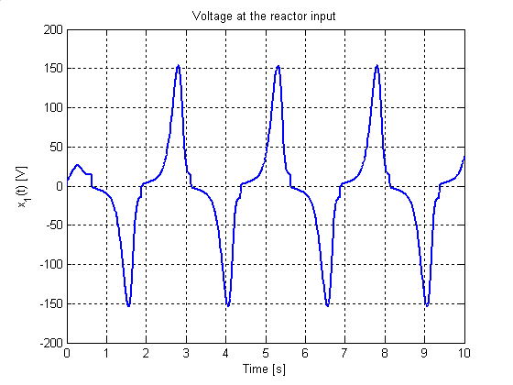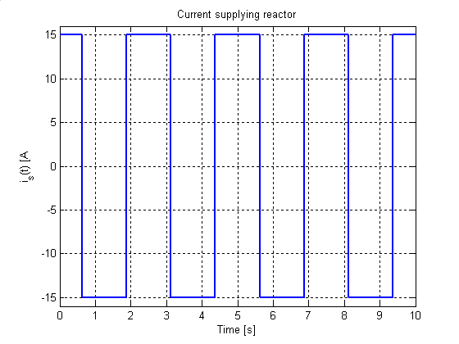

b)

a)

c)

d)

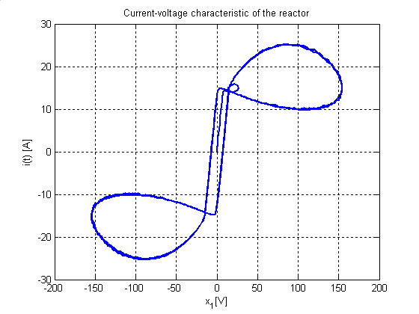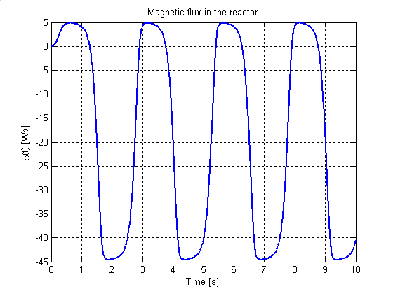

**Figure 5.** Changes in time of supplyin current (a), current (b) and magnetic flux (c) in the

reactor and voltage - current characteristic (d) of the reactor

Applying the mentioned numerical procedure implemented in MATLAB we get the

solutions shown in Fig.5 and Fig.6 for different time varying is. We solved (14) with the variable step ODE45 procedure from MATLAB with RelEr = AbsEr = 10−6 and 0 ≤ t ≤ 20 s and zero initial conditions. The steady-state response of the large amplitude oscillations were identified in the interval 2 s ≤ t ≤ 20 s. Note also that the type of the supplying current is exhibits different very different system responses, in particular with regard to changes in time of the magnetic flux and voltage - current characteristics of the reactor.

The important point to note here lies in the fact that in the case of supplying the system from a straight sinusoidal current rectifier, the current flowing through the reactor takes similar course in time to the supplying current and a significantly different nature of the magnetic flux waveform is exhibited and, with the over time, it tends to a constant value. However, in the case of supplying the reactor with periodic bipolar current, the current flowing through the reactor takes very different from it in time. Moreover, the steady-state voltage-current characteristics of the reactor in these two cases of supplying currents take considerably different shapes, which appear as a result from the influence of a significant constant in time component which is contained in the rectified sinusoidal current. Although simple topologically, the system can exhibit complex dynamical responses and its dynamical properties can be characterized through Farey arithmetic and fractal dimensions of their devil's staircases. Several interesting properties of the circuits can be identified through bifurcation diagrams, phase plane and time series responses [16].

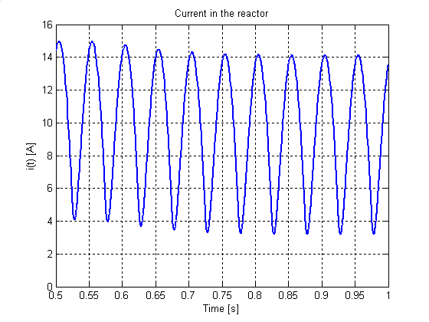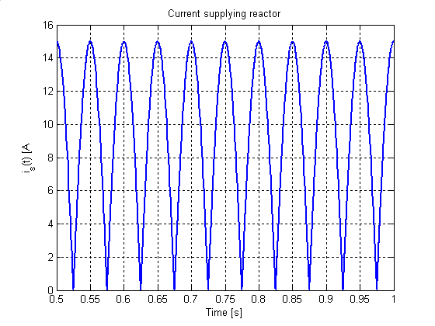

a)

b)

c)

d)

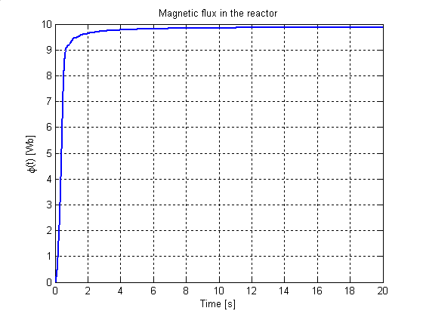

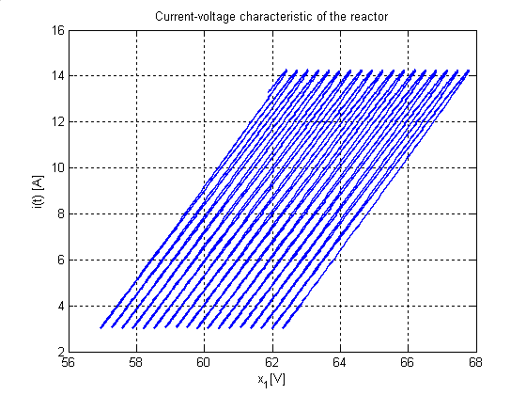

**Figure 6.** Varying in time: a) supplying rectified sinusoidal current, b), c)current and magnetic flux in the reactor, d) voltage - current characteristic of the reactor

From the extensive set of solutions, we will focus in what follows our attention on the particular type of voltage and current waveforms that can be accordingly transformed on the effects of the electrochemical processes. It has to be noted that the aspect of circuit variables distribution can have a major effect on the reactor performance. A detailed analysis is outside the scope of this article although it may give a qualitative view of the effect due to its significance in design of electrochemical reactors for industrial processes.

In such a case as that above mentioned one the important problem is concerned with mixed mode oscillations (MMOs), which have not been investigated so far in relation to electrochemical reactors. No results on memristive electrochemical reactors with mixed-mode oscillation responses have been published yet. Those interesting periodic oscillatory responses have been reported in resistive nonlinear circuits (usually having cubic current–voltage characteristics) and in the tunnel diode and Bonhoeffer-van der Pol oscillators, the Hudgkin-Huxley model of neuron dynamics, Belousov-Zhabotinskii chemical reaction, Taylor-Couette flow, surface oxidation and autocatalytic reactions, human heart arrhythmias and in epileptic brain neuron activity[17].

.

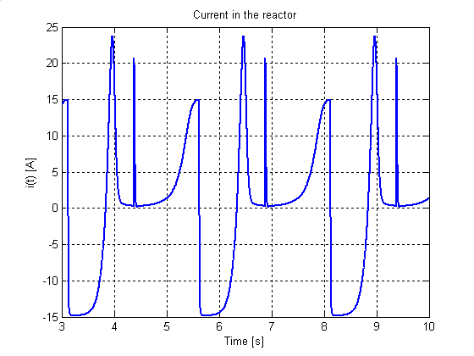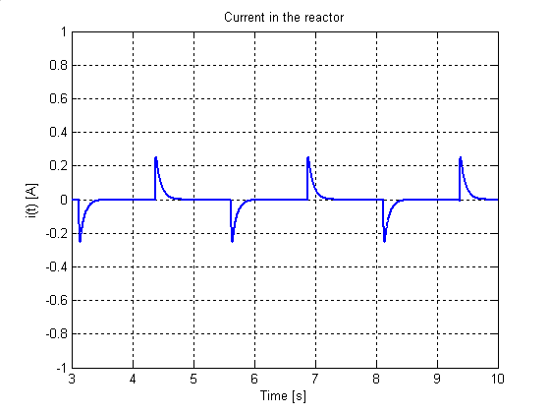

a)

b)

c)

d)

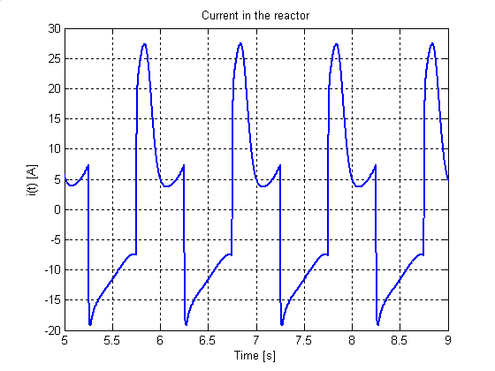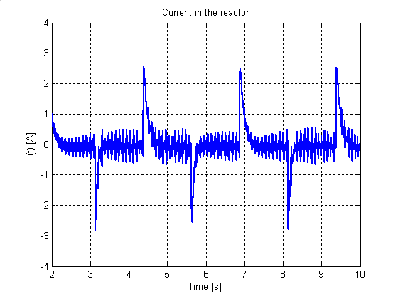

**Figure 7.** Solutions of (14) for various sets of parameters I and b with unchanged other parameters: a) SAO at I = 0.15 A, a = -1.75 and b=0.15, b) LAO at I = 15 A, a = -2.75 and b=0.15, c) LAO at I = 15 A, a = -1.25 and b=0.15, d) MMO at I = 1.5 A, a = -1. 75, b=0.15 and T = 2.5 s.

Generally, to MMOs we refer complex patterns that arise in dynamical systems, exhibiting oscillations with different amplitudes that are interspersed. These amplitude regimes differ roughly by an order of magnitude. By changing appropriate variables or parameters of a system MMOs may occur in larger regions as the dynamical switches between small amplitude oscillations (SAOs) and large amplitude oscillations (LAOs). As the control parameter is varied, MMOs exhibiting alternation between SAOs and LAOs can arise. The system can be considered as a coupling of two oscillators: linear and nonlinear ones. In our analysis, we use the letters L and s in Ls to describe the number of local maximum values of steady-state LAOs and SAOs, respectively, and not the number of LAOs and SAOs. It is worth point out that the MMOs of type Ls are not the only possible dynamical characterization of such systems. In fact, all parameters (T, I, Re, Rp, Cp, Cs, Cd, a and b) in (14) may be considered as bifurcation parameters. We shall analyze local maximum values of LAOs and SAOs and show that, by slowly changing any of the above parameters, we can obtain local maximum values of the charges, magnetic fluxes, currents and voltages that can form appropriate sequences. We emphasize that a numerical technique addressing this coupled phenomenon for all ranges of parameters will open up the possibilities for value-added electrochemical processes and producing new materials.

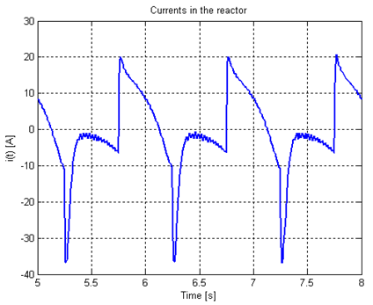

T

T1

T2

Ts

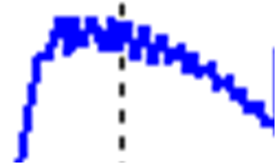

a)

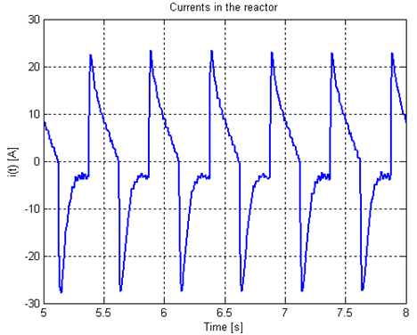

b)

**Figure 8.** MMOs: a) 118 for T = 1 s, b) 17 for T = 0.5 s

The three basic modes of operation are illustrated in Fig.7 which shows the solutions of (14) with I $ϵ$ {0.15, 1.5, 15}A, a $ϵ$ {-1.25, -1.75, -2.75}, b $=$ 0.15 and T $ϵ \left\{1, 2.5\right\}s$. In the SAOs only case, the small amplitude oscillations around the origin (0, 0, 0) are due to Hopf bifurcation for a = 0. In the LAOs only case, a trajectory passing close to the origin bypasses the region of small amplitude oscillations. The MMOs case is in some sense a combination of the previous two cases. The mechanism in which SAOs and LAOs occur is quite complex and has been the topics of recent papers [13] $÷\text{[15}].$ In the MMOs case, a series of SAOs around the origin (considered as canard solutions) undergoes a rapid canard explosion yielding an LAO, which, through a special return mechanism brings back the system into the vicinity of the origin. The canard explosion described in details in[13] is triggered when a trajectory leaves a fold point of a cubic nonlinearity ending a series of SAOs and entering the relaxation mode with one or more LAOs. This explosion occurs, for example, in Fig.7, bottom right part, when two or four SAOs transform into an LAO. Depending on the parameters, the system may continue with one (or more) LAOs, or may go through a new series of SAOs after which trajectory leaves again the vicinity of the origin (a fold) and the phenomenon repeats.

Each period of MMOs can be divided into intervals of various natures: intervals with a sequence of SAOs and intervals of LAOs. One period of LAOs can be estimated as TL = T1 + T2 (as shown in Fig. 8) and one period of SAOs can be determined as whole duration interval Ts divided by s indicating the number of local maximum values of steady state SAOs. Thus, the total period of one MMOs oscillation is T = TL + Ts. The corresponding expressions specifying the individual components of the period T are presented in[14] and can easily be adapted to the case under examination.

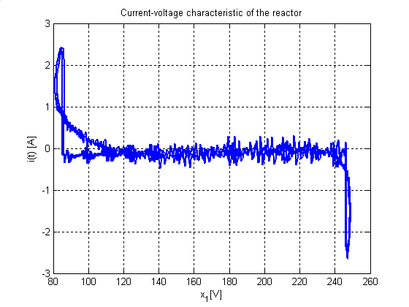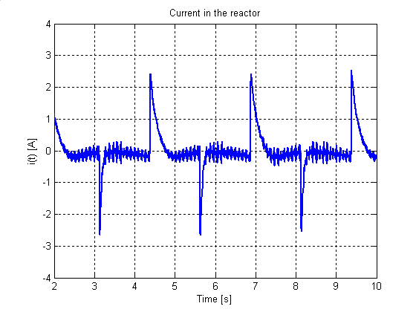

b)

a)

**Figure 9.** MMO at I = 1.5A (bipolar pulse), b = 0.5 and T = 2.5: a) reactor current, b) voltage-current characteristic of the reactor

Taking into account a small amount of perturbation in the characteristic q() it is possible to get MMOs exhibiting in each period a train of SAOs separated by a large amplitude pulse (Fig.9a). By varying pairs of control parameters, one can observe how the dynamical behaviour of the system changes and map out “dynamical phase diagrams” showing regions of the parameter space in which qualitatively different MMOs occurs, or, by varying a single parameter, one can trace out hysteresis loops of the sort shown in Fig. 9b. This type of time-varying electric currents and magnetic fields are most probably generated by an electric double layer within individual particles and a temporal excess of ion carriers within the sample. Perhaps the shape and magnitude of the induced temporal signals depend on the reaction zone propagation mode, reaction mechanism, and reactant properties. It is worth noticing that the exact solution of the above set of equations for real multi-component electrolytes is rather complicated, therefore by imposing appropriate restrictions which are satisfied under corresponding electroplating conditions it is possible elaborate models which lead to satisfied results when matching them with experimental data.

**Conclusions**

Electrocrystallization method gives the ability to control the internal structure of the deposits, which is a great potential for use in the development of new material properties. This method is exceptionally suitable for preparations of specific materials, mainly the protective layers, and in the near future may be more effective than previously involved methods in surface modification technologies of known materials, as well as newly produced materials. These layers can be used together with their grounds or separated from them. Taking into account the specificity of materials electrollytically produced, it is possible the formation of such a structure of the material and its properties that cannot be obtained by other technologies. The possibility of conscious control of the structures in the nanometric areas leads up to producing the useful materials with new properties and overcome previously insurmountable barriers to the development of technology.

The problem of obtaining smooth, uniform layers can be solved by a combination of clever electrode design, electrolyte flow control and judicious use of the chemical additives that lead to desired results. Significant improvement of the results can be achieved by appropriate modelling of processes occurring in the electrocrystallizator and taking into account the influence of its own magnetic field in the double layer near the working electrode. Circuit models can lead to methods for fast treating large quantities of electrocrystallizator data and extracting from them kinetic parameters importantly influenced the structure of the produced materials. Particular attention should be paid to the problem of the generation of processes with mixed mode oscillations, because they can favourably affect the quality of the material produced in electrochemical processes. This is of great importance in the case of nanostructured materials whose final structure is very sensitive to rapid changes in the conditions of the manufacturing process. A particularly interesting context is that of current waveforms supplying the electrocrystallizator because their influence on mixed mode oscillations seems most important for the efficiency of realized processes.

**References**

1. Silberberg M. Chemistry - The Molecular Nature of Matter and Change. New York, McGraw-Hill Science/Engineering/Math, 2008

2. Epstein IR., Pojman JA. An Introduction to Nonlinear Chemical Dynamics: Oscillations, Waves, Patterns, and Chaos. Oxford University Press, New York, 1998.

**3. Laganà** A,Gregory **AP.** Chemical Reactions. Basic Theory and Computing. Springer, New Yok, 2018

4. Trzaska M, Trzaska Z.Nanomaterials Produced by Electrocrystallization Method. in: Aliofkhazraei M, Makhlouf A. (eds) Handbook of Nanoelectrochemistry. Springer, Cham, 2016

# 5. **Lona F**, Maria L. Step by Step Approach to the Modeling of Chemical Engineering Processes. Using Excel for simulation. Springer, New Yok, 2018

6. **Kreysa** G, **Ota** Ken-ichiro, **Savinell** RF. (Eds.) Encyclopedia of Applied Electrochemistry. Springer, New York, 2014

7. Cieślak G, Trzaska M. Tribological properties of nanocomposite Ni/grapheme coatings produced by electrochemical reduction method. Composites: Theory and Practice 2016; 2, 79–83.

8. Trzaska M, Trzaska Z. Electrochemical impedance spectroscopy in materials engineering. Publisher Office of the Warsaw University of Technology, Warsaw, 2010.

9. Sangeetha S, Kalaignan GP., Anthuvan JT. Pulse electrodeposition of self-lubricating Ni–W/PTFE nanocomposite coatings on mild steel surface. Applied Surface Science 2015; 359 , 412–419

10. Kamnerdkhag P, Free ML, Shah A, et al. The effects of duty cycles on pulsed current electrodeposition of ZneNieAl2O3 composite on steel substrate: Microstructures, hardness and corrosion resistance. International Journal of Hydrogen Energy 2017; 42, 20783–20790.

11. Abdul J, Yasin G, Khan WQ, et al. Electrochemical deposition of nickel graphene composite coatings: effect of deposition temperature on its surface morphology and corrosion resistance. The Royal Society of Chemistry 2017; 7, 31100–31109.

12. Djokić SS. Electrodeposition: theory and practice. Springer, New York. 2010, https://doi.org/10.1007/978-1-4419-5589-0.

13. Focus issue: Mixed-mode oscillations: experiment, computation, and analysis. Chaos, 2008, 18, 015101.

14. Marszalek W, Trzaska ZW. Mixed-mode oscillations in a modified Chua’s circuit. Circuits Syst. Signal Proc 2010; 29, 1075–1087

15. Marszalek W, Trzaska ZW. Properties of memristive circuits with mixed-mode oscillations. Electron. Lett 2015; 51(2): 140–141.

16. Beardmore RE., Laister R. The flow of a differential-algebraic equation near a singular equilibrium. SIAM J. Matrix Anal 2002; 24(1): 106–120, 2002.

17. Sagués F, Epstein IR. Nonlinear chemical dynamics. Dalton Transactions 2003, 1201–1217.