**Selective deprotection of strategy for TBS ether under mild condition**

Vipin Singh, Shanta Raj Lakshmi and L. Raju Chowhan*

*Corresponding author. Centre for Applied Chemistry Central university of Gujarat, Sector 30 Gandhinagar, INDIA-382030.

**ABSTRACT**



A selective, high yielding and convenient method for deprotection of *tert*-butyldimethylsilyl ether (TBS) using catalytic amount of ZnBr2and *N*-chlorosuccinimide in methanol/DCM as solvent at room temperature is described. The methodology iseconomical, robust, clean, rapid, high yielding and highly selective in for deprotection of TBS ether.Methodology is applicable for deprotection of acetonide also.

***Key words:*** TBS deprotection; acetonide deprotection; selective deprotection; protection group chemistry

**Introduction**

Synthesis of diverse organic compounds still cannot be realised without using protecting groups. En route of synthesis of natural products, in a multi-functional molecule under the similar reaction conditions some functional groups also react and give un wanted side products. Thus, required to protect some of the functional groups in order to get required products. Since several decades many such protecting groups have been devised, developed and used by synthetic organic chemists (Figure 1).Consequently, even enabled them with solutions of various classical problems by making use of synthetic mutation and even evolution. Most of the organic compounds have more than one functional groups, and almost all of the functional groups can react in more than one way. Then it becomes considerable to predict that how, which and where a specific functional group will react. Till date numerous such groups have been developed and are still being tailored to meet the challenging and ever-growing requirements of modern synthetic chemistry.[1,2]

In a multifunctional compound, reaction at one site keeping other intact known as chemoselectivity. Contemporarily, the art of organic synthesis has to go a long way for being sovereign of protective group. This is exemplified by the widespread and ever-growing usage of protective groups during the creation of multifunctional molecules. Many natural products have hydroxy or polyol functional groups. Protection and deprotection of alcoholic functional group is essential and plays a pivotal role in total synthesis of natural products. A glut of methods and reagents devised emphasizes the strength underlying with protection of hydroxyl group. The same can be observed very well in synthesis of biologically active molecules in particular. On the other hand, silyl ethers are the most widely used protecting groups due to several advantages like easy to protect and purifying methods. However, selective deprotection of such protecting groups is still remains challenging task.[3-5]

Owing to ease of selective deprotection of *tert*-butyldimethylsilyl (TBS)[6] in presence various acid sensitive groups still remains challenging for hydroxyl group.[6-8]Stability to a plethora of reaction conditions and strength to resist basic and considerably acidic reagents further strengthens up popularity of TBS ether. Although numerous methods exists[9-18] for removal of TBS group in non-selective approach but still there are ample of challenges associated while using them like harsh chemical environment, inert reaction conditions, costly reagents or usage of strong reducing, [12]oxidizing,[13,14] hazardous reagents, acidic or basic[9] medium, cumbersome workup, a large excess of phase transfer reagents and long reaction times which are usually avoided by organic chemists.



**Figure 1.** Common protective groups

In literature there exist a few methods for cleavage of alkylsilyl ethers which can uninstall TBS ethers while differentiating TBDMS and TBDPS ethers. Majority of the existing methods involve elevated temperature, basic reagents with harsh reaction conditions and leave behind an ample void for a method utilizing milder reagents.[19-22]Chemoselectivity between TBS and TBDPS and efficiency towards ejection of alcohol is another key aspect which point towards development of a protocol which would be useful for multi-step synthetic sequences demanding for selective removal of either of TBDMS or TBDPS at a specific stage.[23]

**Results and Discussion**

Herein we are reporting a method for selective cleavage of TBDMS ether by N-chlorosuccinimide (NCS) in presence of catalytic amount of ZnBr2 under mild condition, Scheme 1, (Table 1). TBS ether **1a** was prepared by following the known method.[24] For standardisation of the reaction condition initially, the reaction was carried out using TBS ether **1a** in MeOH, 10 mol% of ZnBr2 and 0.1 eq of NCS afforded the product **2a** in 10% yield.



**Scheme 1**. Deprotection of TBS ether

|  |  |  |  |  |  |  |
| --- | --- | --- | --- | --- | --- | --- |
| **Entry** | **Solvent** | **NCS** | **ZnBr2(Mole %)** | **Temp °C** | **Time (mins)** | **Yield (%)** |
| 1 | DCM | 0.1 | 0.1 | RT | 180 | 10 |
| 2 | DCM | 0.5 | 0.1 | RT | 150 | 45 |
| 3 | DCM | 0.5 | 0.2 | RT | 120 | 50 |
| 4 | DCM | 1.0 | 0.1 | RT | 90 | 99 |
| 5 | DCM | 1.0 | 0.1 | Reflux | 90 | 92 |
| 6 | THF | 1.0 | 0.1 | RT | Nr | Na |
| 7 | Et2O | 1.0 | 0.1 | RT | Nr | Na |
| 8 | CHCl3 | 1.0 | 0.1 | RT | Nr | Na |
| 9 | EtOH | 1.0 | 0.1 | RT | 200 | 95 |
| 10 | IPA | 1.0 | 0.1 | RT | 250 | 85 |
| 11 | MeOH | 1.0 | 0.1 | RT | 25 | 99 |

All experiments were performed at 0.5 mmol scale. To a solution of ether (0.5 mmol) insolvent (0.25 M), *N*-chlorosuccinimide (0.5 mmol), ZnBr2(0.1 mol %)were added and stirred for 30 mins at RT. Nr: No reaction,Na: Not applicable.

**Table 1.** Optimization of reaction condition

In anticipation to increase the yield of the product, keeping other parameters constant the amount of NCS is increased to 0.5 equivalent which afforded the required product in 45% yield. Further reaction was planned with 20-30 mol % of the ZnBr2 gave slight increase in the product yield (entry 3, Table 1). Finally, we found the best optimised condition for the deprotection of TBS is 10 mol% of ZnBr2 and stoichiometric amount of NCSafforded 99% yield. Reaction in DCM also shown similar results (entry 11, Table 1). However, under the reflux condition decreased the yield of the product (entry 5, Table 1).A range of TBDMS ether was subjected to this procedure and the result is summarized in Table 2.

|  |  |  |  |  |  |  |
| --- | --- | --- | --- | --- | --- | --- |
| Entry | Substrate | Solvent | TempoC | Time(mins) | Product | Yield % |
|  |  | MeOH | RT | 25 |  | 99 |
| DCM | RT | 90 |  | 99 |
|  |  | MeOH | RT | 40 |  | 99 |
| MeOH | Reflux | 30 |  | 99 |
| DCM | Reflux | 90 |  | 15 |
|  |  | MeOH | RT | 30 |  | 99 |
| MeOH | Reflux | 25 |  | 95 |
| DCM | Reflux | 90 |  | 30 |
|  |  | MeOH | RT | 70 |  | 95 |
| MeOH | Reflux | 50 |  | 90 |
| DCM | Reflux | 90 |  | 20 |
|  |  | MeOH | RT | 40 |  | 95 |
| MeOH | Reflux | 30 |  | 87 |
| DCM | Reflux | 90 |  | 37 |

All experiments were performed at 0.5 mmol scale. To a solution of TBS ether (0.5 mmol.) in 0.25M solvent, *N*-chlorosuccinimide (0.5 mmol), ZnBr2(0.1 mol %)were added and stirred at the temperature till completion of the reaction.

**Table 2.** Selective deprotection of TBS ether

To test the chemoselectivity the reaction was performed on mono TBS, TBDPS ether **1b-c** under the standardised condition yielded the mono TBDPS ether**2b-c** in excellent yield(entry 2-3, Table 2).Further the reaction was performed using primary TBDPS and secondary TBS ether**1d**, under this protocol only TBS deprotected keeping TBDPS intact in excellent yield(entry 4, Table 2). Similarly, the reaction on primary TBS and secondary TBDPS ether **1e**high chemoselectivity was observed(entry 5, Table 2). Thus, the methodology proves that its highly selective towards deprotection of TBS ether and can be employed for selective deprotection of TBS ethers.

To increase the scope of the methodology, under the above-mentioned conditions were applied on the acetonide substrate **1f** afforded diol **2f** in quantitative yield. Scheme 2, Table 3.



**Scheme 2**. Deprotection of acetonide

|  |  |  |  |  |  |  |
| --- | --- | --- | --- | --- | --- | --- |
| Entry | Substrate | Solvent | Temp | Time (mins) | Product | Yield% |
| **1** |  | MeOH | RT | 70 |  | 90 |
| **2** |  | MeOH | Reflux | 30 |  | 95 |
| **3** |  | DCM | Reflux | 90 | No reaction | n. a |

All experiments were performed at 0.5 mmol scale. To a solution of acetonide (0.5 mmol.) in 2 mL of solvent, *N*-chlorosuccinimide (0.5 mmol), ZnBr2(0.1 mol %)were added and stirred at the temperature till completion of the reaction.

**Table 3.** Deprotection of acetonide

Using MeOH as solvent, acetonide group of **1f** was deprotected.In DCM solvent, acetonide was completely unaffected and starting material was largely recovered.Therefore, NCS is an excellent, high yielding, safe, operationally simple, clean and no precaution is to be taken to exclude moisture or oxygen from reaction system. As no strongly acidic or basic conditions are used, hence it is more suitable for concrete organic synthesis.[25-30]

**Material and Methods**

Alcohols, silyl reagents, Zn dust, 1,2 dibromo ethane 2,2 DMP and solvents were acquired from Avra Synthesis and used without further purification. Analytical thin layer chromatography was performed with the help of pre-coated silica gel plate (200 μm) which were acquired from Merk on Aluminium with fluorescent indicator. Column chromatography was performed over silica gel of 60–120 mesh, both acquired from Rankem fine chemicals. NMR Spectral analysis was recorded in CDCl3 with Bruker- Biospin Avance-III 500 MHz FT-NMR instrument.

**Preparation of ZnBr2**



In a 500 mL 2 neck round bottom flask unactivated Zn dust (200 mmol) was weighed. The round bottom flask was fitted with reflux condenser and dry THF (100 mL) was added under inert condition. The mixture was stirred and heated up to 60 oC. 1,2 dibromo ethane (5 mmol) was added initially and stirred till generation of ZnBr2 and another 95 mmol of dibromo ethane was added drop wise and further refluxed for 1h. After completion of the reaction unreacted Zn dust was settle down in flask and supernatant layer was syphoned in to dry bottle and stored under N2 atmosphere and used for the reaction.

**Preparation of tert-butyl((4-methoxybenzyl)oxy)dimethylsilane1a**



To a solution of alcohol**2a** (3.4 g, 25 mmol) in dry DCM (100 mL), cooled at 0 °C, imidazole (4.2 g, 62.5 mmol) and TBDMSCl (3.768 g, 25 mmol) were added. The reaction mixture was stirred for 3 hours under argon atmosphere. Upon complete conversion of alcohol into corresponding silyl ether, monitored by TLC, reaction was quenched by adding cold water. The layers were separated and the aq. layer was extracted with DCM (3x30 mL), combined organic layer were washed with brine (30 mL), dried over anhydrous Na2SO4. Solvent was evaporated under reduced pressure to obtain crude compound which was further purified by column chromatography using hexanes to acquire pure product **1a** in 95% yield as viscous oil. TLC R*f* = 0.5 (5% EtOAc/Hexanes); 1H NMR (500 MHz, CDCl3) δ 7.15 (d, *J*= 8.52 Hz, 2H), 6.78 (d, *J* = 8.20 Hz, 2H), 4.59 (s, 2H), 3.71 (s, 3H), 0.85 (s, 9H), 0.00 (s, 6H).

**Preparation of 2,2,3,3,11,11-hexamethyl-10,10-diphenyl-4,9-dioxa-3,10-disiladodecane 1b**



1,4-butane diol **2b** (8.1g, 90 mmol) in dry DCM (120 mL) was cooled to 0 °C, imidazole (5.1 g, 75 mmol), TBSCl (4.5 g,30 mmol) and DMAP (916 mg,7.5 mmol) was added. The reaction was stirred for 40 min. The reaction mixture was quenched by adding cold water the layers were separated and aq. layer was extracted with DCM (3x60 mL), combined organic layer was washed with brine(60 mL) and dried over Na2SO4. Solvent was evaporated under reduced pressure to afford crude product, which was purified by column chromatography using 5% EtOAc/hexanes to afford pure compound in 35% yield as viscous oil. R*f=* 0.35 (10% EtOAc/Hexanes). To a solution of above prepared TBS alcohol (3.6 g, 18 mmol) in dry DCM (72 mL), cooled at 0 °C triethylamine (7.5 mL, 54 mmol), TBDPSCl (16.2 mmol, 4.2 mL) and DMAP (0.549 g, 4.5mmol) were added and stirred under inert atmosphere for 4 h. The reaction was quenched by adding cold water. The layers were separated and aq. layer was extracted with DCM (3x50 mL), combined organic layer was washed with brine (50 mL), dried over anhydrous sodium sulphate. Solvent was evaporated under reduced pressure to obtain crude compound and was then purified by column chromatography in hexanes to afford pure compound **1b** in 90% yield as oil. TLC R*f*= 0.35 (5% EtOAc/Hexanes); 1H NMR (500 MHz, CDCl3) δ 7.64 (s, 4H), 7.29 (s, 6H), 3.66 (s, 2H), 3.57 (s, 2H), 1.24 (sc, 2H), 1.03 (s, 8H), 0.86 (s, 12H), 0.00(s, 6H).

**Preparation of 2,2,3,3,16,16,17,17-octamethyl-4,15-dioxa-3,16-disilaoctadecane 1c**



To a solution of diol **2c** (1.7 g, 10 mmol) in dry DCM (40 mL) , cooled at 0 °C, imidazole (2.0 g, 30 mmol), TBDMSCl (3.0 g, 20 mmol) was added and stirred for 3 hours under argon atmosphere. The reaction was quenched by adding cold water. The layers were separated and aq. layer was extracted with DCM (3x30 mL), combined organic layer was washed with brine (30 mL) and dried over anhydrous sodium sulphate. Solvent was evaporated under reduced pressure to obtain crude compound and was then purified by column chromatography in hexanes to afford pure compound **1c** in 95% yield as oil. TLC R*f* = 0.60 (5% EtOAc/Hexanes);1H NMR (500 MHz, CDCl3) δ 3.55 (t, *J*= 6.6 Hz, 4H), 1.48-1.42 (m, 4H), 1.27-1.21 (m, 12H), 0.86-0.84 (m, 18H), 0.01-0.00 (m, 12H).

**Preparation of 5-butyl-2,2,3,3,9,9-hexamethyl-8,8-diphenyl-4,7-dioxa-3,8-disiladecane 1d**



1,2-hexane diol**2d** (8.1g,20 mmol), in dry DCM (80 mL) was cooled at 0 °C, and triethylamine (5.5 mL, 40 mmol) and TBDPSCl (5.2 mL, 20 mmol) was added. The reaction was stirred for 3 h. The reaction mixture was quenched by adding cold water.The layers were separated and aq. layer was extracted with DCM (3x60 mL), combined organic layer was washed with brine (60 mL) and dried over anhydrous sodium sulphate. Solvent was evaporated under reduced pressure to obtain crude compound and was then purified by column chromatography by using 10% EtOAc/hexanes (v/v) to afford pure compound in 90% yield as viscous. TLC R*f* = 0.56 (5% EtOAc/Hexanes).To a solution of above prepared alcohol (1.0 g, 3 mmol) in dry DCM (72 mL), cooled at 0 °C, imidazole (0.6 g, 9 mmol), TBSCl (2.7 mmol, 0.40 g) and DMAP (0.09 g, 0.75mmol) were added and stirred under inert atmosphere for 12 hours. The reaction mixture was quenched by adding cold water. The layers were separated and aq. layer was extracted with DCM (3x50 mL), combined organic layer was washed with brine (50 mL) and was dried over anhydrous sodium sulphate. Solvent was evaporated under reduced pressure to obtain crude compound and was then purified by column chromatography in hexanes to afford pure compound **1d** in 40% yield as viscous oil. TLC R*f* = 0.42 (3% EtOAc/Hexanes); 1H NMR (500 MHz, CDCl3) δ 7.72-7.65 (m, 4H), 7.44-7.31 (m, 6H), 3.76-3.66 (m, 1H), 3.59-3.53 (m, 1H) 3.50-3.39 (m, 1H), 1.49-1.13 (m, 6H), 1.05z-1.03 (m, 9H), 0.97-0.81 (m,12H), 0.00 (m, 6H).

**Preparation 5-butyl-2,2,8,8,9,9-hexamethyl-3,3-diphenyl-4,7-dioxa-3,8-disiladecane 1e**



To a solution of diol **2e** (1.0 g, 3mmol) in dry DCM (60 mL), cooled at 0 °C, imidazole (3.0 g,45 mmol), TBSCl (13.5 mmol, 2.0 g) and DMAP (0.458 g, 3.75mmol) were added and stirred under inert atmosphere for 4 hours. The reaction was quenched by adding cold water. The layers were separated and aq. layer was extracted with DCM (3x50 mL),combined organic layer was washed with brine (50 mL) and dried over anhydrous sodium sulphate. Solvent was evaporated under reduced pressure to obtain crude compound and was then purified by column chromatography in 5% EtOAc/Hexanes afford pure compound in 90% yield as viscous oil. TLC R*f* = 0.35 (3% EtOAc/Hexanes). To a solution of above prepared alcohol (1.7 g, 7 mmol) in dry DCM (30 mL), cooled at 0 °C, triethylamine (9.7 mL, 70 mmol), TBDPSCl (0.9 mL, 3.6 mmol) and DMAP (7 mmol, 0.8 g) were added and stirred for 72 hours. The reaction mixture was quenched by adding cold water. The layers were separated and aq. layers were extracted and with DCM (3x30 mL), combined organic layers was washed with brine (30 mL) and dried over anhydrous sodium sulphate. Solvent was evaporated under reduced pressure to obtain crude compound and was then purified by column chromatography in Hexanes to afford pure compound **1e** in 30% yield as viscous oil. TLC R*f* = 0.42 (3% EtOAc/Hexanes); 1H NMR (500 MHz, CDCl3) δ 7.83-7.69 (m, 4H), 7.53-7.26 (m, 6H), 3.97-3.72 (m, 1H), 3.62-3.42 (m, 2H), 1.46- 1.17 (m, 6H), 1.17-1.03 (m, 9H), 0.97-0.84 (m, 12H), 0.10-0 (s,6H).

**Preparation of 4-butyl-2,2-dimethyl-1,3-dioxolane 1f**



A round bottom flask cooled at 0 °C was charged with 1,2-hexane diol **2f** (2.3 g, 20 mmol), 80 mL of dry DCM, 2,2-dimethoxy propane (3.64 mL, 30 mmol) and camphorsulfonic acid (464 mg,0.1 mmol) under inert atmosphere. The mixture was allowed to stir for 1.5 h. The reaction was quenched by addition of cold water. The layers were separated and aq. layer was extracted with DCM (3x40 mL), combined organic layer was washed with brine (40 mL), NaHCO3(5mL) and was dried over anhydrous sodium sulphate. Solvent was evaporated under reduced pressure to obtain crude compound and was then purified by column chromatography in 10% EtOAc/hexanes (v/v) to afford pure compound **1f**as viscous oil. TLC R*f* = 0.52 (15% EtOAc/Hexanes); 1H NMR (500 MHz, CDCl3) δ 4.05-3.87 (m, 2H), 3.43-3.34 (m, 1H), 1.60-1.50 (s, 1H), 1.45-1.36 (s, 1H), 1.36-1.13 (m, 10 H), 0.86-0.78 (t, *J=*6.5 Hz, 3H).

**General Experimental Procedure for the deprotection of TBS ethers and Acetonide group**

To a solution of TBS ether/acetonide (0.5 mmol.) in MeOH/DCM (2 mL),*N*-chlorosuccinimide (0.5 mmol) and ZnBr2 (0.1 mol %)were added and stirred at room temperature till completion of the reaction. Solvent was evaporated under vacuum and the crude product was purified by column chromatography by using Hexanes/EtOAc.

**NMR Spectra**



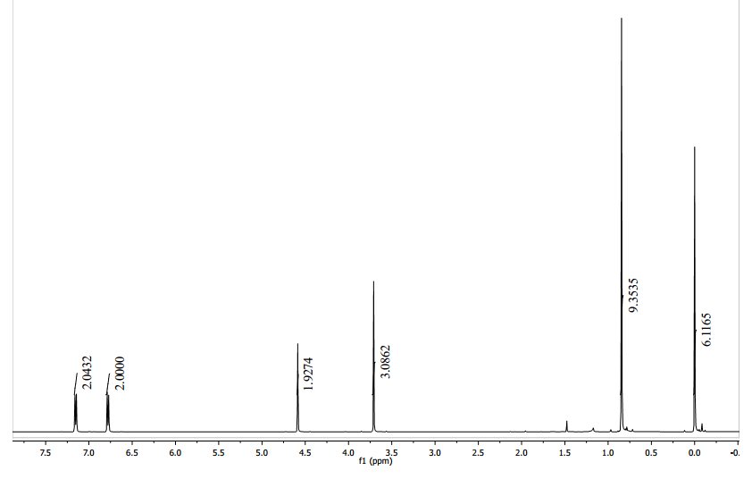

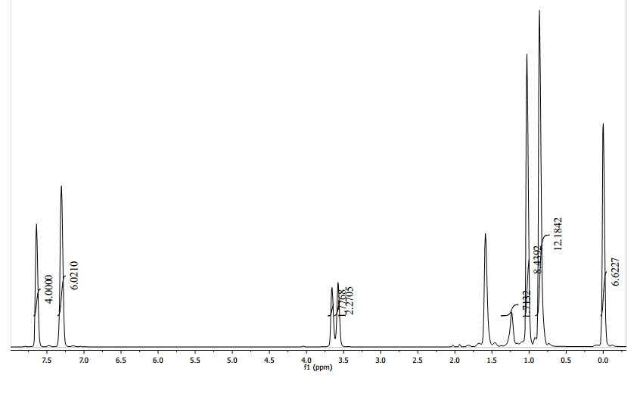



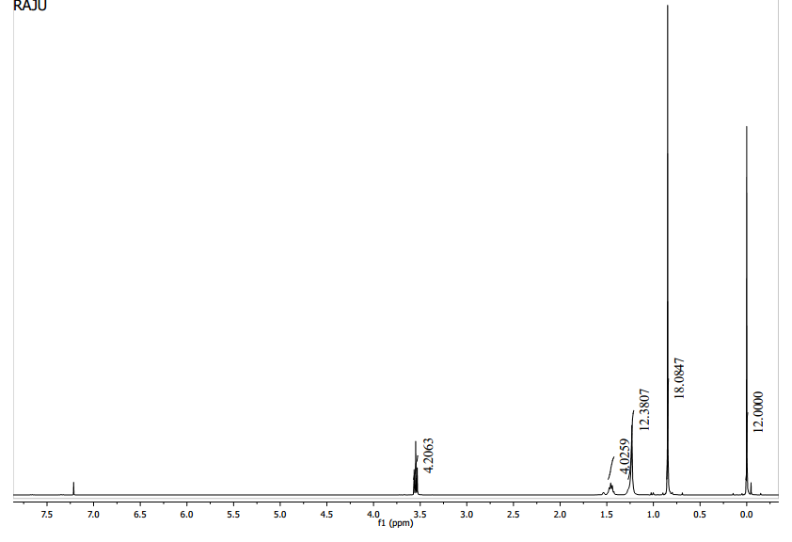



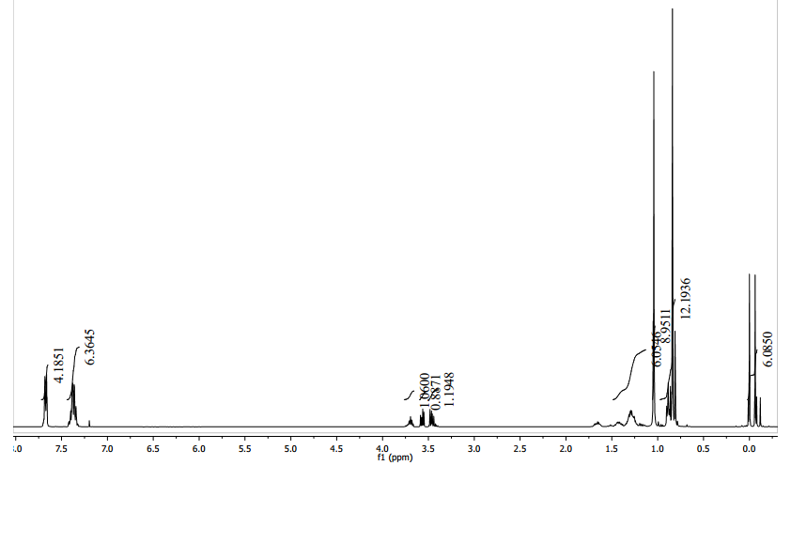

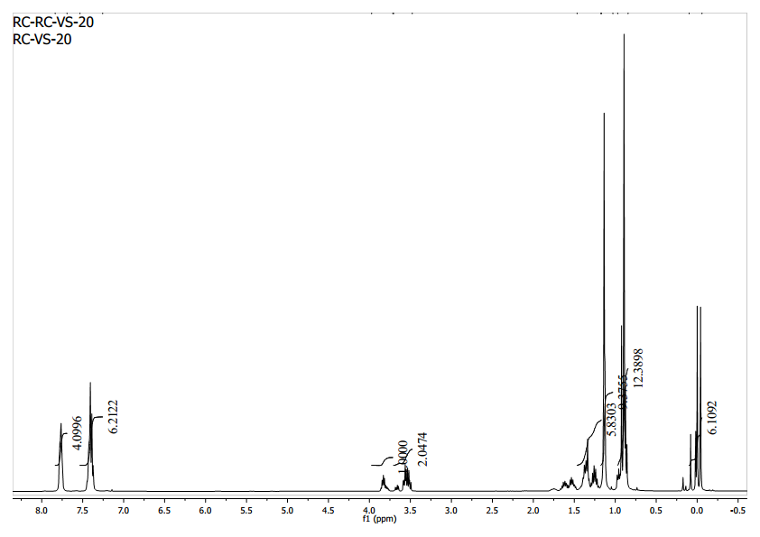



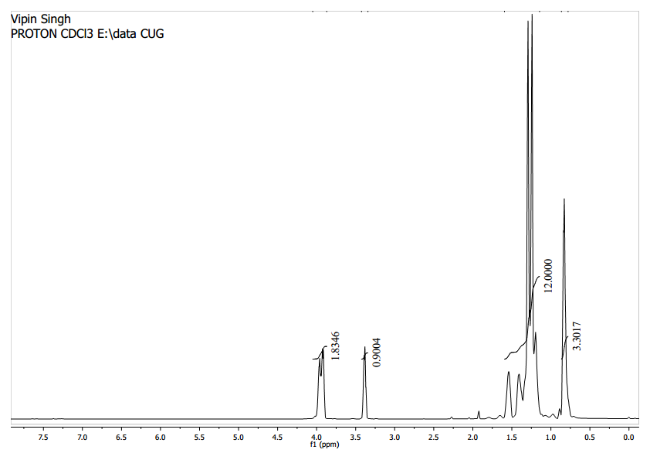



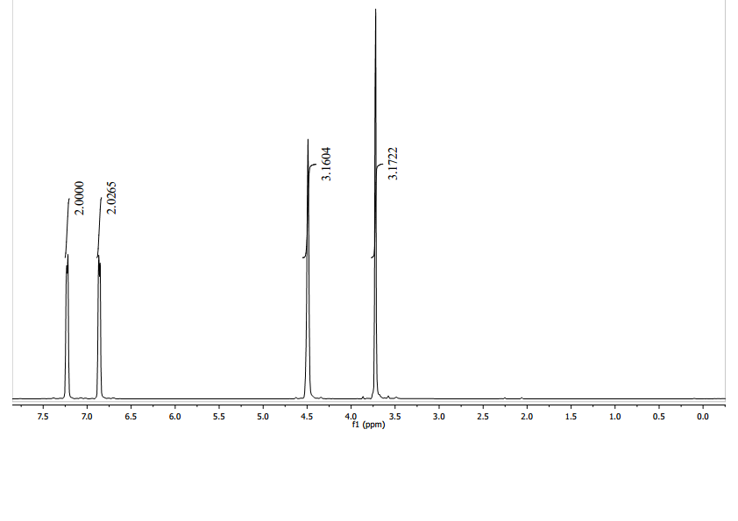



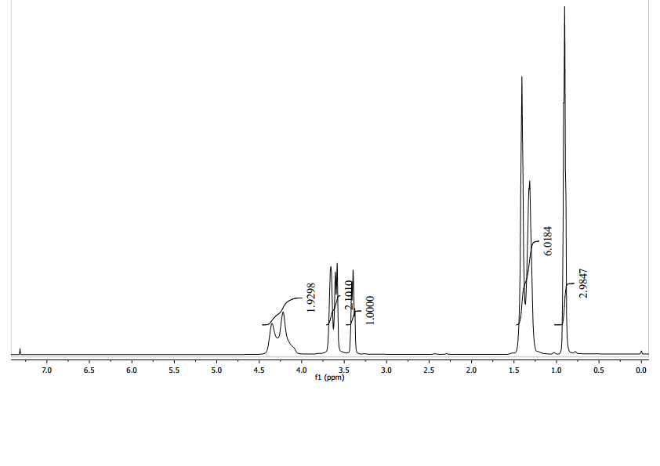



**Conclusion**

In conclusion a mild, convenient, efficient, eco-friendly and chemoselective protocol for selective deprotection of TBS ether is developed. Primary and secondary TBS ethers also selectively deprotected under the standardised condition. Similarly, the methodology is successfully applicable on acetonide substrates.

**Acknowledgement**

Authors thanks CUG and SERB for providing the facility and financial support. V. S thanks to RGNF for fellowship and S. R. L thanks UGC for non-NET Fellowship.

**References**

1. Greene TW., Wuts PGM. Protective Groups in OrganicSynthesis, 3rd ed John Wiley & Sons: New York, 1999.

2. (a) Clode DM. Carbohydrate cyclic acetal formation and migration [J]. Chem. Rev 1979; 79: 491-513.(b) Nicolaou KC, Daines RA, Uenishi J, et al. Total synthesis of amphoteronolide B and amphotericin B. 1. Strategy and stereocontrolled construction of key building blocks [J]. J. Am. Chem. Soc 1988; 110: 4672-4685.(c) Kim Y, Singer RA, Carreira EM. Total synthesis of macrolactin A with versatile catalytic, enantioselective dienolate aldol addition reactions[J]. Angew. Chem. Int. Ed 1998; 37: 1261-1263.

3. Zhang Q, Kang X, Long L, *et al*. Mild and selective deprotection of tert-Butyl(dimethyl)silyl ethers with catalytic­ amounts of sodium tetrachloroaurate(III) dihydrate [J]. Synthesis. 2015; 47: 55-64.

4. Khan AT., Mondal EA. Highly efficient and useful synthetic protocol for the cleavage of tert-Butyldimethylsilyl (TBS) ethers using a catalytic amount of acetyl chloride in dry methanol [J].Synlett, 2003, 694.

5. DiLauro AM., Seo W, Phillips ST. Use of catalytic fluoride under neutral conditions for cleaving silicon–oxygen bonds [J]. J. Org. Chem 2011; 76: 7352-7358.

6. Corey EJ., Venkateswarlu A. Protection of hydroxyl groups as tert-butyldimethylsilyl derivatives [J]. J. Am. Chem. Soc 1972; 94: 6190-6191.

7. (a) Chaudhary SK., Hernandez O. 4-dimethylaminopyridine: an efficient and selective catalyst for the silylation of alcohols [J]. Tetrahedron Lett 1979; 20: 99-102. (b) Corey EJ., Cho H, Rucker C, *et al.* Studies with trialkylsilyltriflates: new syntheses and applications [J]. Tetrahedron Lett 1981; 22: 3455-3458. (c) Lombardo L. Diisopropylethylamine: An effective catalyst for the introduction of the t-butyldimethylsilyl group [J]. Tetrahedron Lett 1984; 25: 227-228.

8. Kocieñski PJ. Protecting Groups; Georg Thieme Verlag: New York, 1994.

9. Corey EJ., Snider BB. Total synthesis of (+-)-fumagillin [J].J. Am. Chem. Soc 1972; 94: 2549-2550.

10. Pilcher AS., Hill DK., Shimshock SJ., *et al*. Selective deprotection of trialkylsilyl ethers using fluorosilicic acid[J]. J. Org. Chem 1992; 57: 2492-2495.

11. Corey EJ., Yi KY. Tetrafluorosilane is a mild and very selective reagent for the cleavage of silyl-protected alcohols [J].Tetrahedron Lett 1992; 33: 2289-2290.

12. Corey EJ., Jones GB. Reductive cleavage of tert-butyldimethylsilyl ethers by diisobutylaluminum hydride [J]. J. Org. Chem 1992; 57: 1028-1029.

13. Tanemura K, Suzuki T, Horaguchi T. Deprotection of silyl ethers using 2,3-dichloro-5,6-dicyano-p-benzoquinone [J]. J. Chem. Soc., Perkin Trans 1.1992, 2997-2998.

14. Dutta Gupta A, Singh R, Singh VK. A mild and efficient method for the cleavage of tert Butyldimethylsilyl and Tetrahydropyranyl ethers by ceric ammonium nitrate in methanol [J]. Synlett 1996; 69-71.

15. Lipshutz BH., Keith J. Selective deprotection of alkyl vs. aryl silyl ethers[J].Tetrahedron Lett 1998; 39: 2495-2498.

16. Oriyama T, Kobayashi Y, Noda K. Chemoselective and practical deprotection of alkyl trialkylsilyl ethers in the presence of aryl trialkylsilyl ethers by a catalytic amount of Sc(OTf)3 [J]. Synlett 1998, 1047-1048.

17. Bartoli G, Bosco M, Marcantoni E, *et al*. A mild, efficient, and selective method for the desilylation of more common Trialkylsilyl ethers by cerium(III) chloride heptahydrate and sodium iodide in acetonitrile [J]. Synlett 1998, 209-211.

18. Karimi B, Zamani A, Zarayee D. N-Iodosuccinimide (NIS) as a mild and highly chemoselective catalyst for deprotection of tert-butyldimethylsilyl ethers [J].Tetrahedron Lett 2004; 45: 9139-9141.

19. Kumar GDK., Baskaran S. A facile, catalytic, and environmentally benign method for selective deprotection of tert-Butyldimethylsilyl ether mediated by phosphomolybdic acid supported on silica gel [J]. J. Org. Chem 2005; 70: 4520-4523.

20. Peng Y, Li WDZ. A mild and efficient desilylation of O-tert-Butyldimethylsilyl ethers mediated by chlorotrimethylsilane and potassium fluoride dihydrate in acetonitrile [J]. Synlett 2006, 1165-1168.

21. Shah STA, Singh S, Guiry PJ. A novel, chemoselective and efficient microwave-assisted deprotection of silyl ethers with selectfluor [J]. J. Org. Chem 2009; 74: 2179-2182.

22. Wang B, Sun HX, Sun ZH. LiOAc-catalyzed chemoselective deprotection of aryl silyl ethers under mild conditions [J]. J. Org. Chem 2009; 74: 1781-1784.

23. Yeom CE, Kim HW, Lee SY, *et al*. DBU-Mediated mild and chemoselective deprotection of aryl silyl ethers and tandem biaryl ether formation [J]. Synlett 2007, 146-150.

24. (a) Raghavan S, Vinoth V, Raju Chowhan L. Highly stereoselective preparation of chiral α-substituted sulfides from α-chloro sulfides via 1,2-asymmetric induction [J]. Synlett 2009; 12: 1807-1810. (b) Raghavan S, Raju Chowhan L. Stereoselective carbon–carbon bond formation via 1,2-asymmetric induction by a β-substituent in the reaction of α-chloro sulfides with organozinc reagents [J]. Indian Journal of Chemistry 2018; 57B: 327-339.

25. (a) Coste G, Gerber-Lemaire S. Selective hydrolysis of anti-1,3-diol-acetonides for the differentiation of 1,3-anti and 1,3-syn diols [J]. Tetrahedron Lett 2006; 47:671-674. (b) Sabitha G, Reddy G S K K, Reddy K B, Reddy N M, Yadav J S.Vanadium(III) chloride: A mild and efficient catalyst for the chemoselective deprotection of acetonides[J]. J. Mol. Catal. A 2005; 238: 229-232. (c) Reddy S M, Reddy YV, Venkateswarlu Y. A mild and efficient method for the chemoselective deprotection of acetonides with lanthanum(III) nitrate hexahydrate [J]. Tetrahedron Lett 2005, 46: 7439-7441. (d) Yadav JS, Satyanarayana M, Raghavendra S, *et al*. Chemoselective hydrolysis of terminal isopropylidene acetals in acetonitrile using molecular iodine as a mild and efficient catalyst [J]. Tetrahedron Lett 2005; 46: 8745-8748. (e) Chari MA., Syamasundar K. Polymer-supported ferric chloride as a heterogeneous catalyst for chemoselective deprotection of acetonides [J].Synthesis 2005, 708-710.

26. Cong X, Hu F, Liu KG., *et al*. Chemoselective deprotection of cyclic N, O-aminals using catalytic bismuth(III) bromide in acetonitrile[J]. J. Org. Chem 2005; 70: 4514-4516. (b) Shaikh NS., Bhor SS., Gajare AS., *et al*. Tetrahedron Lett 2004, 45, 5395.

27. Chang CC, Liao BS, Liu ST. Deprotection of acetals and ketals in a colloidal suspension generated by ­sodium tetrakis(3,5-trifluoromethylphenyl)borate in water [J]. Synlett 2007, 283-287.

28. Singh S, Duffy CD, Shah STA., *et al.* ZrCl4 as an efficient catalyst for a novel one-pot protection/deprotection synthetic methodology [J].  J. Org. Chem 2008; 73: 6429-6432.

29. Maddani MR, Prabhu KR. Metal-free deprotection of terminal acetonides by using tert-butyl hydroperoxide in aqueous medium [J]. Synlett 2011, 821-825.

30. Pfrengle F, Dekaris V, Schefzig L, *et al*. Indium trichloride mediated cleavage of acetonides in the presence of acid-labile functional groups - enhancing the synthetic utility of 1,3-dioxolanyl-substituted 1,2-oxazines [J]. Synlett 2008, 2965-2968.